Enhanced Classification and Detection of Brain Tumor using Hybrid Deep Learning and Machine Learning Models

*A Project Report submitted in the partial fulfillment of the Requirements for the award of the degree*

### BACHELOR OF TECHNOLOGY

**IN**

### COMPUTER SCIENCE AND ENGINEERING

Submitted by

**D. Bala Sri Abhigna (21471A0519)**

**SK. Sameera (21471A0555)**

**CH. Harini (21471A0516)**

Under the esteemed guidance of

Dr. Sireesha Moturi, B.Tech., M.Tech., Ph.D.

Associate Professor



### DEPARTMENT OF COMPUTER SCIENCE AND ENGINEERING

NARASARAOPETA ENGINEERING COLLEGE: NARASAROPET

(AUTONOMOUS)

Accredited by NAAC with A+ Grade and NBA under Tyre -1 NIRF rank in the band of 201-300 and an ISO 9001:2015 Certified

Approved by AICTE, New Delhi, Permanently Affiliated to JNTUK, Kakinada

KOTAPPAKONDA ROAD, YALAMANDA VILLAGE, NARASARAOPET- 522601

2024-2025

### NARASARAOPETA ENGINEERING COLLEGE

**(AUTONOMOUS)**

### DEPARTMENT OF COMPUTER SCIENCE AND ENGINEERING



**CERTIFICATE**

**This is to certify that the project that is entitled with the name “Enhanced Classification and Detection of Brain Tumor Using Hybrid Deep Learning and Machine Leraning Models” is a bonafide work done by the team** D. Bala Sri Abhigna (21471A0519), SK. Sameera (21471A0555), CH. Harini(21471A0516) in partial fulfillment of the requirements forthe award of the degree of BACHELOR OF TECHNOLOGY in the Department of COMPUTER SCIENCE AND ENGINEERING during 2024-2025.

PROJECT GUIDE PROJECT CO-ORDINATOR

**Dr. Sireesha Moturi, B.Tech., M.Tech., Ph.D. Dr. Sireesha Moturi, B.Tech., M.Tech., Ph.D.**

**Associate Professor Associate Professor**

HEAD OF THE DEPARTMENT EXTERNAL EXAMINER

**Dr. S. N. Tirumala Rao, M.Tech., Ph.D.,**

**Professor & HOD**

### DECLARATION

We declare that this project work titled "Enhanced Classification and Detection of Brain Tumor using Hybrid Deep Learning and Machine Learning Models " is composed by ourselves that the work contain here is our own except where explicitly stated otherwise in the text and that this work has been submitted for any other degree or professional qualification except as specified.

D. Bala Sri Abhigna (21471A0519)

SK. Sameera (21471A0555)

CH. Harini (21471A0516)

## ACKNOWLEDGEMENT

We wish to express my thanks to carious personalities who are responsible for the completion of the project. We are extremely thankful to our beloved chairman Sri **M. V. Koteswara Rao, B.Sc.,** who took keen interest in us in every effort throughout thiscourse. We owe out sincere gratitude to our beloved principal **Dr. S. Venkateswarlu, Ph.D.,** for showing his kind attention and valuable guidance throughout the course.

We express our deep felt gratitude towards **Dr. S. N. Tirumala Rao, M.Tech., Ph.D.,** HOD of CSE department and also to our guide **Dr. Sireesha Moturi, B.Tech, M.Tech., Ph.D.,** of CSE department whose valuable guidance and unstinting encouragement enable us to accomplish our project successfully in time.

We extend our sincere thanks towards **Dr. Sireesha Moturi, B.Tech, M.Tech., Ph.D.,** Associate professor & Project coordinator of the project for extending her encouragement. Their profound knowledge and willingness have been a constant source of inspiration for us throughout this project work.

We extend our sincere thanks to all other teaching and non-teaching staff to department for their cooperation and encouragement during our B.Tech degree.

We have no words to acknowledge the warm affection, constant inspiration and encouragement that we received from our parents.

We affectionately acknowledge the encouragement received from our friends and those who involved in giving valuable suggestions had clarifying out doubts which had really helped us in successfully completing our project.

By

**D. Bala Sri Abhigna (21471A0519)**

**SK. Sameera (21471A0555)**

**CH. Harini (21471A0516)**



### INSTITUTE VISION AND MISSION

**INSTITUTION VISION**

To emerge as a Centre of excellence in technical education with a blend of effective student centric teaching learning practices as well as research for the transformation of lives and community,

**INSTITUTION MISSION**

M1: Provide the best class infra-structure to explore the field of engineering and research

M2: Build a passionate and a determined team of faculty with student centric teaching, imbibing experiential, innovative skills

M3: Imbibe lifelong learning skills, entrepreneurial skills and ethical values in students for addressing societal problems



**DEPARTMENT OF COMPUTER SCIENCE AND ENGINEERING**

**VISION OF THE DEPARTMENT**

To become a center of excellence in nurturing the quality Computer Science & Engineering professionals embedded with software knowledge, aptitude for research and ethical values to cater to the needs of industry and society.

**MISSION OF THE DEPARTMENT**

The department of Computer Science and Engineering is committed to

**M1:** Mould the students to become Software Professionals, Researchers and Entrepreneurs by providing advanced laboratories.

**M2:** Impart high quality professional training to get expertize in modern software tools and technologies to cater to the real time requirements of the Industry.

**M3:** Inculcate team work and lifelong learning among students with a sense of societal and ethical responsibilities.



## Program Specific Outcomes (PSO’s)

**PSO1:** Apply mathematical and scientific skills in numerous areas of Computer Science and Engineering to design and develop software-based systems.

**PSO2:** Acquaint module knowledge on emerging trends of the modern era in Computer Science and Engineering

**PSO3:** Promote novel applications that meet the needs of entrepreneur, environmental and social issues.



#### Program Educational Objectives (PEO’s)

The graduates of the programme are able to:

**PEO1:** Apply the knowledge of Mathematics, Science and Engineering fundamentals to identify and solve Computer Science and Engineering problems.

**PEO2:** Use various software tools and technologies to solve problems related to academia, industry and society.

**PEO3:** Work with ethical and moral values in the multi-disciplinary teams and can communicate effectively among team members with continuous learning.

**PEO4:** Pursue higher studies and develop their career in software industry.



## Program Outcomes

1. **Engineering knowledge:** Apply the knowledge of mathematics, science, engineering fundamentals, and an engineering specialization to the solution of complex engineering problems.
2. **Problem analysis:** Identify, formulate, research literature, and analyse complex engineering problems reaching substantiated conclusions using first principles of mathematics, natural sciences, and engineering sciences.
3. **Design/development of solutions:** Design solutions for complex engineering problems and design system components or processes that meet the specified needs with appropriate consideration for the public health and safety, and the cultural, societal, and environmental considerations.
4. **Conduct investigations of complex problems:** Use research-based knowledge and research methods including design of experiments, analysis and interpretation of data, and synthesis of the information to provide valid conclusions.
5. **Modern tool usage:** Create, select, and apply appropriate techniques, resources, and modern engineering and IT tools including prediction and modeling to complex engineering activities with an understanding of the limitations.
6. **The engineer and society:** Apply reasoning informed by the contextual knowledge to assess societal, health, safety, legal and cultural issues and the consequent responsibilities relevant to the professional engineering practice.
7. **Environment and sustainability:** Understand the impact of the professional engineering solutions in societal and environmental contexts, and demonstrate the knowledge of, and need for sustainable development
8. **Ethics:** Apply ethical principles and commit to professional ethics and responsibilities and norms of the engineering practice.
9. **Individual and team work**: Function effectively as an individual, and as a member or leader in diverse teams, and in multidisciplinary settings.
10. **Communication**: Communicate effectively on complex engineering activities with the engineering community and with society at large, such as, being able to comprehend and write effective reports and design documentation, make effective presentations, and give and receive clear instructions.
11. **Project management and finance**: Demonstrate knowledge and understanding of the engineering and management principles and apply these to one’s own work, as a member and leader in a team, to manage projects and in multidisciplinary environments.
12. **Life-long learning**: Recognize the need for, and have the preparation and ability to engage in independent and life-long learning in the broadest context of technological change.



**Project Course Outcomes (CO’S):**

**CO421.1:** Analyse the System of Examinations and identify the problem.

**CO421.2:** Identify and classify the requirements.

**CO421.3:** Review the Related Literature

**CO421.4:** Design and Modularize the project

**CO421.5:** Construct, Integrate, Test and Implement the Project.

**CO421.6:** Prepare the project Documentation and present the Report using appropriate method.

**Course Outcomes – Program Outcomes mapping**

|  |  |  |  |  |  |  |  |  |  |  |  |  |  |  |  |
| --- | --- | --- | --- | --- | --- | --- | --- | --- | --- | --- | --- | --- | --- | --- | --- |
|  | **PO1** | **PO2** | **PO3** | **PO4** | **PO5** | **PO6** | **PO7** | **PO8** | **PO9** | **PO10** | **PO11** | **PO12** | **PSO1** | **PSO2** | **PSO3** |
| **C421.1** |  | ✓ |  |  |  |  |  |  |  |  |  |  | ✓ |  |  |
| **C421.2** | ✓ |  | ✓ |  | ✓ |  |  |  |  |  |  |  | ✓ |  |  |
| **C421.3** |  |  |  | ✓ |  | ✓ | ✓ | ✓ |  |  |  |  | ✓ |  |  |
| **C421.4** |  |  | ✓ |  |  | ✓ | ✓ | ✓ |  |  |  |  | ✓ | ✓ |  |
| **C421.5** |  |  |  |  | ✓ | ✓ | ✓ | ✓ | ✓ | ✓ | ✓ | ✓ | ✓ | ✓ | ✓ |
| **C421.6** |  |  |  |  |  |  |  |  | ✓ | ✓ | ✓ |  | ✓ | ✓ |  |

**Course Outcomes – Program Outcome correlation**

|  |  |  |  |  |  |  |  |  |  |  |  |  |  |  |  |
| --- | --- | --- | --- | --- | --- | --- | --- | --- | --- | --- | --- | --- | --- | --- | --- |
|  | **PO1** | **PO2** | **PO3** | **PO4** | **PO5** | **PO6** | **PO7** | **PO8** | **PO9** | **PO10** | **PO11** | **PO12** | **PSO1** | **PSO2** | **PSO3** |
| **C421.1** | 2 | 3 |  |  |  |  |  |  |  |  |  |  | 2 |  |  |
| **C421.2** |  |  | 2 |  | 3 |  |  |  |  |  |  |  | 2 |  |  |
| **C421.3** |  |  |  | 2 |  | 2 | 3 | 3 |  |  |  |  | 2 |  |  |
| **C421.4** |  |  | 2 |  |  | 1 | 1 | 2 |  |  |  |  | 3 | 2 |  |
| **C421.5** |  |  |  |  | 3 | 3 | 3 | 2 | 3 | 2 | 2 | 1 | 3 | 2 | 1 |
| **C421.6** |  |  |  |  |  |  |  |  | 3 | 2 | 1 |  | 2 | 3 |  |

**Note: The values in the above table represent the level of correlation between CO’s and PO’s:**

1. Low level
2. Medium level
3. High level

**Project mapping with various courses of Curriculum with Attained PO’s:**

|  |  |  |
| --- | --- | --- |
| **Name of the course from which principles are applied in this project** | **Description of the device** | **Attained PO** |
| C2204.2, C22L3.2 | Gathering the requirements and defining the problem, plan to develop model for detection and classification of Brain Tumor in MRI Scans using CNN-SVM model | PO1, PO3 |
| CC421.1, C2204.3, C22L3.2 | Each and every requirement is critically analyzed, the process model is identified | PO2, PO3 |
| CC421.2, C2204.2, C22L3.3 | Logical design is done by using the unified modelling language which involves individual team work | PO3, PO5, PO9 |
| CC421.3, C2204.3, C22L3.2 | Each and every module is tested, integrated, and evaluated in our project | PO1, PO5 |
| CC421.4, C2204.4, C22L3.2 | Documentation is done by all our four members in the form of a group | PO10 |
| CC421.5, C2204.2, C22L3.3 | Each and every phase of the work in group is presented periodically | PO10, PO11 |
| C2202.2, C2203.3, C1206.3, C3204.3, C4110.2 | Implementation is done and the project will be handled by the social media users and in future updates in our project can be done based on detection for Brain Tumor | PO4, PO7 |
| C32SC4.3 | The physical design includes website to check Brain umor in MRI scans | PO5, PO6 |

## ABSTRACT

In recent years, deep learning has become an influential tool in medical imaging,especially the present work illustrates a new technique for brain tumor identification based on magnetic resonance images(MRI) using the combination of convolutional neural networks and support vector machine techniques. The proposed model combines CNNs performing feature extraction effectively, while SVMs classify with high precision. To begin with, some preprocessing methods like adaptive gamma correction, adaptive contrast enhancement, and median filtering are applied to MRI images so as to improve image quality and minimize noise interference. Fuzzy c-means clustering technique is used to extract important texture features like energy, mean values or entropy from GLCMs represented as matrices of grey levels co-occurrence pairs. CNN helps with acquiring deeper features from segmented images which serve as inputs during training phases of SVM classifiers based on those features thus obtained from them (CNN), eventually yielding high performance levels. An hybrid model using CNN-SVM showed an accuracy rate of 97 .94%, sensitivity 95% , specificity 98.1% when it came to distinguishing between normal and abnormal brain tissue. Therefore, this hybrid model demonstrates its capability in tumor detection due to combination of both CNN and SVM hence providing an alternative automated approach for early diagnosis.

### INDEX

**S.NO. CONTENT PAGE NO**

1. Introduction 01
2. Literature Survey 04
   1. Deep learning and Machine Learning 05
   2. Deep learning and machine learning methods 07
   3. Applications of deep Learning and machine learning 09
   4. Prevalence of brain tumor detection and classification 11
   5. Importance of Integrated Deep and Machine Learning

Approaches in brain tumor detection and classification 12

* 1. Python for Medical Imaging 14

1. Existing System 17
2. Proposed System 19
3. System Requirements 21
   1. Hardware Requirements 21
   2. Software Requirements 21
4. System Analysis 22
   1. Scope of the Project 22
   2. Analysis 23
   3. Data Pre-processing 26
   4. Feature Extraction 27
   5. Modelbuilding 28
   6. Classification 33
   7. Confusion matrix 37
5. Design 41
6. Implementation 43
7. Result Analysis 79
8. Test Cases 82
9. User interface 84
10. Conclusion 87
11. Future Scope 88
12. Reference 90

### LIST OF FIGURES

**S.NO. CONTENT PAGE NO**

1. Fig 1. Classification of healthy brain tissue and tumor brain tissue 03
2. Fig 2.1 Deep Learning and Machine Learning Models 06
3. Fig 2.2 Machine Learning Models 08
4. Fig 2.3 Applications of Deep Learning and Machine Learning 11
5. Fig 2.4 Machine Learning Libraries 15
6. Fig 2.5 Deep Learning Libraries 16
7. Fig 3. Flow chart of existing system for brain tumor classification 18
8. Fig 4. Flowchart of proposed system 19
9. Fig 6.1 Different Tumor Classes images 24
10. Fig 6.2Image after applying the preprocessing technique 27
11. Fig 6.3 CNN model architecture 30
12. Fig 6.4 CNN-SVM architecture 31
13. Fig 6.5 classification of brain tumors 34
14. Fig 6.6 Training and validation graphs 35
15. Fig 6.7 Structure of a Confusion Matrix 38
16. Fig 6.8 Confusion Matrix for CNN-SVM proposed model 40
17. Fig 7. Design overview 42
18. Fig 9.1 Accuracy comparison on different model. 79
19. Fig 9.2 Sensitivity Comparison on different models. 80
20. Fig 9.3 Specificity comparison on different models. 80
21. Fig 9.4. Jaccard Coefficient on different models. 81

1. Fig 10.1 Status tumor detected 8
2. Fig 10.2 Status No Tumor detected 83
3. Fig 10.3 Status Invalid Image 83
4. Fig 11.1 Home Screen 85
5. Fig 11.2 About Screen 85
6. Fig 11.3 project screen 79
7. Fig 11.4 model evaluation screen 86
8. Fig 11.5 project flowchart screen 86

### INTRODUCTION

#### Introduction

Brain tumors are among the most severe and life-threatening forms of cancer, demanding immediate and accurate detection to enable effective treatment. These tumors pose a significant challenge to healthcare due to their diverse types, complex structures, and varying impacts based on size, location, and aggressiveness. Early detection and precise classification are critical to improving survival rates and guiding therapeutic interventions. Magnetic Resonance Imaging (MRI) plays a pivotal role in detecting brain tumors, offering unparalleled imaging quality and precision compared to other modalities. However, relying solely on manual interpretation by radiologists can be time-intensive and prone to inconsistencies, leading to delays or potential diagnostic errors. These limitations underscore the need for automated systems capable of achieving accurate and efficient brain tumor detection and classification.

Brain tumors are a significant health challenge in India, affecting thousands of people every year. These tumors can be either benign (non-cancerous) or malignant (cancerous) and impact individuals of all age groups, including children. The increasing prevalence of brain tumors in India is attributed to various factors such as lifestyle changes, environmental exposure, genetic predisposition, and improved diagnostic capabilities. Despite medical advancements, brain tumor awareness remains low, leading to delayed diagnosis and treatment.

According to medical reports, brain tumors account for about **2% of all cancers** in India. Studies estimate that over **40,000 to 50,000 new cases** are reported annually, with a rising trend in both adults and children. Among childhood cancers, **20% are brain tumors**, making them one of the most common pediatric malignancies. The most aggressive and frequently diagnosed malignant brain tumor in India is **Glioblastoma Multiforme (GBM)**, known for its rapid progression and poor prognosis.

One of the biggest challenges in managing brain tumors in India is the **lack of early diagnosis**. Many patients do not recognize the symptoms or seek medical attention only when the tumor has reached an advanced stage. The symptoms of a brain tumor vary but commonly include persistent headaches, seizures, blurred vision, memory loss, difficulty in speech, and weakness in limbs.

Another major challenge is the **high cost of treatment**. Brain tumor surgeries, chemotherapy, and radiation therapy require specialized infrastructure and skilled professionals, making them expensive. While top hospitals in metropolitan cities offer world-class neurosurgical facilities, rural and semi-urban areas lack access to advanced treatment. Additionally, India faces a **shortage of neurosurgeons and neuro-oncologists**, further delaying critical interventions.

In recent years, deep learning and machine learning techniques have transformed medical imaging by introducing automated and efficient diagnostic tools. Convolutional Neural Networks (CNNs) are particularly effective in medical image analysis, as they excel at learning hierarchical features from data, enabling high precision in image classification tasks. On the other hand, Support Vector Machines (SVMs) are renowned for their robustness in classification problems, offering high generalization capabilities and excellent performance in binary and multi-class classification tasks. By integrating these two technologies, hybrid models combine the feature extraction strength of CNNs with the precise decision-making power of SVMs, creating a robust solution for brain tumor detection.

The Indian government has also taken steps to make brain tumor treatment more accessible. The **Ayushman Bharat Health Scheme** provides financial assistance to low-income patients, making expensive surgeries and therapies more affordable. Increased public awareness campaigns and collaborations with global medical research organizations are further strengthening India's fight against brain tumors.

This research proposes an innovative hybrid model that integrates CNN and SVM for brain tumor recognition and classification. The model leverages several advanced preprocessing techniques to enhance the quality of MRI images, ensuring improved analysis and accuracy.

These preprocessing methods include the Adaptive Contrast Enhancement Algorithm (ACEA) for localized contrast optimization, adaptive gamma correction for brightness enhancement, normalization to standardize data, equalization for improving image contrast, median filtering for noise reduction, and data augmentation to expand and diversify the dataset. Together, these techniques prepare the images for effective segmentation and feature extraction. For segmentation, the model employs the Fuzzy C-Means (FCM) clustering technique, which identifies tumor regions with precision by clustering pixels based on intensity similarities. Following segmentation, texture-based features such as contrast, energy, correlation, and homogeneity are extracted using the Gray-Level Co-occurrence Matrix (GLCM). These features provide valuable information about the spatial relationships of pixel intensities in the tumor region, aiding in accurate classification.

The hybrid CNN-SVM model is designed to achieve higher accuracy and reliability in detecting and classifying brain tumors. CNNs are utilized to extract deep features from segmented MRI images, capturing complex patterns and details that traditional methods might miss. These features are then input into an SVM classifier, which efficiently separates normal and abnormal brain tissues. The combination of these technologies enables the model to achieve superior performance compared to standalone approaches.

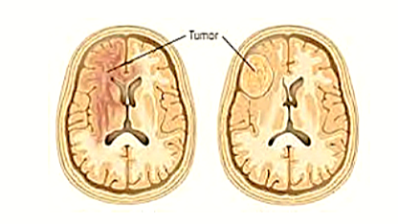

**Fig 1. Classification of healthy brain tissue and tumor brain tissue**

With its ability to process MRI images with high precision, the proposed hybrid model has the potential to significantly enhance diagnostic accuracy, reduce the time required for tumor detection, and improve patient outcomes. Moreover, the model's scalability and efficiency make it a promising candidate for integration into clinical workflows, providing healthcare professionals with a powerful tool for personalized treatment planning. As advancements in artificial intelligence continue, such hybrid approaches are likely to become indispensable in the fight against brain tumors, offering hope for early diagnosis and improved survival rates.

### 2. LITERATURE SURVEY

Brain tumor detection and classification using deep learning have been extensively studied in recent years due to the increasing need for accurate and automated diagnostic solutions. Traditional machine learning techniques, such as Support Vector Machines (SVMs) and Random Forest classifiers (RFs), have been widely used for tumor identification from MRI scans. However, these methods often struggle with feature extraction and automation challenges. In contrast, deep learning approaches, particularly Convolutional Neural Networks (CNNs), have demonstrated remarkable improvements in classification accuracy by effectively capturing spatial features in medical images.

With the advent of **transfer learning** and **advanced CNN architectures**, researchers have developed innovative models that significantly enhance tumor detection performance. Transfer learning allows pre-trained models to adapt to new medical datasets, overcoming issues related to limited labeled MRI data. Furthermore, multi-modal fusion techniques and preprocessing strategies have emerged as effective solutions for refining image quality and optimizing feature extraction. The following studies highlight key advancements in deep learning for brain tumor detection.

Solanki S. addresses techniques for identifying and classifying brain tumors using CNNs and transfer learning models, including RESNET-100 and VGGNET. Traditional methodologies like SVMs and Random Forest Classifiers (RFs) present challenges in automation, whereas CNNs enhance classification accuracy by a margin of 10-15%. Furthermore, transfer learning significantly boosts performance, adding an additional 5-10% accuracy to the classification outcomes.

M. Imran [4] proposed an enhanced CNN-based detection method utilizing a Deep Convolutional Neural Network (DCNN) combined with a three-stage preprocessing technique. This approach demonstrated improved results when evaluated against models like VGG16 and VGG19. The study highlights the effectiveness of advanced preprocessing steps in enhancing the accuracy of CNN models for brain tumor detection.

Ahmad S. and Choudhury P.K. [5] systematically reviewed the progress in machine learning and deep learning for tumor identification from MRI images. Their findings revealed that pretrained models such as Inception-v3 and DenseNet201 can achieve accuracy levels exceeding 90%. However, optimization challenges, including fine-tuning and computational resource requirements, remain significant barriers to further improvements.

To address limitations in single-modal imaging techniques, Shah H. A. [6] introduced a CNN designed for multi-modal MRI fusion. This approach integrates data from different MRI modalities, improving the model's robustness and accuracy in tumor detection. Additionally, Efficient Net-B0, as noted in [8], is regarded as one of the top-performing models for tumor detection. Its performance is further enhanced by employing transfer learning and data augmentation methods, particularly useful for addressing challenges posed by limited datasets.

M. Agrawal proposed a brain tumor detection and classification approach using deep learning models, specifically leveraging the Inception V3 architecture for superior results [9]. Similarly, Sireesha M. demonstrated the effectiveness of CNNs in tumor classification, utilizing magnetic resonance images to achieve high accuracy. This study underscores the importance of CNNs in advancing the precision and efficiency of tumor detection systems [10].

Another noteworthy method is the Faster R-CNN [11], which employs region proposal networks for real-time tumor detection in MRI images. This technique stands out for its high precision, enabling rapid and accurate tumor identification while reducing the time required for diagnosis in the imaging process.

#### Deep learning and Machine Learning

Deep learning, a specialized branch of machine learning, utilizes algorithms inspired by the human brain's neural architecture, commonly referred to as artificial neural networks. These algorithms are specifically designed to process vast amounts of data, learning to recognize patterns and extract meaningful features automatically. This capability makes deep learning particularly adept at analyzing unstructured data formats like images, audio, and text, with widespread applications in medical diagnostics, autonomous systems, and language processing.

A standout feature of deep learning is its ability to perform automatic feature extraction. In medical imaging, for example, convolutional neural networks (CNNs) can efficiently analyze MRI scans, identifying intricate patterns to distinguish between normal and abnormal tissues with remarkable precision. Other advanced deep learning models, such as Recurrent Neural Networks (RNNs), Transformers, and Generative Adversarial Networks (Gans), further broaden its application scope. These architectures excel in sequential data analysis, complex dependency modeling, and synthetic data creation.

One of deep learning’s greatest strengths lies in its scalability. As the availability of data and computational resources grows, deep learning models demonstrate improved accuracy and performance. Moreover, techniques like transfer learning, where pre-trained models are fine-tuned for specific tasks, and data augmentation , which increases dataset diversity, make deep learning accessible and effective even when data is limited. This adaptability and robustness solidify deep learning as a cornerstone of modern artificial intelligence.

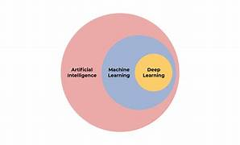

**Fig 2.1** **Deep Learning and Machine Learning**

Machine learning is a broader domain that encompasses algorithms capable of learning patterns and making decisions based on data. Unlike deep learning, machine learning models often rely on feature engineering, where human expertise is used to identify and select features from the dataset. Popular algorithms include Support Vector Machines (SVMs), Random Forest Classifiers (RFCs), K-Nearest Neighbors (KNN), and Naive Bayes.

#### Deep Learning and Machine Learning Models

Deep learning models can be categorized based on their architecture and the type of tasks they’re designed to perform. Below are some major classifications of deep learning models:

* **Artificial Neural Networks (ANNs)** - This is a popular model that refers to the structure and function of the human brain. It consists of interconnected nodes based on various layers and is used for various ML tasks.
* **Convolutional Neural Networks (CNNs)** - A CNN is a deep learning model that automates the spatial hierarchies of features from input data. This model is commonly used in image recognition and classification.
* **Recurrent Neural Networks (RNNs) -** This model is designed for the processing of sequential data. It enables the memory input which is known for Neural network architectures.
* **Feedforward Neural Networks (FNN) -** The simplest type of neural network where data flows in one direction, from input to output. General-purpose prediction tasks (e.g., predicting house prices based on features like size, location).
* **Generative Adversarial Networks (GANs) -** Comprises two networks: a generator that creates data (like images) and a discriminator that tries to tell if the data is real or fake. The two networks compete and improve over time. Generating realistic images, video, or even artwork (e.g., creating fake celebrity photos).

Machine Learning models are very powerful resources that automate multiple tasks and make them more accurate and efficient. ML handles new data and scales the growing demand for technology with valuable insight. It improves the performance over time. This cutting-edge technology has various benefits such as faster processing or response, enhancement of decision-making, and specialized services.

Machine learning models can be broadly categorized into four main paradigms based on the type of data and learning goals:

1. Supervised Learning
2. Unsupervised Learning
3. Reinforcement Learning

* **Supervised Learning** uses labeled data to make predictions or classify data. Common models include Linear Regression, which predicts continuous values like house prices based on features such as size or location, and Logistic Regression, used for binary classification tasks like distinguishing spam from non-spam. Decision Trees split data into branches based on decisions, making them easy to understand but prone to overfitting. Random Forest improves accuracy by combining multiple decision trees, where each tree makes a prediction.

Support Vector Machines (SVM) find the best boundary to separate different classes, while K-Nearest Neighbors (KNN) classifies data by looking at the closest data points in the feature space, though it can be slow with large datasets.

* **Unsupervised Learning** involves learning from data without labels. K-Means Clustering groups similar data points into clusters, while Hierarchical Clustering builds a tree of clusters to show how data is related. Principal Component Analysis (PCA) reduces the number of features in data, making it easier to analyze while keeping important information. Autoencoders compress data into a smaller form and learn a more efficient way to represent it, often used for tasks like anomaly detection or data compression.

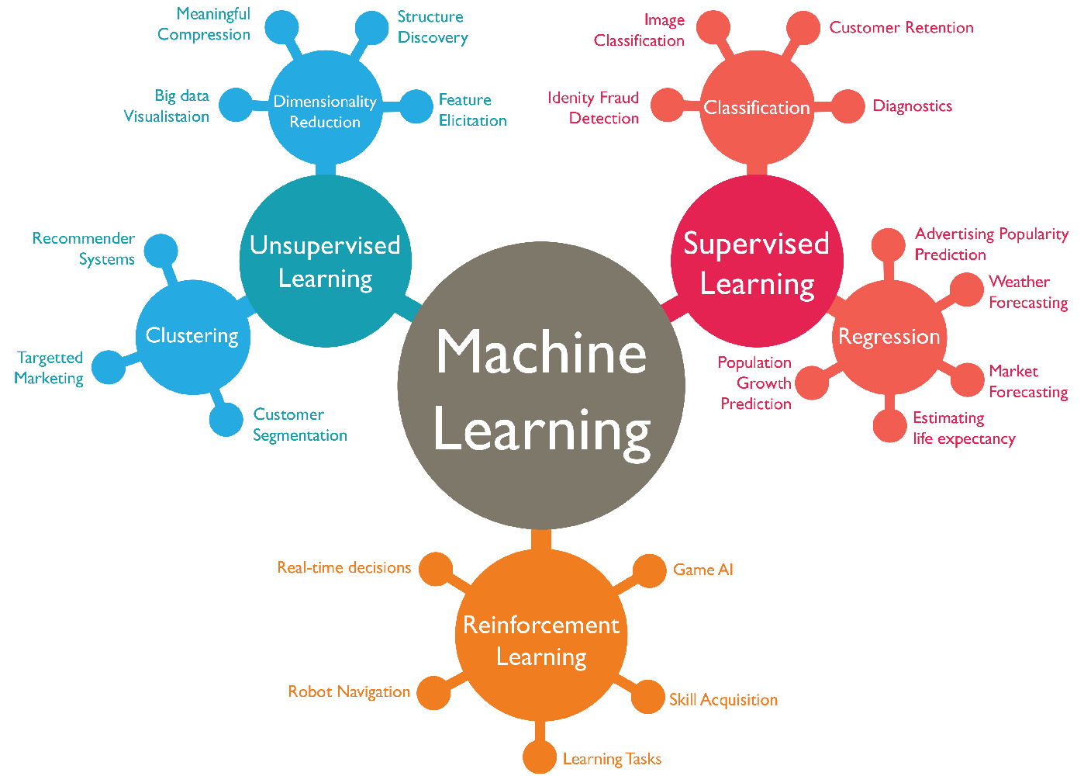

**Fig 2.2** **Machine Learning Models**

* **Reinforcement Learning** involves learning by trial and error to maximize rewards. Q-Learning helps an agent learn the best actions to take in an environment by trying different options and receiving feedback. Deep Q-Network (DQN) combines deep learning with Q-learning to handle more complex data, such as images or large datasets. Policy Gradient Methods focus on directly learning the best strategy or policy for decision-making to maximize rewards over time.

#### Applications of deep learning and Machine Learning

1. ***HealthCare***

Medical Imaging, Disease Prediction, Drug Discovery: Deep learning models, such as Convolutional Neural Networks (CNNs), are used to analyze medical images like MRI scans, CT scans, and X-rays for detecting conditions such as tumors, fractures, and diseases. Machine learning algorithms can predict the likelihood of diseases like cancer, diabetes, and heart disease by analyzing patient data, including medical history and test results. Machine learning accelerates the process of discovering new drugs by predicting how different molecules will behave and identifying potential candidates for development.

1. ***Natural Language Processing (NLP)***

uses deep learning and machine learning to understand and process human language. Speech recognition is a key application, where deep learning models are used in virtual assistants like Siri, Alexa, and Google Assistant to convert spoken language into text and comprehend user queries. Text classification is another important use, where machine learning models categorize text into different classes, such as detecting spam emails or analyzing customer feedback for sentiment. Additionally, translation services like Google Translate are powered by deep learning models, enabling automatic translation between languages and making communication easier across language barriers. Speech Recognition

1. ***Finance***

In finance, machine learning plays a crucial role in various applications. Fraud detection is one key area, where machine learning models analyze transaction patterns in real time to identify anomalies and prevent fraudulent activities. In algorithmic trading, machine learning algorithms predict stock market trends and make buy or sell decisions based on vast amounts of historical data, enabling faster and more accurate trading strategies. Additionally, credit scoring models assess the creditworthiness of individuals and businesses by analyzing financial history, payment behavior, and other relevant factors, helping lenders make informed decisions.

1. ***Autonomous Vehicles***

Self-Driving Cars Deep learning algorithms help autonomous vehicles interpret their surroundings using sensors, cameras, and radar to navigate roads, detect obstacles, and make driving decisions. Traffic Prediction Machine learning can predict traffic patterns and optimize routes to reduce congestion and travel time. Healthcare Diagnostics

1. ***Retail and E-Commerce***

Recommendation Systems Machine learning models power personalized recommendations on platforms like Amazon and Netflix, suggesting products, movies, or content based on user preferences. Inventory Management Machine learning helps predict demand for products, optimize stock levels, and reduce waste. Environmental Monitoring

1. ***Manufacturing and Industry***

Predictive Maintenance Machine learning models predict equipment failures and maintenance needs, reducing downtime and improving efficiency. Quality Control Computer vision, powered by deep learning, is used to inspect products on production lines for defects and inconsistencies. Financial Forecasting

1. ***Entertainment***

Content Generation: Deep learning models are used to create music, art, and even video game characters, providing personalized entertainment experiences. Video Enhancement Machine learning models improve video quality by enhancing resolution, reducing noise, or upscaling images.

1. ***Agriculture***

Crop Prediction Machine learning models analyze weather, soil, and crop data to predict yields and help optimize farming practices. Disease Detection Deep learning models can detect plant diseases by analyzing images of leaves, improving crop health monitoring.

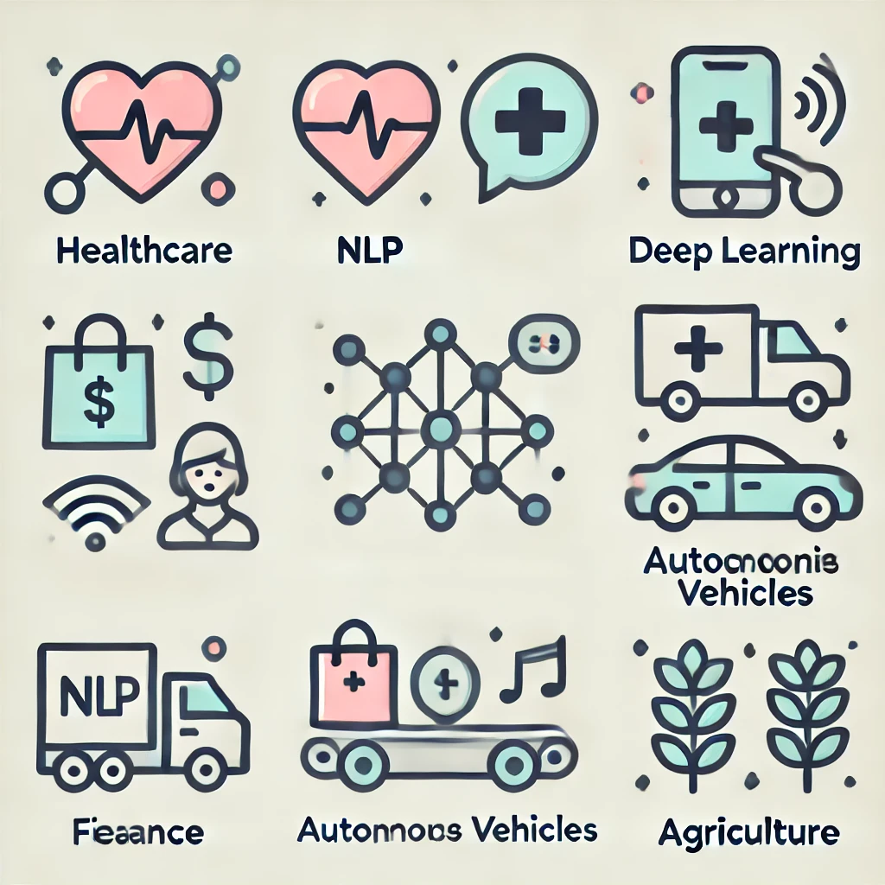

#### Fig 2.3 Applications of Deep Learning and Machine Learning

#### Prevalence of Brain Tumor Detection and Classification:

#### Brain tumors, though less common than other types of cancer, are increasingly being detected due to advancements in imaging technology. Early detection is essential for effective treatment, as tumors can grow rapidly and cause significant damage to brain functions. The use of medical imaging techniques like MRI and CT scans has made it easier to identify brain tumors, but accurately classifying them can be challenging due to the complexity of brain structures.

#### Machine learning and deep learning models have significantly improved brain tumor detection and classification. These technologies can analyze large volumes of medical images to identify and classify brain tumors more accurately than traditional methods. The increasing availability of advanced imaging and machine learning tools is making brain tumor detection more prevalent and effective, leading to better diagnosis and treatment outcomes.

#### The prevalence of brain tumor detection has grown significantly with the help of artificial intelligence (AI) and machine learning. As imaging techniques like MRI and CT scans continue to improve, AI models are able to analyze these images more efficiently and accurately, allowing for earlier detection of tumors. This has led to improved diagnosis rates and better treatment planning, as tumors can be detected in their early stages. As technology continues to evolve, the role of machine learning and deep learning in detecting and classifying brain tumors is expected to increase, further enhancing the ability to identify tumors quickly and precisely.

#### Importance of Integrated Deep Learning and Machine Learning Approaches in brain tumor detection and classification.

#### The integration of deep learning (DL) and machine learning (ML) approaches has become increasingly important in the detection and classification of brain tumors. These advanced technologies offer several advantages over traditional methods, significantly improving the accuracy, speed, and reliability of brain tumor diagnosis.

#### Moreover, the integration of DL and ML significantly reduces the time required for diagnosis. Automated systems can process hundreds of images in a fraction of the time it would take a radiologist, thereby facilitating faster decision-making and potentially life-saving interventions. Furthermore, these systems minimize human error, enhancing the overall reliability of the diagnostic process. Another key advantage is their scalability and adaptability. As more data becomes available, DL and ML models can be retrained and optimized, ensuring continuous improvement in diagnostic accuracy. The integration of these technologies also paves the way for personalized medicine, where patient-specific data can be used to predict treatment responses and outcomes.

#### 1. *Enhanced Accuracy and Sensitivity:*

#### Deep learning models, particularly Convolutional Neural Networks (CNNs), excel at recognizing complex patterns in medical images such as MRI and CT scans. By combining these with machine learning techniques like Support Vector Machines (SVM) or Random Forests, which are effective for classification, these integrated approaches can achieve higher accuracy in detecting and classifying tumors. This helps in distinguishing between benign and malignant tumors, providing clinicians with more precise information for treatment decisions.

#### 2. *Early Detection and Diagnosis:*

#### Integrating DL and ML approaches allows for earlier identification of tumors, even in their subtle stages. The ability to automatically analyze large volumes of imaging data enables early detection, which is crucial for improving patient outcomes. Early detection of brain tumors often leads to more effective treatment options and better chances of survival.

#### 3. *Reduced Human Error:*

#### While human radiologists are highly skilled, the complexity and volume of medical images can lead to errors or missed diagnoses. By using integrated DL and ML models, the risk of human error is minimized. These models can process and analyze images more quickly and consistently, allowing for more reliable results.

#### 4. *Personalized Treatment Plans:*

#### Machine learning and deep learning models can also assist in creating personalized treatment plans for patients. By analyzing large datasets, these models can predict how different tumor types may respond to various treatments, helping doctors to tailor interventions based on individual patient needs.

#### *5. Scalability and Efficiency:*

#### An integrated approach allows for the analysis of large amounts of data quickly, which is particularly important in hospitals and research settings where time is crucial. These systems can handle vast quantities of imaging data, making them scalable and efficient for widespread use in brain tumor detection and classification.

#### In summary, integrating deep learning and machine learning techniques improves the speed, accuracy, and reliability of brain tumor detection and classification, leading to better diagnosis, early treatment, and enhanced patient outcomes. As these technologies evolve, their potential to revolutionize the field of medical imaging continues to grow.

#### Python for Machine Learning and Deep Learning

#### Python is widely used in the field of medical image analysis, particularly for brain tumor detection and classification. Due to its rich ecosystem of libraries and frameworks, it provides an efficient platform to develop machine learning (ML) and deep learning (DL) models for analyzing brain MRI scans. The combination of ML algorithms and DL architectures can significantly improve the accuracy of tumor detection and classification, assisting clinicians in early diagnosis and treatment planning.

#### The most recent major version of Python is Python 3. However, Python 2, although not being updated with anything other than security updates, is still quite popular. It is possible to write Python in an Integrated Development Environment, such as Thonny, PyCharm, NetBeans or Eclipse, Anaconda which are particularly useful when managing larger collections of Python files. Python was designed for its readability. Python uses new lines to complete a command, as opposed to other programming languages which often use semicolons or parentheses. Python relies on indentation, using whitespace, to define scope; such as the scope of loops, functions and classes. Other programming languages often use curly-brackets for this purpose.

#### Machine learning (ML) and deep learning (DL) have revolutionized numerous fields, from healthcare and finance to natural language processing and computer vision. Python has become the go-to programming language for implementing both ML and DL due to its simplicity, versatility, and the robust ecosystem of libraries and frameworks it offers. In particular, Python's role in enabling innovative solutions in fields like brain tumor detection, medical imaging, autonomous driving, and speech recognition is crucial. Python is known for its easy-to-read syntax, which allows both beginners and experts to quickly understand and implement complex algorithms. This accessibility reduces the learning curve for those interested in exploring machine learning and deep learning, making Python a popular choice among data scientists, researchers, and developers

***Machine Learning Libraries:***

* **scikit-learn -** scikit-learn is one of the most popular and widely used machine learning libraries in Python. It offers a comprehensive set of tools for building and evaluating machine learning models, and it is particularly known for its simplicity and user-friendly interface.
* **Boost -** Boost (Extreme Gradient Boosting) is an optimized gradient boosting framework that is widely used for machine learning tasks, especially for structured/tabular data. It is known for its speed and performance, often outperforming other algorithms.
* **Pandas -** Pandas is a fundamental library for data manipulation and analysis in Python. While it is not specifically a machine learning library, it is a critical tool for data preprocessing and feature engineering in the machine learning pipeline.

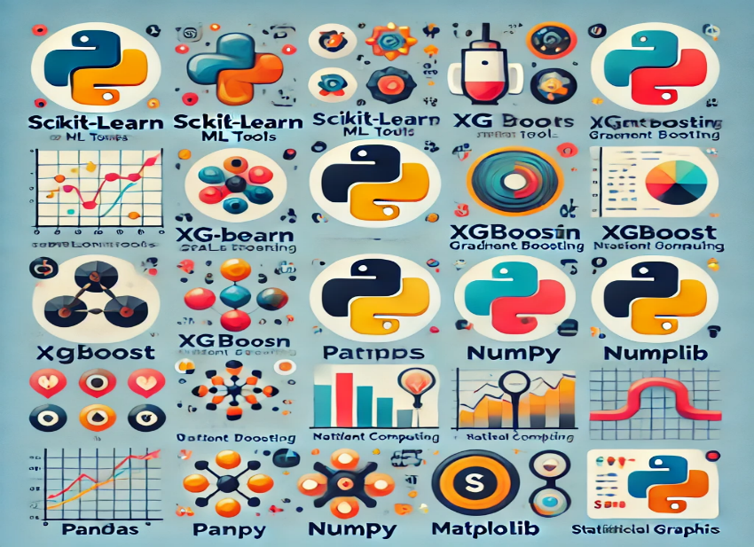

**Fig 2.4 Machine Learning Libraries**

* **Sci-kit Optimized -** Sci-kit-learn also has a collection of tools for optimization problems, such as grid search, random search, and optimization algorithms to find the best hyperparameters for machine learning models. Libraries like Optima can be used for automated hyperparameter optimization.
* **NumPy -** NumPy (Numerical Python) is a core library for scientific computing in Python. It provides support for large, multi-dimensional arrays and matrices, along with a large collection of high-level mathematical functions to operate on these arrays.
* **Matplotlib -** Matplotlib is a powerful plotting library in Python that allows you to create static, animated, and interactive visualizations. It is widely used for creating line plots, scatter plots, histograms, bar charts, and more.
* **Seaborn -** Seaborn is a data visualization library built on top of Matplotlib, designed for making statistical graphics. It provides a high-level interface for drawing attractive and informative statistical graphics and is well-suited for data exploration.

***Deep Learning Libraries:***

* **TensorFlow -** TensorFlow is an open-source deep learning framework developed by Google. It is widely used for building neural networks, particularly for large-scale machine learning models. TensorFlow supports both CPU and GPU computation, making it scalable and efficient for production-level applications.
* **Karas -** Keres is a high-level deep learning API, written in Python, that runs on top of lower-level libraries like TensorFlow, Theano, or Microsoft Cognitive Toolkit. It was developed to simplify building and training deep learning models with minimal code.
* **PyTorch -** PyTorch is an open-source deep learning library developed by Facebook’s AI Research lab. It is known for its flexibility and dynamic computation graph, making it suitable for research and experimentation.
* **Theano -** Theano is a deep learning library developed by the Montreal Institute for Learning Algorithms. Though it has been largely superseded by TensorFlow and PyTorch, it remains a key component in the deep learning community, especially in the early stages of deep learning development.

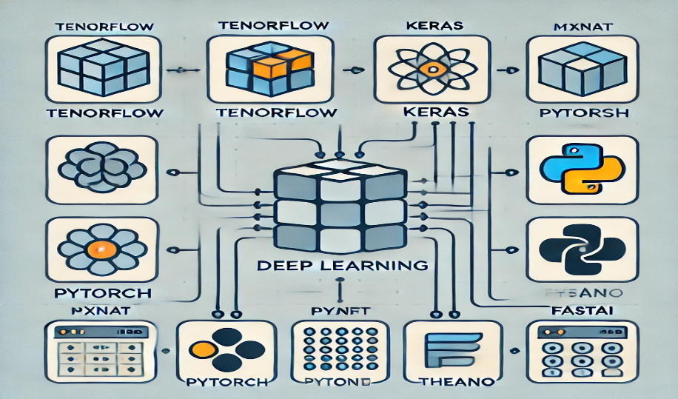

**Fig 2.5 Deep Learning Libraries**

### 3. EXISTING SYSTEM

Brain tumor detection and classification have traditionally relied on manual analysis of **Magnetic Resonance Imaging (MRI)** scans by radiologists and neurologists. This manual approach, while effective, is time-consuming and highly dependent on the expertise of medical professionals. Moreover, human interpretation is prone to errors, leading to misdiagnosis or delayed treatment. To address these challenges, computational methods have been developed, ranging from traditional machine learning techniques to advanced deep learning models.

Early machine learning (ML) approaches, such as **Support Vector Machines (SVMs), Random Forest (RF), k-Nearest Neighbors (k-NN), and Decision Trees**, focused on extracting handcrafted features from MRI images. These methods required extensive preprocessing and manual selection of features such as texture, intensity, and shape descriptors. Although these models provided reasonable accuracy (around **70-85%**), their performance was limited by feature dependency, poor generalization to different datasets, and an inability to handle complex variations in tumor structures. The introduction of **Convolutional Neural Networks (CNNs)** revolutionized brain tumor detection by automating feature extraction and improving classification accuracy. CNN architectures such as **Alex Net, VGG16, ResNet, and DenseNet** have been widely used in medical image analysis, achieving accuracy levels of **85-95%**. However, CNNs come with challenges such as the need for large labeled datasets, high computational requirements, and potential overfitting when trained on small datasets. To overcome data limitations, **transfer learning** has been widely adopted, where pretrained models like **Inception-v3, ResNet-50, and EfficientNet-B0** are fine-tuned for brain tumor classification. This approach not only reduces training time but also enhances accuracy by an additional **5-10%**.

In addition to CNN-based models, hybrid approaches combining CNN with **Support Vector Machines (CNN-SVM)** have shown promising results. In this technique, CNNs extract deep features from MRI scans, while SVMs handle the final classification, leading to improved performance. Another innovative technique is **multi-modal MRI fusion**, where data from different MRI sequences (such as T1-weighted, T2-weighted, and FLAIR) are integrated to enhance the model’s robustness and improve tumor detection accuracy.

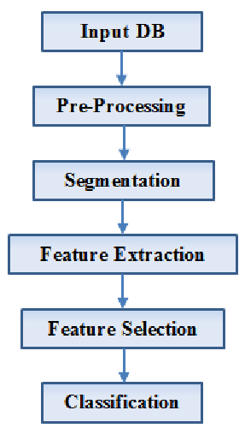

**Fig 3.** Flow chart of existing system for brain tumor classification

This flowchart outlines a typical image processing pipeline for brain tumor detection and classification from medical images, such as MRI scans. The process begins with an input database of medical images, which undergoes pre-processing to improve their quality. Pre-processing techniques include noise reduction to eliminate artifacts, image enhancement to amplify critical details, and bias field correction to address intensity inhomogeneities. These steps ensure that the images are uniform and ready for subsequent analysis. Once the images are pre-processed, the segmentation phase isolates the region of interest (ROI) that potentially contains the tumor. Segmentation techniques vary from traditional methods like thresholding, region growing, and clustering to advanced approaches such as active contours and deep learning-based models, which offer higher accuracy and adaptability. The segmentation phase is critical, as it focuses on delineating the tumor area, forming the basis for the following steps in the pipeline.

After segmentation, **feature extraction** derives key characteristics like shape, texture, and intensity of the tumor. **Feature selection** methods, such as **Principal Component Analysis (PCA)**, reduce dimensionality and computational complexity while preventing overfitting. Finally, classifiers like **SVM, k-NN, decision trees, or CNNs** categorize the tumor as benign, malignant, or normal tissue. This automated pipeline improves accuracy and assists medical professionals in diagnosis.

### 4. PROPOSED SYSTEM

#### The proposed model utilizes a hybrid approach combining Convolutional Neural Networks (CNN) and Support Vector Machines (SVM) to improve the accuracy and reliability of brain tumor detection and classification from MRI images. This integration leverages the strengths of both deep learning and traditional machine learning techniques. CNN is employed for its exceptional ability to extract hierarchical and detailed features from images, while SVM is used for its precision in classification tasks, particularly in distinguishing between tumor categories.

#### 

**Fig 4.** Flow chart of proposed System

#### The workflow begins with preprocessing MRI images to enhance their quality. Techniques like Adaptive Gamma Correction and Adaptive Contrast Enhancement optimize the brightness and contrast of the images, while Median Filtering removes noise. These steps ensure that the images are clean and suitable for further processing.

#### After preprocessing, segmentation is conducted using Fuzzy C-Means (FCM) clustering. This technique identifies and isolates the tumor region with high precision by considering the natural fuzziness in data, which makes it more effective than traditional hard classification methods. Following segmentation, features such as texture and spatial relationships are extracted using the Grey Level Co-occurrence Matrix (GLCM), which provides crucial information for differentiating tumor types. The extracted features are then passed through a CNN to capture deep and intricate patterns from the segmented images.

#### The CNN acts as an advanced feature extractor, transforming the data into a format suitable for classification. These features are subsequently fed into an SVM classifier, which categorizes the data into classes such as healthy tissue, benign tumor, or malignant tumor. The SVMs ability to establish clear decision boundaries enhances the overall classification accuracy of the model.

#### *Advantages:*

1. **High Accuracy and Precision:** Combines CNN's feature extraction capabilities with SVMs robust classification mechanism. Ensures more reliable tumor detection and classification.
2. **Enhanced Preprocessing:** Adaptive algorithms improve the quality of MRI scans, allowing for better analysis and feature extraction.
3. **Effective Segmentation:** Fuzzy C-Means clustering provides a more accurate delineation of the tumor region compared to conventional methods.
4. **Reduced Overfitting:** Feature selection techniques, such as GLCM, focus on the most relevant features, enhancing the model's generalization capability.
5. **Superior Performance Metrics:** High sensitivity and specificity ensure reliable differentiation between normal and diseased tissues, reducing false negatives and positives.
6. **Automated and Scalable:** The model automates brain tumor detection, aiding radiologists in faster and more consistent diagnoses. Adaptable to other medical imaging tasks with minimal changes

### 5. SYSTEM REQUIREMENT

#### Hardware Requirements:

* + - 1. System Type : intel®core™[i3-7500UCPU@2.40gh](mailto:i3-7500UCPU@2.40gh)
      2. Cache memory : 4MB(Megabyte)
      3. RAM : 8GB (gigabyte)
      4. Hard Disk : 4GB

#### 5.2 Software Requirements:

* + - 1. Operating System : Windows 11, 64-bit Operating System
      2. Coding Language : Python
      3. Python distribution : Anaconda, Flask
      4. Browser : Any Latest Browser like Chrome

### 6. SYSTEM ANALYSIS

#### Scope of the project

This project focuses on enhancing the detection and classification of brain tumors using a hybrid deep learning and machine learning approach. By integrating Convolutional Neural Networks (CNNs) for effective feature extraction with Support Vector Machines (SVMs) for precise classification, the model aims to provide a reliable and automated diagnostic tool. The ultimate goal is to assist in the early detection of brain tumors, improving treatment outcomes and reducing diagnostic errors in medical imaging.

The model leverages MRI scans, particularly T1-sequenced images, sourced from publicly available datasets like the Kaggle Fig share Brain Tumor Dataset. These images represent different tumor types, including glioma, meningioma, and pituitary tumors. Advanced preprocessing techniques, such as Adaptive Contrast Enhancement (ACE), Adaptive Gamma Correction (AGC), and Median Filtering, are applied to improve image quality by enhancing contrast, reducing noise, and ensuring better visualization of tumor regions.

To ensure accurate tumor region identification, the project employs Fuzzy C-Means (FCM) clustering for segmentation and uses the Grey Level Co-occurrence Matrix (GLCM) to extract critical texture features from MRI images. These features are then fed into the CNN-SVM hybrid model. The CNN component extracts deep features, while the SVM classifier provides precise decision boundaries, resulting in superior performance in distinguishing between healthy and abnormal brain tissues.

The effectiveness of the proposed model is evaluated using key performance metrics, including accuracy, sensitivity, specificity, and Jaccard coefficient. The model targets high performance levels, aiming for an accuracy of 97.94%, a sensitivity of 95%, and a specificity of 98.1%. This hybrid approach outperforms traditional methods such as standalone CNN, ANN, and RFC models, demonstrating its capability in accurate and efficient tumor classification.

The applications of this project extend to providing healthcare professionals with a powerful tool for automated and efficient brain tumor diagnosis. By minimizing misdiagnosis and expediting decision-making, the model contributes to improved patient outcomes. Looking ahead, the scope of the project includes extending the methodology to colored MRI images and 3D scans to further enhance segmentation and classification accuracy. Additionally, integrating the hybrid CNN-SVM model into clinical diagnostic software will enable real-time applications in hospitals and medical imaging centers, fostering advancements in medical diagnostics.

#### Analysis

#### *Data Set:*

#### The dataset utilized in this project is a curated collection of T1-sequenced, enhanced MRI scans sourced from the Kaggle platform. It forms the foundation for developing an advanced brain tumor detection and classification model. The dataset represents diverse diagnostic scenarios, encompassing four distinct categories: meningioma tumors, glioma tumors, pituitary tumors, and normal brain tissues without tumors. Meningioma tumors originate from the meninges, the protective membranes surrounding the brain and spinal cord, while gliomas arise from glial cells that support brain function. Pituitary tumors are located in the pituitary gland, a vital endocrine structure at the brain's base. In addition to its diagnostic variety, the dataset features grayscale MRI scans converted into PNG format, ensuring compatibility with modern image-processing frameworks. The dataset is meticulously balanced across tumor types and normal cases, offering unbiased training and testing opportunities. Furthermore, it includes diverse tumor sizes, shapes, and intensities to simulate real-world diagnostic challenges effectively.

#### This dataset plays a pivotal role in the project's objective of developing a robust hybrid CNN-SVM model. Advanced preprocessing techniques, such as adaptive gamma correction, adaptive contrast enhancement, and median filtering, are employed to improve image clarity and reduce noise. Fuzzy C-Means clustering is used to accurately segment tumor regions, while the Gray-Level Co-Occurrence Matrix (GLCM) is applied for extracting critical texture features, such as contrast, energy, homogeneity, and correlation, essential for precise classification. These features are then fed into the CNN-SVM hybrid model, enabling high-precision differentiation between tumor types and healthy brain tissues. The dataset's comprehensive nature makes it an invaluable resource for advancing research in medical imaging, enabling the development of cutting-edge diagnostic tools for early and accurate tumor detection.

#### 

| Feature | Details |
| --- | --- |
| Total Images | 3064 |
| Total Patients | 233 |
| Tumor Classes | Glioma, Meningioma, Pituitary, No Tumor |
| Class Distribution | Glioma: 1426, Meningioma: 708, Pituitary: 930 No Tumor 804 |
| Image Type | T1-weighted contrast-enhanced MRI |
| Applications | Tumor classification and detection |

**Table 1 . Dataset Description**

#### *Tumor Classes:*

#### Glioma (1426 images): These are irregular and infiltrative tumors commonly located in the brain's temporal or frontal lobes.

#### Meningioma (708 images): These are slow-growing, rounded tumors often found near the skull base.

#### Pituitary Tumor (930 images): These tumors are localized around the pituitary gland and can vary in size and shape.

#### No Tumor: Normal brain MRIs without any pathological indications.

This dataset contains 3064 T1-weighted contrast-enhanced MRI images obtained from 233 patients, categorized into four classes: Glioma, Meningioma, Pituitary Tumor, and No Tumor. It is designed to support research in brain tumor detection and classification.

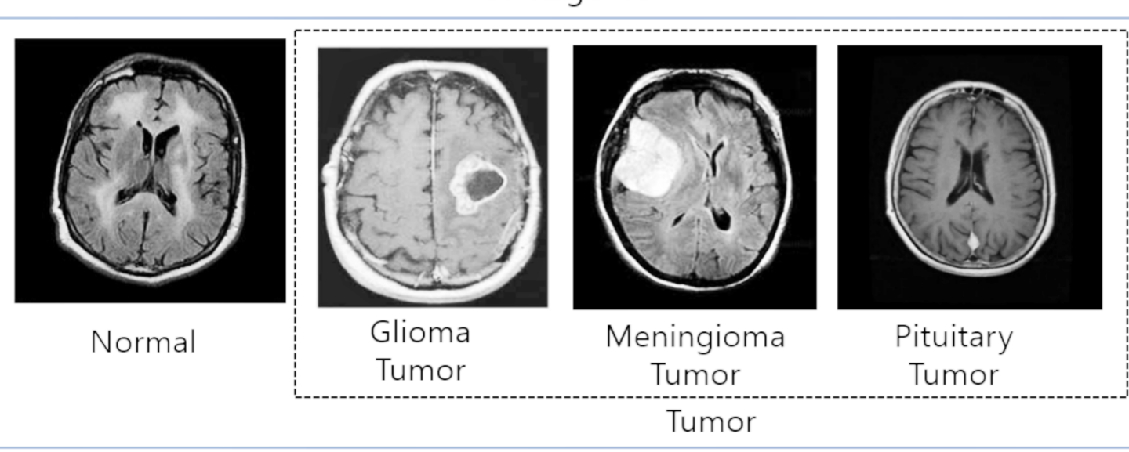

**Fig 6.1** Different Tumor Classes images.

***Image Characteristics:***

* All images are T1-weighted and contrast-enhanced, improving the visibility of soft tissues and tumor boundaries.
* Stored in **PNG format**, facilitating easy use in machine learning workflows.

***Applications:***

* Used in training and testing **machine learning** and **deep learning models** for medical image analysis.
* Supports tasks like tumor detection, classification, and segmentation in medical and research settings.

#### Data Pre-processing

Before feeding data to an algorithm, we have to apply transformations to our data which is referred as pre-processing. By performing pre-processing, the raw data which is not feasible for analysis is converted into clean data. In-order to achieve better results using a model in Deep Learning, data format has to be in a proper manner. The data should be in a particular format for different algorithms. Pre-processing refers to the transformations applied to our data before feeding it to the algorithm. Preprocessing is the first step while creating the deep learning model. During this preprocessing, images undergo several preprocessing methods applied to MRI images to enhance their quality and ensure accurate brain tumor classification. These methods are as follows:

***Adaptive Contrast Enhancement (ACE):*** Enhances image contrast by calculating local statistics like mean pixel intensity and standard deviation.

***Adaptive Gamma Correction (AGC):*** Dynamically adjusts brightness and contrast in different image regions for better visualization of tumors.

***Median Filtering:*** Median filtering is used to reduce noise in the MRI images without losing important details, especially edges and fine structures. It works by replacing each pixel value with the median value of its surrounding neighborhood, which helps to remove outliers or noise that could otherwise distort the image. This filtering technique is particularly effective in eliminating speckle noise or salt-and-pepper noise, ensuring that the tumor regions are preserved while irrelevant noise is minimized.

***Fuzzy C-Means (FCM) Segmentation:*** Extracts precise tumor regions by grouping similar intensity pixels. FCM is a clustering technique used to segment the MRI image into distinct regions based on pixel intensity. Unlike traditional segmentation methods that assign each pixel to a single cluster, FCM allows for fuzzy assignments, meaning each pixel can belong to multiple clusters with different membership degrees. This is particularly useful in medical imaging, where the tumor region may have varying intensities and blend with surrounding tissues. FCM ensures more accurate and precise segmentation of tumor regions, which is essential for further analysis and classification.

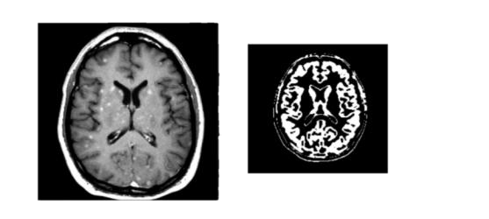

**Fig 6.2** Image after applying the preprocessing technique.

* 1. **FEATURE EXTRACTION**

Feature extraction using Gray Level Co-occurrence Matrix (GLCM) is a widely used method in image processing, particularly for the analysis of medical images like MRI scans for brain tumor detection and classification. GLCM is a statistical method that captures the spatial relationship between pixels in an image, allowing the extraction of texture features that can reveal important characteristics of the image that are often difficult to discern with the naked eye. These features are crucial for improving the performance of classification models, especially in the case of detecting and classifying brain tumors.

The Gray Level Co-occurrence Matrix (GLCM) is a matrix that describes the frequency of pixel pairs with specific values in a specified spatial relationship, typically focusing on pairs of pixels separated by a certain distance in a particular direction. The main idea is to quantify the spatial patterns of pixel intensities in an image, which are often associated with different tissue types, such as healthy tissue, tumor regions, and surrounding structures in MRI scans.

***Key Features Extracted from GLCM:***

Following several statistical features can be obtained from GLCM to characterize the MRI image texture. In this approach was suggested, contrast, dissimilarity, homogeneity, energy, correlation

* **Contrast**: It measures the intensity difference between neighboring pixels. A higher contrast value which may be useful in differentiating tumor areas from normal tissue. 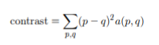
* **Correlation:** In an image, correlation measures of how much image data points(pixels) are related linearly to one another. This indicative bare skeleton measure indicates how intensity correlates with the pixel map of different positions in any given place. 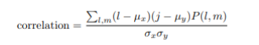
* .**Energy:** It represents the combination of the class features in the GLCM, which means that the text is identical.

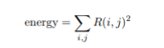

* **.Homogeneity**: In measures how close the distribution of features in the GLCM is to the diagonal.

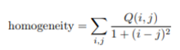

#### Model building :

Model building in the context of deep learning refers to the process of designing and constructing hybrid model using neural network architectures and support vector machines to solve specific tasks such as classification of different brain tumors. Deep learning models typically consist of multiple layers of neurons organized in a hierarchical fashion, enabling the model to learn intricate patterns and representations from the data.

The hybrid CNN-SVM architecture integrates the feature extraction capabilities of Convolutional Neural Networks (CNNs) with the classification strengths of Support Vector Machines (SVMs) to achieve high accuracy and reliability in brain tumor detection and classification. The model is designed to process MRI images, extract relevant features, and classify them into different categories such as glioma, meningioma, pituitary tumors, or normal tissue. The CNN-SVM hybrid model is a powerful computational approach for detecting and classifying brain tumors from MRI images. This model leverages the strengths of Convolutional Neural Networks (CNNs) for feature extraction and Support Vector Machines (SVMs) for precise classification, achieving high accuracy and reliability in medical imaging.

***Convolutional Neural Networks:***

A Convolutional Neural Network (CNN) is a type of deep learning model particularly well-suited for processing structured data such as images. CNNs automatically and adaptively learn spatial hierarchies of features from input data through the use of convolutional filters, pooling, and fully connected layers.

***Layers in Convolutional Neural Networks:***

* **Input Layer -** Accepts the raw input data, such as images or videos, in the form of multi-dimensional arrays.
* **Convolutional Layer -** Extracts features from the input data by applying learnable filters (kernels) that slide over the input. Detects low-level features (e.g., edges) in initial layers and high-level patterns (e.g., shapes) in deeper layers. Outputs feature maps that represent the detected patterns.
* **Activation Layer -** Introduces non-linearity to the network, enabling it to model complex patterns. Most common activation function **ReLU** , Other options Sigmoid, Tanh, or Leaky ReLU**.**
* **Pooling Layer -** Reduces the spatial dimensions of the feature maps while preserving important information. Reduces computation and mitigates overfitting. Common types:

**Max Pooling:** Retains the maximum value from each pooling window.

**Average Pooling:** Computes the average value within each pooling window.

* **Flattening Layer** - Converts the multi-dimensional feature maps into a one-dimensional vector.
* **Fully Connected Layer (Dense Layer) -** Connects every neuron in one layer to every neuron in the next, enabling complex pattern learning. Combines and processes the extracted features for classification or regression tasks. Outputs a vector of class scores or predictions.
* **Output Layer -** Produces the final predictions of the network. Number of neurons matches the number of target classes.

**Common activation functions:**

**SoftMax**: For multi-class classification, outputs probabilities for each class.

**Sigmoid**: For binary classification, outputs a probability between 0 and 1.

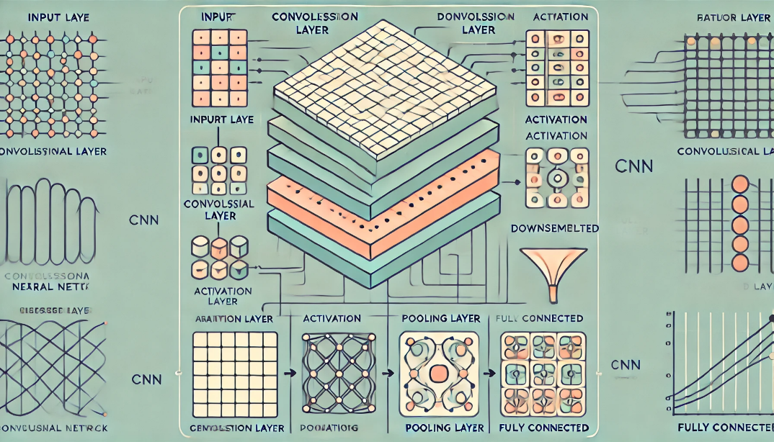

**Fig 6.3 CNN model architecture**

***Support Vector Machine(SVM):***

The Support Vector Machine (SVM) is a supervised machine learning algorithm designed for classification and regression tasks. It works by identifying the optimal decision boundary, known as a hyperplane, which separates data points belonging to different classes. The SVM aims to maximize the margin, which is the distance between the hyperplane and the closest data points from each class. These critical data points are called support vectors, and they play a vital role in defining the hyperplane.

For data that is not linearly separable, SVM uses a technique called the kernel trick. Kernels map the input data into a higher-dimensional space where a linear separation becomes possible. Common kernel functions include the linear kernel (used for linearly separable data), polynomial kernel, and Radial Basis Function (RBF) kernel, which handles more complex, non-linear data patterns.

SVM training involves solving an optimization problem to find the hyperplane that maximizes the margin while minimizing misclassification. To balance accuracy and robustness, a regularization parameter C is used. A larger Crocuses on minimizing classification errors, while a smaller C allows for a wider margin, tolerating some misclassifications to improve generalization.

SVM is effective in high-dimensional spaces and works well with small datasets due to its robustness against overfitting. However, it can be computationally intensive for large datasets, and its performance heavily depends on the choice of kernel and hyperparameters. Despite these challenges, SVM is widely used in applications such as text classification, image recognition, and bioinformatics for its ability to provide accurate and reliable results.

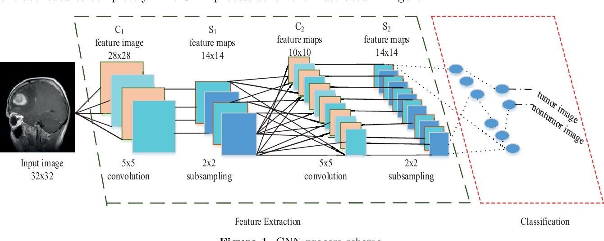

**Fig 6.4 CNN-SVM architecture**

***CNN-SVM Model Building Process:***

The CNN-SVM model combines the strengths of Convolutional Neural Networks (CNNs) for feature extraction and Support Vector Machines (SVMs) for classification. The process begins with input MRI images, which are preprocessed to improve quality and reduce noise. Techniques like adaptive contrast enhancement, gamma correction, and median filtering are used to enhance image clarity. These preprocessed images are then fed into the CNN for feature extraction.

In the CNN, convolutional layers apply filters to detect spatial features such as edges, textures, and patterns. Each layer generates feature maps that capture various aspects of the image. To introduce non-linearity and help the network capture complex relationships, ReLU (Rectified Linear Unit) is applied, zeroing out negative pixel values while retaining positive ones. Pooling layers, such as max-pooling or average-pooling, are used to down-sample the feature maps, reducing their dimensions while preserving critical information. Finally, the output feature maps are flattened into a one-dimensional vector to prepare them for input into the SVM classifier.

The flattened feature vectors are passed to the SVM, which uses a kernel function to map the data into a higher-dimensional space where a linear decision boundary can be identified. The SVM determines the optimal hyperplane that separates the classes, such as tumor vs. normal tissue, and outputs the predicted category of the MRI image.

The training process involves training the CNN first with a loss function, such as cross-entropy, to minimize classification errors during feature extraction. Once trained, the CNN is used solely for feature extraction, without its built-in classification layer. The extracted features are then used to train the SVM, which optimizes its parameters for precise class separation.

Finally, the CNN and SVM are integrated into a hybrid model. During inference, MRI images pass through the CNN to extract features, which are subsequently classified by the SVM. This combination leverages the deep feature extraction capabilities of CNN and the precise classification of SVM, yielding accurate predictions.

***Advantages of Hybrid Model:***

* Enhanced Feature Extraction
* Improved Classification Accuracy
* Robust Performance with Limited Data
* Adaptability to Non-Linear Data
* Reduced Overfitting
* Efficient Computation
* Scalable for Advanced Architectures
* Real-World Applicability
  1. **CLASSIFICATION**

***Classification using CNN-SVM proposed hybrid model :***

The convolutional neural network was originally proposed by LeCun et al. for handwritten recognition has been successful in image identification, detection, and segmentation of the image. CNN has a high ability in large-scale image classification.

The CNN-SVM hybrid model effectively integrates Convolutional Neural Networks (CNNs) for feature extraction and Support Vector Machines (SVMs) for classification, offering a robust and accurate approach to brain tumor detection. The classification process begins with the CNN component, which processes input MRI images to extract meaningful features. Convolutional layers detect patterns like edges, textures, and shapes that represent the visual features of the image. The activation function (typically ReLU) introduces non-linearity by retaining positive pixel values and discarding negative ones, enabling the network to capture complex relationships. Pooling layers then reduce the spatial dimensions of the feature maps, preserving essential information while minimizing computational costs. Finally, the multi-dimensional feature maps are flattened into a one-dimensional vector to make the data compatible with the SVM classifier.

A Convolutional layer and pooling layer are the most important layers on CNN. Convolutional layer is used for extract feature by combining the image area with many filters. Pooling layer reduces the size of the output map of the convolution layer and prevents overfitting. A very popular approach to down sampling is to use pooling layers. Pooling layer usually deciphers the image (like ax) in the aggregation into a single unit. Through these two layers the number of neurons, parameters, and connections is much less than there is a CNN model. This makes CNN more efficient compared with BP networks with similar layers.

The flattened feature vectors are passed into the SVM, where classification occurs. For non-linearly separable data, the SVM employs a kernel function, such as the Radial Basis Function (RBF) kernel, to project the features into a higher-dimensional space where a linear separation becomes possible. The SVM then identifies the optimal hyperplane that maximizes the margin between classes, with the margin being the distance between the hyperplane and the nearest data points, known as support vectors. Based on the position of the input features relative to the hyperplane, the SVM assigns the MRI image to a specific class, such as glioma, meningioma, pituitary tumor, or normal tissue.

Training the CNN-SVM model involves separate training phases for the CNN and SVM components. The CNN is first trained using a loss function, such as cross-entropy loss, to minimize errors during feature extraction. Once trained, the CNN’s classification layer is removed, and it is used solely for extracting feature vectors from input images. These extracted features are then used to train the SVM, which optimizes its parameters to achieve

precise class separation. During inference, MRI images are processed through the trained CNN to extract features, which are then classified by the SVM to provide the final prediction. This hybrid model combines the ability of CNNs to learn intricate visual features with the precision of SVMs in boundary creation, resulting in highly accurate classifications.

The CNN-SVM model’s classification approach is particularly advantageous in medical applications. It combines the deep feature extraction capabilities of CNNs with the precise decision-making ability of SVMs, ensuring improved diagnostic accuracy. The hybrid model is effective in handling both linearly and non-linearly separable data, reducing false positives and negatives. This makes it a reliable and efficient tool for detecting and classifying brain tumors, aiding early diagnosis and improving treatment outcomes.

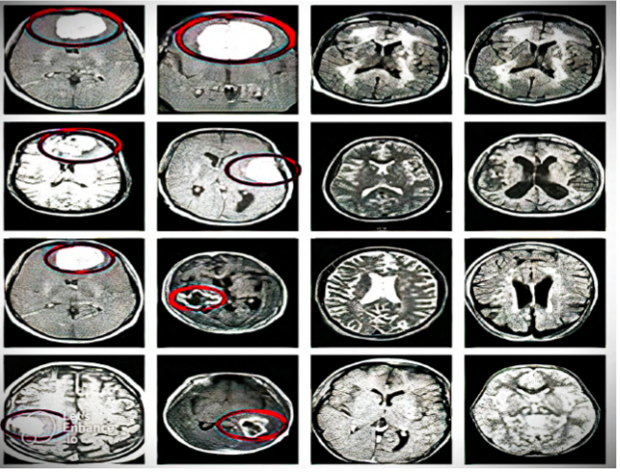

**Fig 6.5 classification of brain tumors**

This hybrid approach significantly enhances the model's overall accuracy compared to using CNN or SVM alone. CNNs excel in automatically extracting rich and meaningful features from raw data, while SVMs are known for their high precision in classifying these features. By combining these two techniques, the CNN-SVM model leverages the best of both worlds, resulting in improved reliability, reduced false positives and negatives, and better generalization to unseen data.

In applications such as brain tumor detection, this enhanced prediction accuracy is critical. Early and accurate diagnosis of tumors can lead to timely medical interventions, improving patient outcomes. The CNN-SVM model, with its ability to handle complex data and deliver precise classifications, proves to be an invaluable tool in medical imaging and other fields requiring high accuracy and reliability.

The training mode for CNN-SVM hybrid model uses dual optimization strategy making use of the two. The CNN [11] is initially trained to extract feature vectors from input MRI images. These are fed into SVM [15] for classifying purposes. This system performs alternating updates of both CNN and SVM based on metrics a. results than when only CNN or SVM were used separately. The developed model identifies and detect the tumor.

The outcome model of CNN-SVM combine CNN to extract features and SVM for the ultimate classification which enhances prediction accuracy.

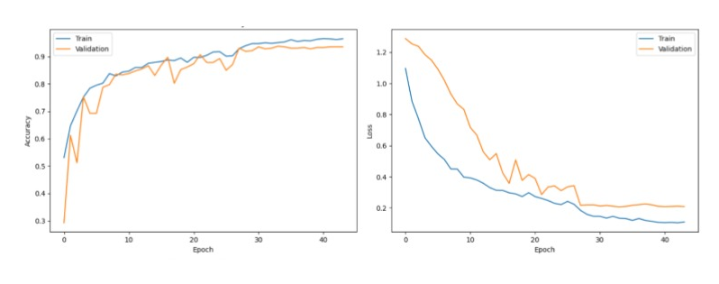

**Fig 6.6 Training and validation graphs**

These graphs illustrate the training progress of a hybrid model, CNN-SVM model, over multiple epochs. The left graph depicts accuracy, showing the percentage of correctly classified samples over time, with separate lines for training and validation data. Both training and validation accuracy increase rapidly initially, indicating effective learning, though the training accuracy continues to climb ,while the validation accuracy plateaus around 90%, creating a noticeable gap.

The right graph displays loss, representing the error between predictions and actual values, also with training and validation lines. Both training and validation loss decrease significantly at first, as expected, but the validation loss flattens and even slightly increases after a certain point, while training loss continues to approach zero. This combination of increasing accuracy and decreasing loss, coupled with the diverging validation metrics, suggests the model is learning well but is also showing signs of overfitting, meaning it's memorizing the training data rather than generalizing effectively to unseen data. Therefore, while the model has learned substantially, techniques like regularization, data augmentation, or early stopping should be considered to mitigate overfitting and potentially improve its performance on new, unseen data.

***Other models compared with the proposed model:***

**Visual Geometry Group Networks (VGG):**

VGG is a type of CNN known for its simple and uniform architecture. It uses small convolutional filters (3x3) and stacks them in multiple layers to increase the depth of the network while maintaining computational feasibility. The uniformity of VGG's design allows for straightforward implementation and scalability. Models like VGG16 and VGG19 (16 and 19 layers deep, respectively) are widely used for image classification tasks. Although computationally expensive and requiring significant memory, VGG networks deliver high accuracy, especially in benchmarks like ImageNet.

**Recurrent Neural Networks (RNNs):**

RNNs are neural networks designed for sequential or time-series data, such as text, audio, or sensor readings. Unlike feedforward networks, RNNs have connections that form cycles, allowing them to maintain a memory of previous inputs. This capability makes them suitable for tasks where context and order are critical, such as natural language processing, speech recognition, and time-series forecasting. However, standard RNNs struggle with long-term dependencies due to issues like vanishing gradients, which more advanced architectures like LSTMs (Long Short-Term Memory) and GRUs (Gated Recurrent Units) address effectively.

**Random Forest Classifier (RFC):**

Random Forest is an ensemble learning technique based on decision trees. It creates multiple decision trees during training and aggregates their outputs (through voting for classification or averaging for regression) to improve accuracy and reduce overfitting. Random Forest is robust to noise and works well with structured tabular data, making it useful for various applications such as fraud detection, medical diagnosis, and financial forecasting. Its versatility and interpretability make it a popular choice in scenarios requiring high accuracy and low computational demands.

**Fully Connected Neural Networks (FCNNs):**

FCNNs, also known simply as dense neural networks, are a basic type of deep learning model where every neuron in one layer is connected to every neuron in the next layer. This architecture is powerful for learning global patterns in data but is less efficient for tasks requiring spatial hierarchies, such as image recognition. While FCNNs can handle structured and unstructured data, their heavy reliance on fully connected layers makes them computationally intensive and prone to overfitting for high-dimensional data.

**Artificial Neural Networks (ANNs):**

ANNs are the foundation of modern neural network architectures. They consist of layers of interconnected nodes (neurons) designed to simulate the way the human brain processes information. Each neuron receives inputs, applies a weighted sum followed by an activation function, and passes the result to subsequent neurons. ANNs are versatile and can handle a wide range of problems, from simple regression tasks to complex pattern recognition. However, their basic structure lacks the specialization of CNNs or the sequence-processing capabilities of RNNs, making them less suitable for certain tasks like image or sequential data analysis.

These models collectively cater to diverse domains, from visual data processing with CNNs and VGG, sequential data analysis with RNNs, to tabular data modeling with RFC and ANN. Their applicability depends on the nature and requirements of the task at hand.

**6.7** **CONFUSION MATRIX**

Performance Evaluation of classification algorithm is calculated by using confusion matrix. A **confusion matrix** is a matrix that summarizes the performance of a machine learning model on a set of test data. It is a means of displaying the number of accurate and inaccurate instances based on the model’s predictions. It is often used to measure the performance of classification models, which aim to predict a categorical label for each input instance. When assessing a classification model’s performance, a confusion matrix is essential. It offers a thorough analysis of true positive, true negative, false positive, and false negative predictions, facilitating a more profound comprehension of a model’s **specificity, accuracy, sensitivity,**and overall effectivenessin class distinction. When there is an uneven class distribution in a dataset, this matrix is especially helpful in evaluating a model’s performance beyond basic accuracy metrics.

***Structure of the Confusion Matrix***

The confusion matrix is typically a 2x2 table for binary classification but can extend to an NxN matrix for multi-class classification. The rows represent the actual classes, and the columns represent the predicted classes.

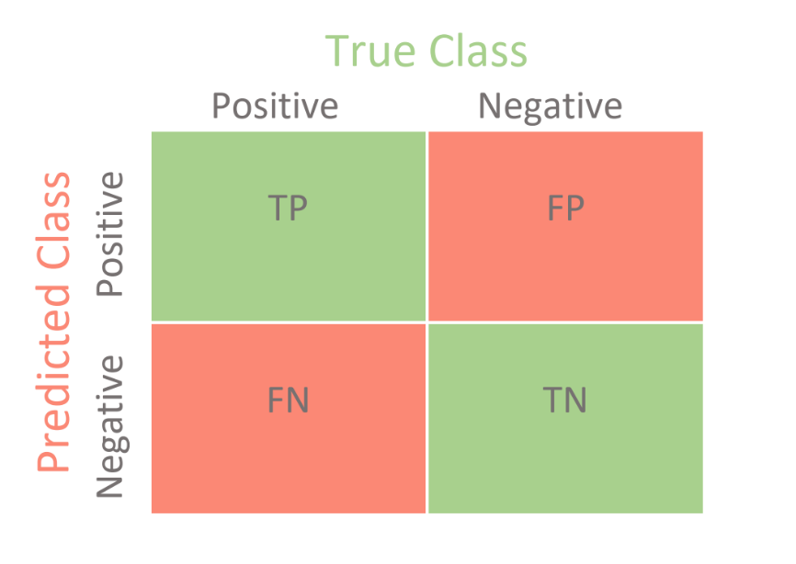

**Fig 6.7 Structure of a Confusion Matrix**

***Metrics Derived from the Confusion Matrix:***

**Accuracy:** Accuracy measures the proportion of correctly predicted observations out of the total observations. Accuracy provides an overall measure of how well the model performs. It is suitable for balanced datasets, where the number of instances in each class is nearly equal.

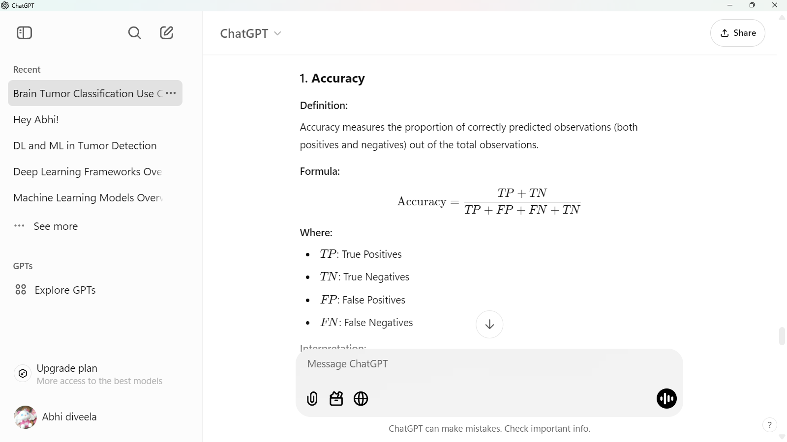

**Sensitivity (Recall or True Positive Rate):** Sensitivity quantifies the ability of a model to correctly identify positive instances. High sensitivity means the model correctly identifies most of the actual positives. Sensitivity is crucial in applications where missing positive cases is costly, such as in medical diagnostics (e.g., identifying brain tumors).

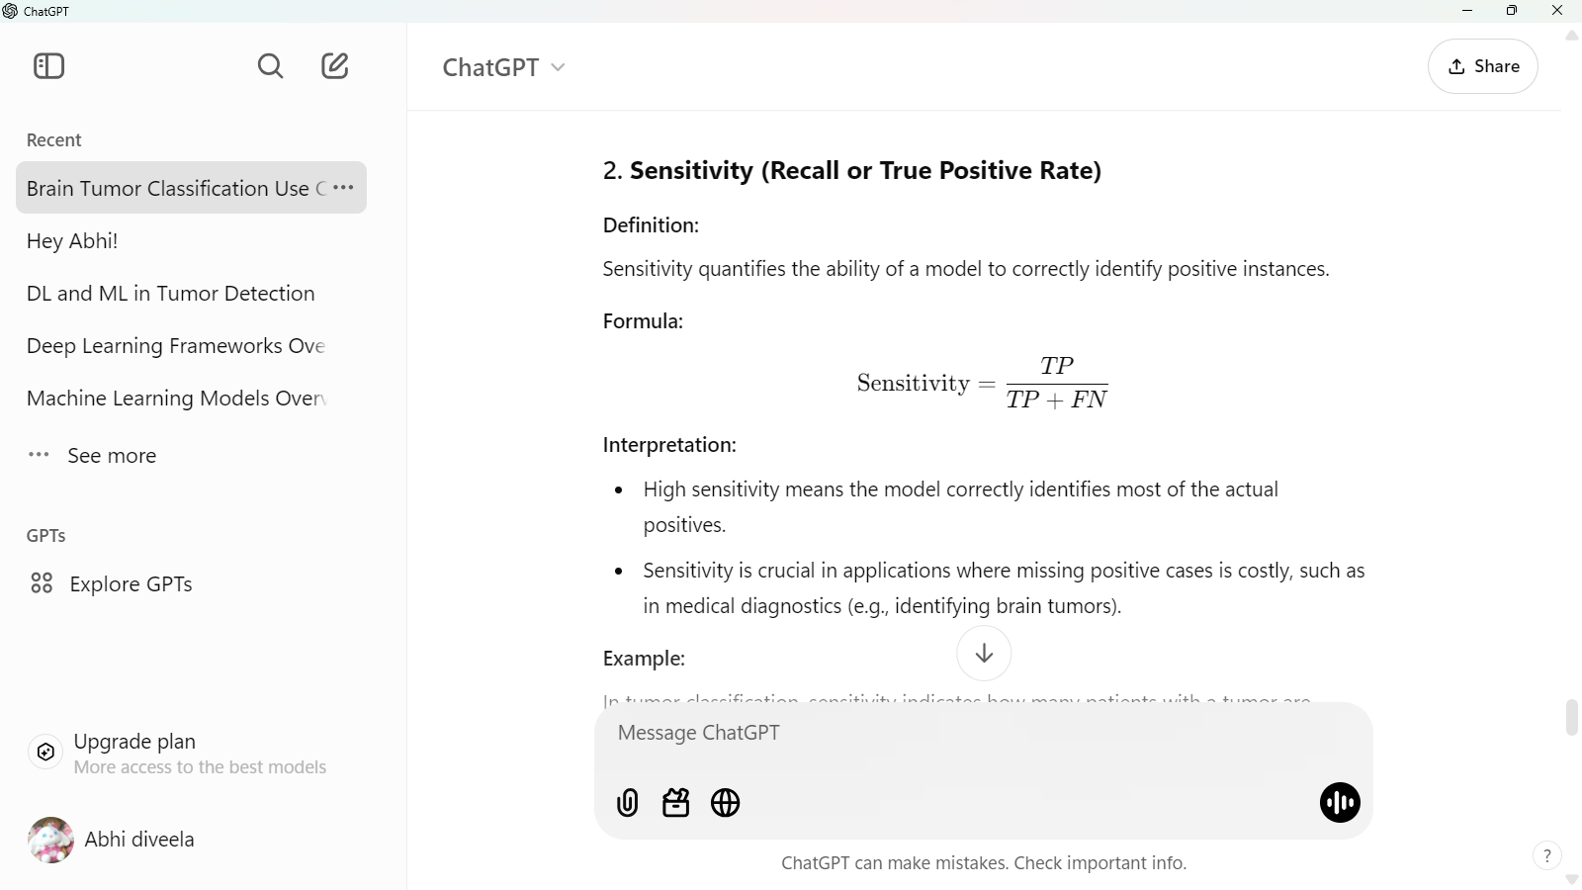

**Specificity (True Negative Rate):** Specificity measures the proportion of actual negatives that are correctly identified by the model. High specificity means the model correctly identifies most of the actual negatives. Specificity is critical in applications where reducing false positives is essential, such as ruling out healthy individuals from further testing.

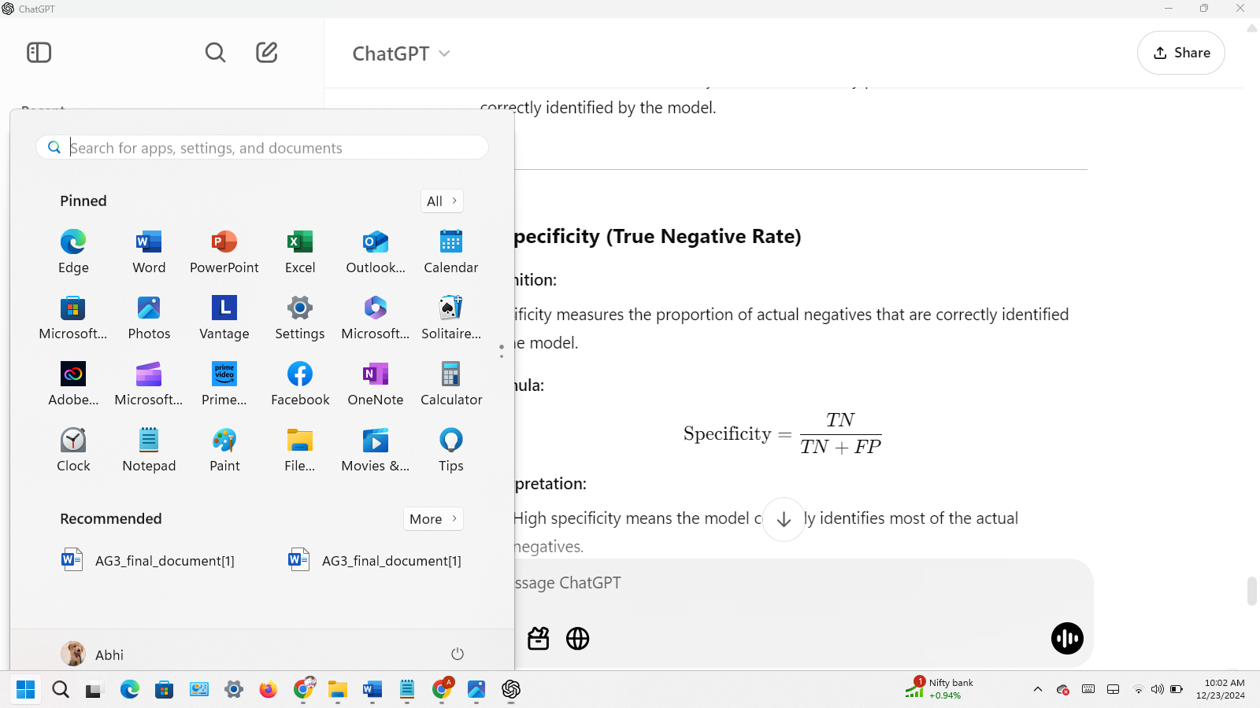

**Jaccard Coefficient (Intersection over Union):** The **Jaccard Coefficient** (or **Jaccard Index**) is a statistical measure used to quantify the similarity and diversity of sample sets. It is particularly useful for evaluating the overlap between two sets, making it widely used in various fields such as information retrieval, image segmentation, and machine learning, particularly in classification tasks.

 .

The Jaccard Coefficient is commonly used in image segmentation tasks, such as identifying tumor regions in MRI scans.confusion matrix , It visually represents how well the model predicts different categories compared to the actual true labels. In this specific matrix, we're dealing with a binary classification problem: "No Tumor" and "Tumor."

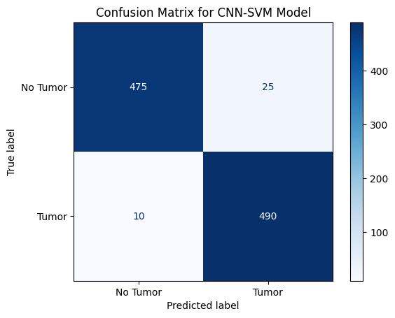

**Fig 6.8 Confusion Matrix for CNN-SVM proposed model**

Specifically, the top-left cell, with a value of 475, represents the True Negatives—cases where the model correctly predicted "No Tumor" when there was indeed no tumor. The top-right cell, with a value of 25, represents False Positives—cases where the model incorrectly predicted "Tumor" when there was no tumor (a false alarm). The bottom-left cell, with a value of 10, represents False Negatives—cases where the model incorrectly predicted "No Tumor" when a tumor was actually present (a miss, and often the most critical error in medical contexts). Finally, the bottom-right cell, with a value of 490, represents True Positives—cases where the model correctly predicted "Tumor" when a tumor was present.

Considering these values in the context of a hypothetical 1000-patient test, the model correctly classified 965 patients (475 True Negatives + 490 True Positives), indicating high overall accuracy. The model also exhibits a relatively low false positive rate (25) and, importantly, a low false negative rate (10). This low false negative rate is particularly crucial in medical applications, where missing a diagnosis can have severe consequences. Overall, this confusion matrix suggests a well-performing model with high accuracy and low error rates, especially in minimizing the critical risk of false negatives.

**7. DESIGN**

The workflow of the CNN-SVM model for brain tumor detection begins with collecting and preprocessing MRI images for training and testing. Preprocessing involves steps such as resizing, normalization, and applying techniques like Adaptive Gamma Correction (AGC) for brightness and contrast adjustment, Median Filtering for noise reduction, and Fuzzy C-Means Clustering (FCM) for tumor region segmentation. Feature extraction is performed using Grey Level Co-Occurrence Matrix (GLCM) to obtain texture features like contrast, energy, and homogeneity.

The processed images are divided into training and testing datasets, and each image is converted into pixel arrays for compatibility with the neural network. The CNN-SVM hybrid model is then trained on the extracted features from the training set, leveraging CNN for feature extraction and SVM for classification. During the testing phase, the model's performance is evaluated using metrics such as accuracy, sensitivity, specificity, and Jaccard Coefficient to measure its effectiveness in tumor detection.

Once the CNN-SVM model is successfully trained, the trained model can be stored for future applications. Saving the model involves preserving its architecture, learned weights, and parameters, enabling it to be reloaded and used without retraining. This is particularly beneficial for deployment in clinical settings, where the model can be integrated into software systems for real-time brain tumor detection and classification. After training, a performance report is generated to evaluate the model's effectiveness and reliability. This report typically includes metrics such as accuracy, sensitivity, specificity, precision, and the Jaccard Coefficient. These metrics provide a quantitative understanding of how well the model performs in distinguishing between tumor and non-tumor cases and correctly identifying specific tumor types.

In clinical applications, such visual insights are invaluable for building trust among healthcare professionals. They allow users to interpret the model's decisions, evaluate its reliability, and make informed choices about integrating it into diagnostic workflows.

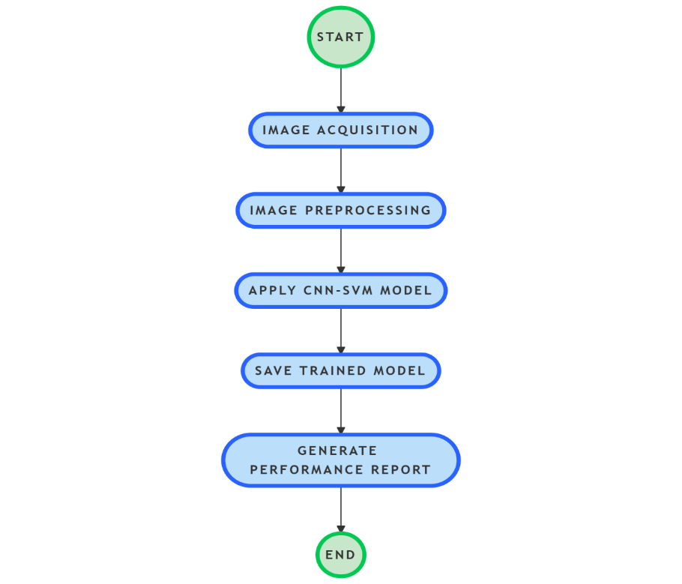

**Fig 7 Design overview**

This flowchart outlines the process of building and evaluating a machine learning pipeline using image data and a hybrid CNN-SVM model. The process begins with image acquisition, where images are collected from sources like cameras, sensors, or datasets. These images are then prepared in the image preprocessing step, which involves cleaning and standardizing the data through resizing, normalization, or removing noise to make it suitable for the model.

Next, the prepared images are processed by the CNN-SVM model. The CNN extracts key features from the images, such as shapes and textures, while the SVM uses these features to classify the images into specific categories. After training, the trained model is saved so it can be reused without retraining.

Finally, the pipeline generates a performance report that evaluates how well the model performs, using metrics like accuracy and precision. The process ends after this evaluation is completed. This streamlined workflow ensures efficient handling of image data and effective model training.

### 8. IMPLEMENTATION

***Using CNN and SVM:***

**PER-PROCESSING SEGMENTATION AND FEATURE EXTRACTION**

import os

from google.colab import drive

import cv2

from google.colab.patches import cv2_imshow

import numpy as np

import albumentations as A

drive.mount('/content/drive')

folder_path = '/content/drive/MyDrive/tumor'

for filename in os.listdir(folder_path):

  print(filename)

!pip install scikit-fuzzy

    import skfuzzy as fuzz

from skimage.feature import graycomatrix, graycoprops

# Define the folder path

folder_path = '/content/drive/MyDrive/tumor/glioma'

# Initialize a list to store GLCM features

gglcm_features_list = []

def extract_glcm_features(image):

    # Compute GLCM

    distances = [1, 2, 3]

    angles = [0, np.pi/4, np.pi/2, 3*np.pi/4]

    glcm = graycomatrix(image, distances=distances, angles=angles, symmetric=True, normed=True)

    # Extract features

    features = {

        'contrast': graycoprops(glcm, 'contrast').flatten(),

        'dissimilarity': graycoprops(glcm, 'dissimilarity').flatten(),

        'homogeneity': graycoprops(glcm, 'homogeneity').flatten(),

        'energy': graycoprops(glcm, 'energy').flatten(),

        'correlation': graycoprops(glcm, 'correlation').flatten(),

        'ASM': graycoprops(glcm, 'ASM').flatten()

    }

    return features

# Counter for processed images

processed_count = 0

max_process = 600

for filename in os.listdir(folder_path):

    if processed_count >= max_process:

        break  # Stop processing if the limit is reached

    if filename.endswith('.jpg') or filename.endswith('.png'):

        image_path = os.path.join(folder_path, filename)

        image = cv2.imread(image_path)

        if image is not None:

            # Normalization

            resize = cv2.resize(image, (224, 224))

            normalized_image = resize / 255.0

            # Histogram Equalization

            gray_image = cv2.cvtColor(resize, cv2.COLOR_BGR2GRAY)

            equalized_image = cv2.equalizeHist(gray_image)

            # Adaptive Contrast Enhancement

            clahe = cv2.createCLAHE(clipLimit=2.0, tileGridSize=(8, 8))

            enhanced_image = clahe.apply(equalized_image)

            # Adaptive Gamma Correction

            gamma = 1.5

            gamma_corrected_image = np.power(enhanced_image / 255.0, gamma) * 255.0

            gamma_corrected_image = gamma_corrected_image.astype(np.uint8)

            # Data Augmentation (example with horizontal flip)

            transform = A.Compose([

                A.HorizontalFlip(p=0.5),

            ])

            augmented_image = transform(image=gamma_corrected_image)['image']

            # Median Filtering

            median_filtered_image = cv2.medianBlur(augmented_image, 5)  # Adjust kernel size as needed

            # Apply Fuzzy C-Means clustering

            # Reshape the image to a 2D array of pixels

            pixel_values = median_filtered_image.reshape((-1, 1))

            pixel_values = pixel_values.astype(float)

            # Perform FCM clustering

            n_clusters = 3

            cntr, u, u0, d, jm, p, fpc = fuzz.cluster.cmeans(

                pixel_values.T, n_clusters, 2, error=0.005, maxiter=1000, init=None)

            # Get the cluster label with the highest membership

            cluster_membership = np.argmax(u, axis=0)

            segmented_image = cluster_membership.reshape(median_filtered_image.shape)

            # Convert the segmented image to a binary image for visualization

            binary_segmented_image = (segmented_image == 1).astype(np.uint8) * 255

            # Extract GLCM features from the grayscale version of the median filtered image

            glcm_features = extract_glcm_features(median_filtered_image)

            gglcm_features_list.append(glcm_features)

            # Display the result

            cv2_imshow(binary_segmented_image)

            print(f"Processed and extracted features from {filename}")

            print(glcm_features)

            # Increment the processed images counter

            processed_count += 1

        else:

            print(f"Failed to load image: {filename}")

# Optionally, process the list of GLCM features

print(f"Extracted GLCM features for {len(gglcm_features_list)} images.")

from skimage.feature import graycomatrix, graycoprops

# Define the folder path

folder_path = '/content/drive/MyDrive/tumor/meningioma'

# Initialize a list to store GLCM features

mglcm_features_list = []

def extract_glcm_features(image):

    # Compute GLCM

    distances = [1, 2, 3]

    angles = [0, np.pi/4, np.pi/2, 3*np.pi/4]

    glcm = graycomatrix(image, distances=distances, angles=angles, symmetric=True, normed=True)

    # Extract features

    features = {

        'contrast': graycoprops(glcm, 'contrast').flatten(),

        'dissimilarity': graycoprops(glcm, 'dissimilarity').flatten(),

        'homogeneity': graycoprops(glcm, 'homogeneity').flatten(),

        'energy': graycoprops(glcm, 'energy').flatten(),

        'correlation': graycoprops(glcm, 'correlation').flatten(),

        'ASM': graycoprops(glcm, 'ASM').flatten()

    }

    return features

# Counter for processed images

processed_count = 0

max_process = 600

for filename in os.listdir(folder_path):

    if processed_count >= max_process:

        break  # Stop processing if the limit is reached

    if filename.endswith('.jpg') or filename.endswith('.png'):

        image_path = os.path.join(folder_path, filename)

        image = cv2.imread(image_path)

        if image is not None:

            # Normalization

            resize = cv2.resize(image, (224, 224))

            normalized_image = resize / 255.0

            # Histogram Equalization

            gray_image = cv2.cvtColor(resize, cv2.COLOR_BGR2GRAY)

            equalized_image = cv2.equalizeHist(gray_image)

            # Adaptive Contrast Enhancement

            clahe = cv2.createCLAHE(clipLimit=2.0, tileGridSize=(8, 8))

            enhanced_image = clahe.apply(equalized_image)

            # Adaptive Gamma Correction

            gamma = 1.5

            gamma_corrected_image = np.power(enhanced_image / 255.0, gamma) * 255.0

            gamma_corrected_image = gamma_corrected_image.astype(np.uint8)

            # Data Augmentation (example with horizontal flip)

            transform = A.Compose([

                A.HorizontalFlip(p=0.5),

            ])

            augmented_image = transform(image=gamma_corrected_image)['image']

            # Median Filtering

            median_filtered_image = cv2.medianBlur(augmented_image, 5)  # Adjust kernel size as needed

            # Apply Fuzzy C-Means clustering

            # Reshape the image to a 2D array of pixels

            pixel_values = median_filtered_image.reshape((-1, 1))

            pixel_values = pixel_values.astype(float)

            # Perform FCM clustering

            n_clusters = 3

            cntr, u, u0, d, jm, p, fpc = fuzz.cluster.cmeans(

                pixel_values.T, n_clusters, 2, error=0.005, maxiter=1000, init=None)

            # Get the cluster label with the highest membership

            cluster_membership = np.argmax(u, axis=0)

            segmented_image = cluster_membership.reshape(median_filtered_image.shape)

            # Convert the segmented image to a binary image for visualization

            binary_segmented_image = (segmented_image == 1).astype(np.uint8) * 255

            # Extract GLCM features from the grayscale version of the median filtered image

            glcm_features = extract_glcm_features(median_filtered_image)

            mglcm_features_list.append(glcm_features)

            print(glcm_features)

            # Display the result if display_count is less than max_display

            if processed_count < max_process:

                cv2_imshow(binary_segmented_image)

                print(f"Processed and extracted features from {filename}")

                processed_count += 1

        else:

            print(f"Failed to load image: {filename}")

# Optionally, process the list of GLCM features

print(f"Extracted GLCM features for {len(mglcm_features_list)} images.")

from skimage.feature import graycomatrix, graycoprops

# Define the folder path

folder_path = '/content/drive/MyDrive/tumor/no'

# Initialize a list to store GLCM features

mglcm_features_list = []

def extract_glcm_features(image):

    # Compute GLCM

    distances = [1, 2, 3]

    angles = [0, np.pi/4, np.pi/2, 3*np.pi/4]

    glcm = graycomatrix(image, distances=distances, angles=angles, symmetric=True, normed=True)

    # Extract features

    features = {

        'contrast': graycoprops(glcm, 'contrast').flatten(),

        'dissimilarity': graycoprops(glcm, 'dissimilarity').flatten(),

        'homogeneity': graycoprops(glcm, 'homogeneity').flatten(),

        'energy': graycoprops(glcm, 'energy').flatten(),

        'correlation': graycoprops(glcm, 'correlation').flatten(),

        'ASM': graycoprops(glcm, 'ASM').flatten()

    }

    return features

# Counter for processed images

processed_count = 0

max_process = 600

for filename in os.listdir(folder_path):

    if processed_count >= max_process:

        break  # Stop processing if the limit is reached

    if filename.endswith('.jpg') or filename.endswith('.png'):

        image_path = os.path.join(folder_path, filename)

        image = cv2.imread(image_path)

        if image is not None:

            # Normalization

            resize = cv2.resize(image, (224, 224))

            normalized_image = resize / 255.0

            # Histogram Equalization

            gray_image = cv2.cvtColor(resize, cv2.COLOR_BGR2GRAY)

            equalized_image = cv2.equalizeHist(gray_image)

            # Adaptive Contrast Enhancement

            clahe = cv2.createCLAHE(clipLimit=2.0, tileGridSize=(8, 8))

            enhanced_image = clahe.apply(equalized_image)

            # Adaptive Gamma Correction

            gamma = 1.5

            gamma_corrected_image = np.power(enhanced_image / 255.0, gamma) * 255.0

            gamma_corrected_image = gamma_corrected_image.astype(np.uint8)

            # Data Augmentation (example with horizontal flip)

            transform = A.Compose([

                A.HorizontalFlip(p=0.5),

            ])

            augmented_image = transform(image=gamma_corrected_image)['image']

            # Median Filtering

            median_filtered_image = cv2.medianBlur(augmented_image, 5)  # Adjust kernel size as needed

            # Apply Fuzzy C-Means clustering

            # Reshape the image to a 2D array of pixels

            pixel_values = median_filtered_image.reshape((-1, 1))

            pixel_values = pixel_values.astype(float)

            # Perform FCM clustering

            n_clusters = 3

            cntr, u, u0, d, jm, p, fpc = fuzz.cluster.cmeans(

                pixel_values.T, n_clusters, 2, error=0.005, maxiter=1000, init=None)

            # Get the cluster label with the highest membership

            cluster_membership = np.argmax(u, axis=0)

            segmented_image = cluster_membership.reshape(median_filtered_image.shape)

            # Convert the segmented image to a binary image for visualization

            binary_segmented_image = (segmented_image == 1).astype(np.uint8) * 255

            # Extract GLCM features from the grayscale version of the median filtered image

            glcm_features = extract_glcm_features(median_filtered_image)

            mglcm_features_list.append(glcm_features)

            print(glcm_features)

            # Display the result if display_count is less than max_display

            if processed_count < max_process:

                cv2_imshow(binary_segmented_image)

                print(f"Processed and extracted features from {filename}")

                processed_count += 1

        else:

            print(f"Failed to load image: {filename}")

# Optionally, process the list of GLCM features

print(f"Extracted GLCM features for {len(mglcm_features_list)} images.")

from skimage.feature import graycomatrix, graycoprops

# Define the folder path

folder_path = '/content/drive/MyDrive/tumor/pituitary'

# Initialize a list to store GLCM features

mglcm_features_list = []

def extract_glcm_features(image):

    # Compute GLCM

    distances = [1, 2, 3]

    angles = [0, np.pi/4, np.pi/2, 3*np.pi/4]

    glcm = graycomatrix(image, distances=distances, angles=angles, symmetric=True, normed=True)

    # Extract features

    features = {

        'contrast': graycoprops(glcm, 'contrast').flatten(),

        'dissimilarity': graycoprops(glcm, 'dissimilarity').flatten(),

        'homogeneity': graycoprops(glcm, 'homogeneity').flatten(),

        'energy': graycoprops(glcm, 'energy').flatten(),

        'correlation': graycoprops(glcm, 'correlation').flatten(),

        'ASM': graycoprops(glcm, 'ASM').flatten()

    }

    return features

# Counter for processed images

processed_count = 0

max_process = 600

for filename in os.listdir(folder_path):

    if processed_count >= max_process:

        break  # Stop processing if the limit is reached

    if filename.endswith('.jpg') or filename.endswith('.png'):

        image_path = os.path.join(folder_path, filename)

        image = cv2.imread(image_path)

        if image is not None:

            # Normalization

            resize = cv2.resize(image, (224, 224))

            normalized_image = resize / 255.0

            # Histogram Equalization

            gray_image = cv2.cvtColor(resize, cv2.COLOR_BGR2GRAY)

            equalized_image = cv2.equalizeHist(gray_image)

            # Adaptive Contrast Enhancement

            clahe = cv2.createCLAHE(clipLimit=2.0, tileGridSize=(8, 8))

            enhanced_image = clahe.apply(equalized_image)

            # Adaptive Gamma Correction

            gamma = 1.5

            gamma_corrected_image = np.power(enhanced_image / 255.0, gamma) * 255.0

            gamma_corrected_image = gamma_corrected_image.astype(np.uint8)

            # Data Augmentation (example with horizontal flip)

            transform = A.Compose([

                A.HorizontalFlip(p=0.5),

            ])

            augmented_image = transform(image=gamma_corrected_image)['image']

            # Median Filtering

            median_filtered_image = cv2.medianBlur(augmented_image, 5)  # Adjust kernel size as needed

            # Apply Fuzzy C-Means clustering

            # Reshape the image to a 2D array of pixels

            pixel_values = median_filtered_image.reshape((-1, 1))

            pixel_values = pixel_values.astype(float)

            # Perform FCM clustering

            n_clusters = 3

            cntr, u, u0, d, jm, p, fpc = fuzz.cluster.cmeans(

                pixel_values.T, n_clusters, 2, error=0.005, maxiter=1000, init=None)

            # Get the cluster label with the highest membership

            cluster_membership = np.argmax(u, axis=0)

            segmented_image = cluster_membership.reshape(median_filtered_image.shape)

            # Convert the segmented image to a binary image for visualization

            binary_segmented_image = (segmented_image == 1).astype(np.uint8) * 255

            # Extract GLCM features from the grayscale version of the median filtered image

            glcm_features = extract_glcm_features(median_filtered_image)

            mglcm_features_list.append(glcm_features)

            print(glcm_features)

            # Display the result if display_count is less than max_display

            if processed_count < max_process:

                cv2_imshow(binary_segmented_image)

                print(f"Processed and extracted features from {filename}")

                processed_count += 1

        else:

            print(f"Failed to load image: {filename}")

# Optionally, process the list of GLCM features

print(f"Extracted GLCM features for {len(mglcm_features_list)} images.")

import pandas as pd

from sklearn.model_selection import train_test_split

# Combine GLCM features into a single DataFrame

all_glcm_features = []

all_labels = []

for features, label in [(gglcm_features_list, 'glioma'),

                        (mglcm_features_list, 'meningioma'),

                        (nglcm_features_list, 'no'),

                        (pglcm_features_list, 'pituitary')]:

    for feature_dict in features:

        flattened_features = [val for sublist in feature_dict.values() for val in sublist]

        all_glcm_features.append(flattened_features)

        all_labels.append(label)

df = pd.DataFrame(all_glcm_features)

df['label'] = all_labels

# Split the data

X = df.drop('label', axis=1)

y = df['label']

X_train, X_temp, y_train, y_temp = train_test_split(X, y, test_size=0.3, random_state=42)

X_val, X_test, y_val, y_test = train_test_split(X_temp, y_temp, test_size=0.5, random_state=42)

print("Training set shape:", X_train.shape, y_train.shape)

print("Validation set shape:", X_val.shape, y_val.shape)

print("Testing set shape:", X_test.shape, y_test.shape)

**Model Training**

**CNN-SVM:**

import pandas as pd

import numpy as np

from sklearn.model_selection import train_test_split, GridSearchCV

from sklearn.preprocessing import LabelEncoder, StandardScaler

from sklearn.svm import SVC

from sklearn.metrics import accuracy_score, jaccard_score, confusion_matrix

from tensorflow.keras.models import Sequential

from tensorflow.keras.layers import Dense, Dropout, Flatten, Conv1D, MaxPooling1D, BatchNormalization, GlobalAveragePooling1D

from tensorflow.keras.optimizers import Adam

from tensorflow.keras.callbacks import EarlyStopping, ReduceLROnPlateau

import matplotlib.pyplot as plt

# Combine GLCM features into a single DataFrame

all_glcm_features = []

all_labels = []

for features, label in [(gglcm_features_list, 'glioma'),

                        (mglcm_features_list, 'meningioma'),

                        (nglcm_features_list, 'no'),

                        (pglcm_features_list, 'pituitary')]:

    for feature_dict in features:

        flattened_features = [val for sublist in feature_dict.values() for val in sublist]

        all_glcm_features.append(flattened_features)

        all_labels.append(label)

df = pd.DataFrame(all_glcm_features)

df['label'] = all_labels

# Encode labels

label_encoder = LabelEncoder()

y = label_encoder.fit_transform(df['label'])

# Split the data

X = df.drop('label', axis=1)

X_train, X_temp, y_train, y_temp = train_test_split(X, y, test_size=0.3, random_state=42)

X_val, X_test, y_val, y_test = train_test_split(X_temp, y_temp, test_size=0.5, random_state=42)

print("Training set shape:", X_train.shape, y_train.shape)

print("Validation set shape:", X_val.shape, y_val.shape)

print("Testing set shape:", X_test.shape, y_test.shape)

# Standardize the features

scaler = StandardScaler()

X_train_scaled = scaler.fit_transform(X_train)

X_val_scaled = scaler.transform(X_val)

X_test_scaled = scaler.transform(X_test)

# Reshape data for CNN (1D convolution)

X_train_cnn = X_train_scaled.reshape(X_train_scaled.shape[0], X_train_scaled.shape[1], 1)

X_val_cnn = X_val_scaled.reshape(X_val_scaled.shape[0], X_val_scaled.shape[1], 1)

X_test_cnn = X_test_scaled.reshape(X_test_scaled.shape[0], X_test_scaled.shape[1], 1)

# Define the improved CNN model with Global Average Pooling

def create_cnn_model(input_shape):

    model = Sequential()

    model.add(Conv1D(64, kernel_size=7, activation='relu', input_shape=input_shape))

    model.add(MaxPooling1D(pool_size=3))

    model.add(Conv1D(128, kernel_size=5, activation='relu'))

    model.add(MaxPooling1D(pool_size=3))

    model.add(Conv1D(256, kernel_size=3, activation='relu'))

    model.add(MaxPooling1D(pool_size=2))

    model.add(GlobalAveragePooling1D())

    model.add(Dense(256, activation='relu'))

    model.add(Dropout(0.5))

    model.add(BatchNormalization())

    model.add(Dense(4, activation='softmax'))  # 4 output classes

    model.compile(optimizer=Adam(learning_rate=0.0005), loss='sparse_categorical_crossentropy', metrics=['accuracy'])

    return model

# Initialize and train CNN

cnn_model = create_cnn_model((X_train_cnn.shape[1], 1))

early_stopping = EarlyStopping(monitor='val_loss', patience=10, restore_best_weights=True)

reduce_lr = ReduceLROnPlateau(monitor='val_loss', factor=0.2, patience=5, min_lr=0.00001)

cnn_history = cnn_model.fit(X_train_cnn, y_train,

                            epochs=150,

                            batch_size=64,

                            validation_data=(X_val_cnn, y_val),

                            callbacks=[early_stopping, reduce_lr])

# Extract features from CNN

cnn_features_train = cnn_model.predict(X_train_cnn)

cnn_features_val = cnn_model.predict(X_val_cnn)

cnn_features_test = cnn_model.predict(X_test_cnn)

# Flatten the CNN features for SVM

cnn_features_train_flattened = cnn_features_train.reshape(cnn_features_train.shape[0], -1)

cnn_features_val_flattened = cnn_features_val.reshape(cnn_features_val.shape[0], -1)

cnn_features_test_flattened = cnn_features_test.reshape(cnn_features_test.shape[0], -1)

# Grid search for SVM hyperparameters

svm_model = SVC(probability=True)

param_grid = {

    'kernel': ['linear', 'rbf'],

    'C': [1, 10, 100],

    'gamma': ['scale', 'auto']

}

grid_search = GridSearchCV(svm_model, param_grid, cv=3, scoring='accuracy')

grid_search.fit(cnn_features_train_flattened, y_train)

# Best SVM model

best_svm_model = grid_search.best_estimator_

# Evaluate SVM

y_pred_test = best_svm_model.predict(cnn_features_test_flattened)

# Calculate metrics

train_accuracy = accuracy_score(y_train, best_svm_model.predict(cnn_features_train_flattened))

val_accuracy = accuracy_score(y_val, best_svm_model.predict(cnn_features_val_flattened))

test_accuracy = accuracy_score(y_test, y_pred_test)

train_jaccard = jaccard_score(y_train, best_svm_model.predict(cnn_features_train_flattened), average='macro')

val_jaccard = jaccard_score(y_val, best_svm_model.predict(cnn_features_val_flattened), average='macro')

test_jaccard = jaccard_score(y_test, y_pred_test, average='macro')

def sensitivity_specificity(y_true, y_pred):

    ccm = confusion_matrix(y_true, y_pred)

    tp = np.diag(ccm)

    fp = ccm.sum(axis=0) - tp

    fn = ccm.sum(axis=1) - tp

    tn = ccm.sum() - (fp + fn + tp)

    accuracy = (tp + tn) / (tp + fp + fn + tn)

    sensitivity = tp / (tp + fn)

    specificity = tn / (tn + fp)

    return sensitivity, specificity

sensitivity_train, specificity_train = sensitivity_specificity(y_train, best_svm_model.predict(cnn_features_train_flattened))

sensitivity_val, specificity_val = sensitivity_specificity(y_val, best_svm_model.predict(cnn_features_val_flattened))

sensitivity_test, specificity_test = sensitivity_specificity(y_test, y_pred_test)

print(f"Training Accuracy: {train_accuracy * 100:.2f}%")

print(f"Validation Accuracy: {val_accuracy * 100:.2f}%")

print(f"Testing Accuracy: {test_accuracy * 100:.2f}%")

print(f"Training Jaccard Coefficient: {train_jaccard:.2f}")

print(f"Validation Jaccard Coefficient: {val_jaccard:.2f}")

print(f"Testing Jaccard Coefficient: {test_jaccard:.2f}")

# Calculate average sensitivity for training set

avg_sensitivity_train = np.mean(sensitivity_train)

print(f"Training Sensitivity: {avg_sensitivity_train:.2f}")

avg_sensitivity_test = np.mean(sensitivity_test)

print(f"Testing Sensitivity: {avg_sensitivity_test:.2f}")

# Iterate through the specificity values for each class

for i, specificity in enumerate(specificity_train):

    print(f"Training Specificity for class {i}: {specificity:.2f}")

for i, specificity in enumerate(specificity_val):

    print(f"Validation Specificity for class {i}: {specificity:.2f}")

for i, specificity in enumerate(specificity_test):

    print(f"Testing Specificity for class {i}: {specificity:.2f}")

# Plot Metrics

plt.figure(figsize=(14, 10))

# Plot CNN Accuracy

plt.subplot(2, 2, 1)

plt.plot(cnn_history.history['accuracy'])

plt.plot(cnn_history.history['val_accuracy'])

plt.title('CNN-SVM Model Accuracy')

plt.xlabel('Epoch')

plt.ylabel('Accuracy')

plt.legend(['Train', 'Validation'])

# Plot CNN Loss

plt.subplot(2, 2, 2)

plt.plot(cnn_history.history['loss'])

plt.plot(cnn_history.history['val_loss'])

plt.title('CNN-SVM Model Loss')

plt.xlabel('Epoch')

plt.ylabel('Loss')

plt.legend(['Train', 'Validation'])

# Plot Jaccard Coefficient

plt.subplot(2, 2, 3)

plt.bar(['Train', 'Validation', 'Test'], [train_jaccard * 100, val_jaccard * 100, test_jaccard * 100], color=['blue', 'orange', 'green'])

plt.xlabel('Dataset')

plt.ylabel('Jaccard Coefficient (%)')

plt.title('Jaccard Coefficient on Different Datasets')

# Plot Sensitivity

plt.subplot(2, 2, 4)

plt.bar(['Train', 'Validation', 'Test'],

        [np.mean(sensitivity_train) * 100,

         np.mean(sensitivity_val) * 100,

         np.mean(sensitivity_test) * 100],

        color=['blue', 'orange', 'green'])

plt.xlabel('Dataset')

plt.ylabel('Average Sensitivity (%)')

plt.title('Average Sensitivity on Different Datasets')

plt.tight_layout()

plt.show()

**ANN:**

import pandas as pd

import numpy as np

from sklearn.model_selection import train_test_split

from sklearn.preprocessing import LabelEncoder, StandardScaler

from sklearn.metrics import accuracy_score, jaccard_score, confusion_matrix

from tensorflow.keras.models import Sequential

from tensorflow.keras.layers import Dense, Dropout

from tensorflow.keras.optimizers import Adam

import matplotlib.pyplot as plt

import time

# Combine GLCM features into a single DataFrame

all_glcm_features = []

all_labels = []

for features, label in [(gglcm_features_list, 'glioma'),

                        (mglcm_features_list, 'meningioma'),

                        (nglcm_features_list, 'no'),

                        (pglcm_features_list, 'pituitary')]:

    for feature_dict in features:

        flattened_features = [val for sublist in feature_dict.values() for val in sublist]

        all_glcm_features.append(flattened_features)

        all_labels.append(label)

df = pd.DataFrame(all_glcm_features)

df['label'] = all_labels

# Split the data

X = df.drop('label', axis=1)

y = df['label']

# Encode labels

label_encoder = LabelEncoder()

y_encoded = label_encoder.fit_transform(y)

X_train, X_temp, y_train, y_temp = train_test_split(X, y_encoded, test_size=0.3, random_state=42)

X_val, X_test, y_val, y_test = train_test_split(X_temp, y_temp, test_size=0.5, random_state=42)

print("Training set shape:", X_train.shape, y_train.shape)

print("Validation set shape:", X_val.shape, y_val.shape)

print("Testing set shape:", X_test.shape, y_test.shape)

# Standardize the features

scaler = StandardScaler()

X_train_scaled = scaler.fit_transform(X_train)

X_val_scaled = scaler.transform(X_val)

X_test_scaled = scaler.transform(X_test)

# Define the ANN model

def create_ann_model(input_dim):

    model = Sequential()

    model.add(Dense(512, input_dim=input_dim, activation='relu'))

    model.add(Dropout(0.5))

    model.add(Dense(256, activation='relu'))

    model.add(Dropout(0.5))

    model.add(Dense(128, activation='relu'))

    model.add(Dense(4, activation='softmax'))  # 4 output classes

    model.compile(optimizer=Adam(learning_rate=0.001), loss='sparse_categorical_crossentropy', metrics=['accuracy'])

    return model

# Initialize and train ANN

ann_model = create_ann_model(X_train_scaled.shape[1])

# Start the timer for training

start_time = time.time()

history = ann_model.fit(X_train_scaled, y_train,

                        epochs=100,

                        batch_size=32,

                        validation_data=(X_val_scaled, y_val))

# End the timer for training

end_time = time.time()

computational_time = end_time - start_time

# Evaluate ANN

y_pred_train = np.argmax(ann_model.predict(X_train_scaled), axis=-1)

y_pred_val = np.argmax(ann_model.predict(X_val_scaled), axis=-1)

y_pred_test = np.argmax(ann_model.predict(X_test_scaled), axis=-1)

# Calculate metrics

def calculate_metrics(y_true, y_pred):

    accuracy = accuracy_score(y_true, y_pred)

    jaccard = jaccard_score(y_true, y_pred, average='macro')

    cm = confusion_matrix(y_true, y_pred)

    tp = np.diag(cm)

    fp = cm.sum(axis=0) - tp

    fn = cm.sum(axis=1) - tp

    tn = cm.sum() - (fp + fn + tp)

    accuracy = (tp + tn) / (tp + fp + fn + tn)

    sensitivity = tp / (tp + fn)

    specificity = tn / (tn + fp)

    return accuracy, sensitivity, specificity, jaccard

train_accuracy, train_sensitivity, train_specificity, train_jaccard = calculate_metrics(y_train, y_pred_train)

val_accuracy, val_sensitivity, val_specificity, val_jaccard = calculate_metrics(y_val, y_pred_val)

test_accuracy, test_sensitivity, test_specificity, test_jaccard = calculate_metrics(y_test, y_pred_test)

# Calculate average metrics

avg_train_accuracy = train_accuracy

avg_val_accuracy = val_accuracy

avg_test_accuracy = test_accuracy

avg_train_sensitivity = np.mean(train_sensitivity)

avg_val_sensitivity = np.mean(val_sensitivity)

avg_test_sensitivity = np.mean(test_sensitivity)

avg_train_specificity = np.mean(train_specificity)

avg_val_specificity = np.mean(val_specificity)

avg_test_specificity = np.mean(test_specificity)

avg_train_jaccard = train_jaccard

avg_val_jaccard = val_jaccard

avg_test_jaccard = test_jaccard

print(f"Training Accuracy: {np.mean(train_accuracy) * 100:.2f}%")

print(f"Validation Accuracy: {np.mean(val_accuracy) * 100:.2f}%")

print(f"Testing Accuracy: {np.mean(test_accuracy) * 100:.2f}%")

print(f"Training Jaccard Coefficient: {train_jaccard:.2f}")

print(f"Validation Jaccard Coefficient: {val_jaccard:.2f}")

print(f"Testing Jaccard Coefficient: {test_jaccard:.2f}")

print(f"Training Sensitivity: {train_sensitivity}")

print(f"Validation Sensitivity: {val_sensitivity}")

print(f"Testing Sensitivity: {test_sensitivity}")

print(f"Training Specificity: {train_specificity}")

print(f"Validation Specificity: {val_specificity}")

print("computational time",computational_time )

# Plot Metrics

plt.figure(figsize=(14, 10))

# Plot Average Accuracy

plt.subplot(2, 2, 1)

plt.bar(['Train', 'Validation', 'Test'],

        [np.mean(avg_train_accuracy) * 100, np.mean(avg_val_accuracy) * 100, np.mean(avg_test_accuracy) * 100],

        color=['blue', 'orange', 'green'])

plt.xlabel('Dataset')

plt.ylabel('Accuracy (%)')

plt.title('Average Accuracy on Different Datasets')

# Plot Average Sensitivity

plt.subplot(2, 2, 2)

plt.bar(['Train', 'Validation', 'Test'], [avg_train_sensitivity * 100, avg_val_sensitivity * 100, avg_test_sensitivity * 100], color=['blue', 'orange', 'green'])

plt.xlabel('Dataset')

plt.ylabel('Average Sensitivity (%)')

plt.title('Average Sensitivity on Different Datasets')

# Plot Average Specificity

plt.subplot(2, 2, 3)

plt.bar(['Train', 'Validation', 'Test'], [avg_train_specificity * 100, avg_val_specificity * 100, avg_test_specificity * 100], color=['blue', 'orange', 'green'])

plt.xlabel('Dataset')

plt.ylabel('Average Specificity (%)')

plt.title('Average Specificity on Different Datasets')

# Plot Average Jaccard Coefficient

plt.subplot(2, 2, 4)

plt.bar(['Train', 'Validation', 'Test'], [avg_train_jaccard * 100, avg_val_jaccard * 100, avg_test_jaccard * 100], color=['blue', 'orange', 'green'])

plt.xlabel('Dataset')

plt.ylabel('Jaccard Coefficient (%)')

plt.title('Jaccard Coefficient on Different Datasets')

plt.tight_layout()

plt.show()

# Plot Computational Time

plt.figure(figsize=(6, 4))

plt.bar(['Computational Time'], [computational_time], color='purple')

plt.xlabel('Metric')

plt.ylabel('Time (seconds)')

plt.title('Computational Time')

plt.show()

**RNNS:**

import numpy as np

import pandas as pd

from sklearn.model_selection import train_test_split

from sklearn.preprocessing import LabelEncoder, StandardScaler

from sklearn.metrics import jaccard_score, confusion_matrix, precision_score, recall_score

import tensorflow as tf

from tensorflow.keras.models import Sequential

from tensorflow.keras.layers import Dense, Dropout, LSTM, BatchNormalization, Bidirectional

from tensorflow.keras.callbacks import EarlyStopping, ReduceLROnPlateau

import time

import matplotlib.pyplot as plt

import seaborn as sns

# Combine GLCM features into a single DataFrame

all_glcm_features = []

all_labels = []

for features, label in [(gglcm_features_list, 'glioma'),

                        (mglcm_features_list, 'meningioma'),

                        (nglcm_features_list, 'no'),

                        (pglcm_features_list, 'pituitary')]:

    for feature_dict in features:

        flattened_features = [val for sublist in feature_dict.values() for val in sublist]

        all_glcm_features.append(flattened_features)

        all_labels.append(label)

df = pd.DataFrame(all_glcm_features)

df['label'] = all_labels

# Encode labels

label_encoder = LabelEncoder()

y = label_encoder.fit_transform(df['label'])

# Split the data

X = df.drop('label', axis=1)

X_train, X_temp, y_train, y_temp = train_test_split(X, y, test_size=0.3, random_state=42)

X_val, X_test, y_val, y_test = train_test_split(X_temp, y_temp, test_size=0.5, random_state=42)

# Standardize the features

scaler = StandardScaler()

X_train = scaler.fit_transform(X_train)

X_val = scaler.transform(X_val)

X_test = scaler.transform(X_test)

# Reshape data for RNN

X_train = X_train.reshape(X_train.shape[0], 1, X_train.shape[1])

X_val = X_val.reshape(X_val.shape[0], 1, X_val.shape[1])

X_test = X_test.reshape(X_test.shape[0], 1, X_test.shape[1])

# Define the RNN model with Bidirectional LSTM layers

model = Sequential()

model.add(Bidirectional(LSTM(128, activation='relu', return_sequences=True), input_shape=(1, X_train.shape[2])))

model.add(BatchNormalization())

model.add(Dropout(0.4))

model.add(Bidirectional(LSTM(64, activation='relu')))

model.add(BatchNormalization())

model.add(Dropout(0.4))

model.add(Dense(64, activation='relu'))

model.add(BatchNormalization())

model.add(Dropout(0.4))

model.add(Dense(4, activation='softmax'))  # 4 output classes: glioma, meningioma, no, pituitary

# Compile the model

model.compile(optimizer=tf.keras.optimizers.Adam(learning_rate=0.001),

              loss='sparse_categorical_crossentropy',

              metrics=['accuracy'])

# Callbacks

early_stopping = EarlyStopping(monitor='val_loss', patience=10, restore_best_weights=True)

reduce_lr = ReduceLROnPlateau(monitor='val_loss', factor=0.2, patience=5, min_lr=0.0001)

# Train the model

start_time = time.time()

history = model.fit(X_train, y_train,

                    epochs=100,

                    batch_size=32,

                    validation_data=(X_val, y_val),

                    callbacks=[early_stopping, reduce_lr])

end_time = time.time()

training_time = end_time - start_time

# Evaluate the model on the test set

rloss, raccuracy = model.evaluate(X_test, y_test)

print("Test Loss:", loss)

print("Test Accuracy:", accuracy)

print("Training Time:", training_time)

# Predictions

y_pred_encoded = model.predict(X_test)

y_pred = np.argmax(y_pred_encoded, axis=1)

# Calculate additional metrics

rjaccard = jaccard_score(y_test, y_pred, average='macro')

rprecision = precision_score(y_test, y_pred, average='macro')

rrecall = recall_score(y_test, y_pred, average='macro')

# Confusion Matrix for Sensitivity and Specificity

rconf_matrix = confusion_matrix(y_test, y_pred)

tn = conf_matrix[0, 0]

tp = np.diag(conf_matrix).sum() - tn

fp = conf_matrix.sum(axis=0) - np.diag(conf_matrix)

fn = conf_matrix.sum(axis=1) - np.diag(conf_matrix)

accuracy = (tp + tn) / (tp + fp + fn + tn)

rsensitivity = tp / (tp + fn)

rspecificity = tn / (tn + fp)

print("accuracy",accuracy)

print("Jaccard Coefficient:", rjaccard)

print("Precision:", rprecision)

print("Recall (Sensitivity):", rrecall)

print("Specificity:", rspecificity)

# Plot training & validation accuracy values

plt.figure(figsize=(12, 4))

plt.subplot(1, 2, 1)

plt.plot(history.history['accuracy'])

plt.plot(history.history['val_accuracy'])

plt.title('Model Accuracy')

plt.xlabel('Epoch')

plt.ylabel('Accuracy')

plt.legend(['Train', 'Validation'], loc='upper left')

# Plot training & validation loss values

plt.subplot(1, 2, 2)

plt.plot(history.history['loss'])

plt.plot(history.history['val_loss'])

plt.title('Model Loss')

plt.xlabel('Epoch')

plt.ylabel('Loss')

plt.legend(['Train', 'Validation'], loc='upper left')

plt.tight_layout()

plt.show()

# Plot confusion matrix

plt.figure(figsize=(8, 6))

sns.heatmap(conf_matrix, annot=True, fmt='d', cmap='Blues', xticklabels=label_encoder.classes_, yticklabels=label_encoder.classes_)

plt.title('Confusion Matrix')

plt.xlabel('Predicted')

plt.ylabel('Actual')

plt.show()

**Prediction:**

from tensorflow.keras.preprocessing import image

import numpy as np

# Function to preprocess the input image

def preprocess_image(img_path, target_size):

    img = image.load_img(img_path, target_size=target_size, color_mode='grayscale')  # Load the image

    img_array = image.img_to_array(img)  # Convert the image to a NumPy array

    img_array = img_array / 255.0  # Normalize pixel values (ensure this is done to match training data)

    # Remove extra dimensions and reshape to match training data

    img_array = img_array.reshape(1, target_size[0], 1)

    return img_array

# Path to the input image

img_path = '/content/drive/MyDrive/tumor/no/1.jpg'

# Get target size from X_train_cnn (assuming it's defined)

target_size = (X_train_cnn.shape[1], X_train_cnn.shape[2])

# Preprocess the image

input_image = preprocess_image(img_path, target_size)

# Check the shape of the preprocessed image

print("Preprocessed image shape:", input_image.shape)

# Perform prediction

predicted_class = np.argmax(cnn_model.predict(input_image), axis=1)[0]

# Map the predicted class index to the label

predicted_label = label_encoder.inverse_transform([predicted_class])[0]

# Output the prediction

print(f"The predicted class for the input image is: {predicted_label}")

**Analysis:**

import matplotlib.pyplot as plt

import numpy as np

# Model names and their corresponding accuracies

models = ['VGG', 'ANN', 'RFC', 'RNNs', 'FCNNs', 'CNN', 'CNN-SVM(proposed model)']

accuracies = [93.75, 95.89, 92.70, 92.5, 93, 95, 97.94]

# Create a color gradient based on accuracy values

colors = plt.cm.viridis(np.linspace(0.2, 0.8, len(models)))

# Create a horizontal bar plot

plt.figure(figsize=(12, 8))

bars = plt.barh(models, accuracies, color=colors, edgecolor='black', linewidth=1.2)

# Add data labels

for bar in bars:

    xval = bar.get_width()

    plt.text(xval + 0.5, bar.get_y() + bar.get_height()/2, f'{xval:.2f}%', ha='left', va='center', fontsize=12, fontweight='bold')

# Customizing the plot

plt.xlabel('Accuracy (%)', fontsize=14, fontweight='bold')

plt.ylabel('Models', fontsize=14, fontweight='bold')

plt.title('Model Accuracies', fontsize=16, fontweight='bold')

plt.xlim([90, 100])  # Set x-axis limits for better visibility

plt.xticks(fontsize=12)

plt.yticks(fontsize=12, fontweight='bold')

plt.grid(axis='x', linestyle='--', alpha=0.7)

# Apply a subtle background gradient

plt.gca().set_facecolor('whitesmoke')

plt.gcf().set_facecolor('lightgray')

# Tight layout to prevent clipping

plt.tight_layout()

plt.show()

import seaborn as sns

import numpy as np

import matplotlib.pyplot as plt

models = ['VGG', 'ANN', 'RFC', 'RNNs', 'FCNNs', 'CNN', 'CNN-SVM(proposed model)']

jaccard_coefficients = [84, 85, 87, 81, 80, 86, 90]

# Convert the Jaccard coefficients into a 2D array format for the heatmap

data = np.array(jaccard_coefficients).reshape(1, -1)

# Create the heatmap with custom color map

plt.figure(figsize=(12, 2))

ax = sns.heatmap(data, annot=True, fmt=".1f", cmap="coolwarm_r", cbar=True, linewidths=1, linecolor='black',

                 xticklabels=models, yticklabels=['Jaccard Coefficient'], annot_kws={"size": 14, "weight": "bold"})

# Title and customization

plt.title('Jaccard Coefficients ', fontsize=16, fontweight='bold', pad=20)

plt.xticks(rotation=45, ha='right', fontsize=12, fontweight='bold')

plt.yticks(fontsize=12, fontweight='bold')

# Adjust layout for better visualization

plt.tight_layout()

plt.show()

import matplotlib.pyplot as plt

import numpy as np

import pandas as pd

# Model names and their corresponding sensitivity values

models = ['VGG', 'ANN', 'RFC', 'RNNs', 'FCNNs', 'CNN', 'CNN-SVM(peoposed model)']

sensitivities = [91, 92, 94, 89, 88, 94, 95]

# Create a DataFrame for easier handling

data = pd.DataFrame({

    'Model': models,

    'Sensitivity': sensitivities

})

# Sort the DataFrame by Sensitivity

data_sorted = data.sort_values(by='Sensitivity')

# Calculate average sensitivity

average_sensitivity = np.mean(sensitivities)

# Create subplots with enhanced styling

fig, ax1 = plt.subplots(figsize=(14, 8))

# Bar plot with advanced styling

bars = ax1.bar(data_sorted['Model'], data_sorted['Sensitivity'], color='teal', edgecolor='black', linewidth=1.5, label='Sensitivity', zorder=3, alpha=0.9)

# Line plot with advanced styling

ax2 = ax1.twinx()

line = ax2.plot(data_sorted['Model'], data_sorted['Sensitivity'], color='darkorange', marker='D', linestyle='--', linewidth=2, markersize=10, label='Sensitivity Trend', zorder=4)

# Adding annotations with improved style

for bar in bars:

    height = bar.get_height()

    ax1.text(bar.get_x() + bar.get_width()/2, height + 0.5, f'{height}%', ha='center', va='bottom', fontsize=12, weight='bold', color='black', zorder=5, bbox=dict(facecolor='white', edgecolor='none', boxstyle='round,pad=0.3'))

# Adding horizontal line for average sensitivity with enhanced style

ax1.axhline(y=average_sensitivity, color='gray', linestyle='--', linewidth=2, label=f'Average Sensitivity: {average_sensitivity:.2f}%', zorder=2)

# Labeling and styling

ax1.set_xlabel('Models', fontsize=14, weight='bold', color='darkblue')

ax1.set_ylabel('Sensitivity (%)', fontsize=14, weight='bold', color='darkblue')

ax1.set_title('Model Sensitivity Comparison with Enhanced Styles', fontsize=16, weight='bold', color='darkred')

ax1.set_ylim([80, 100])

ax1.tick_params(axis='x', rotation=45, labelsize=12, colors='black')

ax1.tick_params(axis='y', labelsize=12, colors='black')

ax1.legend(loc='upper left', fontsize=12, frameon=True, shadow=True)

ax2.legend(loc='upper right', fontsize=12, frameon=True, shadow=True)

# Add grid lines with improved styling

ax1.grid(True, linestyle='--', alpha=0.7, color='gray', zorder=1)

# Format y-axis for better readability

ax1.yaxis.set_major_locator(plt.MaxNLocator(integer=True))

ax2.yaxis.set_major_locator(plt.MaxNLocator(integer=True))

# Add a secondary x-axis with improved formatting

ax1.set_xticks(data_sorted['Model'])

ax1.set_xticklabels(data_sorted['Model'], rotation=45, ha='right', fontsize=12, weight='bold', color='black')

# Adjust layout for better spacing

plt.tight_layout()

# Show the plot

plt.show()

import matplotlib.pyplot as plt

import seaborn as sns

import numpy as np

# Data

models = ['VGG', 'ANN', 'RFC', 'RNNs', 'FCNNs', 'CNN', 'CNN-SVM (Proposed)']

specificities = [96, 97, 97, 86, 84, 97, 98.1]

# Create a DataFrame for seaborn

data = np.array(specificities).reshape(1, -1)

# Create heatmap

plt.figure(figsize=(10, 6))

sns.heatmap(data, annot=True, fmt=".1f", cmap="coolwarm", xticklabels=models, yticklabels=["Specificity"], cbar_kws={'label': 'Specificity (%)'})

# Labeling

plt.title("Specificity Across Models", fontsize=16, weight='bold')

plt.xlabel("Models", fontsize=14, weight='bold')

plt.ylabel("Metric", fontsize=14, weight='bold')

plt.show()

**app.py**

from flask import Flask, request, jsonify, render_template

import numpy as np

import tensorflow as tf

from tensorflow.keras.models import load_model

from tensorflow.keras.preprocessing import image

import os

# Initialize Flask app

app = Flask(__name__)

# Path to the trained model

MODEL_PATH = "classification_model (1).h5"

# Load the trained model

try:

model = load_model(MODEL_PATH)

print(f"Model loaded successfully from {MODEL_PATH}")

except Exception as e:

print(f"Error loading model: {e}")

model = None

# Allowed file extensions

ALLOWED_EXTENSIONS = {'png', 'jpg', 'jpeg'}

def allowed_file(filename):

return '.' in filename and filename.rsplit('.', 1)[1].lower() in ALLOWED_EXTENSIONS

def preprocess_image(file_path):

img = image.load_img(file_path, target_size=(224, 224)) # Adjust the size as per your model input

img_array = image.img_to_array(img) / 255.0 # Normalize the image

img_array = np.expand_dims(img_array, axis=0) # Add batch dimension

return img_array

@app.route('/')

def index():

return render_template('index.html')

@app.route('/predict', methods=['POST'])

def predict():

if 'file' not in request.files:

return jsonify({'error': 'No file uploaded'})

file = request.files['file']

if file.filename == '':

return jsonify({'error': 'No file selected'})

if not allowed_file(file.filename):

return jsonify({'error': 'Invalid file type. Please upload a .png, .jpg, or .jpeg file.'})

try:

file_path = os.path.join('temp', file.filename)

file.save(file_path)

# Preprocess the image

input_image = preprocess_image(file_path)

# Perform prediction

prediction = model.predict(input_image)

predicted_class = np.argmax(prediction, axis=1)[0]

# Mapping the predicted class to labels

labels = ['Glioma', 'Meningioma', 'No Tumor', 'Pituitary'] # Adjust these labels as per your model

result = labels[predicted_class]

# Clean up

os.remove(file_path)

return jsonify({'prediction': result})

except Exception as e:

return jsonify({'error': str(e)})

# Main entry point

if __name__ == '__main__':

if not os.path.exists('temp'):

os.makedirs('temp') # Create a temporary directory for uploads

app.run(debug=True)

**index.html**

<!DOCTYPE html>

<html lang="en">

<head>

    <meta charset="UTF-8">

    <meta name="viewport" content="width=device-width, initial-scale=1.0">

    <title>Brain Tumor Classifier</title>

    <style>

        /* General styles */

        body {

            margin: 0;

            font-family: 'Arial', sans-serif;

            min-height: 100vh;

            background: linear-gradient(135deg, #000000 0%, #8e44ad 50%, #3498db 100%);

            color: #fff;

            scroll-behavior: smooth;

        }

        /* Navigation bar */

        .navbar {

            background-color: rgba(0, 0, 0, 0.7);

            display: flex;

            justify-content: space-around;

            align-items: center;

            padding: 15px 20px;

            position: fixed;

            width: 100%;

            top: 0;

            z-index: 1000;

            box-shadow: 0px 4px 10px rgba(0, 0, 0, 0.5);

        }

        .navbar a {

            color: #fff;

            text-decoration: none;

            font-size: 1rem;

            font-weight: bold;

            padding: 8px 15px;

            border-radius: 5px;

            transition: background-color 0.3s ease, color 0.3s ease;

        }

        .navbar a:hover {

            background-color: #2575fc;

            color: #fff;

        }

        /* Section styles */

        section {

            padding: 80px 20px;

            text-align: center;

        }

        section:nth-child(even) {

            background-color: rgba(255, 255, 255, 0.1);

        }

        section h2 {

            margin-bottom: 15px;

            font-size: 2rem;

        }

        section p {

            font-size: 1rem;

            line-height: 1.5;

        }

        li {

            text-align: left;

        }

        h2 {

            margin-bottom: 15px;

            font-size: 20px;

        }

        /* Container for Predictions */

        .container {

            background-color: rgba(255, 255, 255, 0.1);

            border-radius: 12px;

            box-shadow: 0px 8px 15px rgba(0, 0, 0, 0.2);

            padding: 20px 40px;

            text-align: center;

            width: 90%;

            max-width: 500px;

            margin: 40px auto;

        }

        .file-input {

            margin-bottom: 20px;

        }

        input[type="file"] {

            display: none;

        }

        label {

            cursor: pointer;

            background-color: #fff;

            color: #2575fc;

            padding: 10px 20px;

            border-radius: 5px;

            font-size: 1rem;

            font-weight: bold;

            transition: background 0.3s ease;

        }

        label:hover {

            background-color: #2575fc;

            color: #fff;

        }

        .submit-btn {

            background-color: #6a11cb;

            border: none;

            color: #fff;

            padding: 12px 25px;

            border-radius: 6px;

            font-size: 1rem;

            font-weight: bold;

            cursor: pointer;

            transition: transform 0.3s ease;

        }

        .submit-btn:hover {

            transform: translateY(-3px);

            background-color: #2575fc;

        }

        /* Image preview styles */

        #image-preview {

            margin-top: 20px;

            display: none;

        }

        #image-preview img {

            width: 100%;

            max-width: 300px;

            height: auto;

            border-radius: 10px;

        }

        /* Display the classification result */

        .result {

            margin-top: 30px;

            font-size: 1.5rem;

            font-weight: bold;

            color: #fff;

            background-color: rgba(0, 0, 0, 0.7);

            padding: 10px;

            border-radius: 5px;

        }

        /* Responsive Design */

        @media (max-width: 768px) {

            .navbar {

                flex-direction: column;

                padding: 10px;

            }

            .navbar a {

                margin: 5px 0;

            }

        }

    </style>

</head>

<body>

    <!-- Navigation Bar -->

    <nav class="navbar">

        <a href="#home">Home</a>

        <a href="#about">About</a>

        <a href="#project">Project</a>

        <a href="#predictions">Predictions</a>

        <a href="#metrics">Model Evaluation Metrics</a>

        <a href="#flowchart">Project Flowchart</a>

    </nav>

    <!-- Sections -->

    <section id="home">

        <h2>Welcome to the Brain Tumor Classifier Tool</h2>

        <p  style="font-size: 25px; font-family: 'Lucida Sans', 'Lucida Sans Regular', 'Lucida Grande', 'Lucida Sans Unicode', Geneva, Verdana, sans-serif;">This application utilizes advanced machine learning models to classify brain tumors accurately from MRI images.</p>

        <p>

            This tool is designed to assist in the early detection and classification of brain tumors using advanced machine learning techniques. By leveraging a hybrid model that combines Convolutional Neural Networks (CNNs) and Support Vector Machines (SVMs), we aim to deliver high-accuracy predictions based on MRI scans of the brain.

            MRI scans provide crucial insights into the structural changes of the brain, and our system processes these images to identify the presence and type of tumors. The hybrid CNN-SVM approach combines the strengths of CNNs in feature extraction from MRI images with the powerful classification capabilities of SVMs. This results in a robust and accurate model capable of classifying different types of brain tumors, such as glioma, meningioma, and pituitary tumors.

            Our goal is to provide a reliable tool that aids medical professionals in their diagnostic process, enhancing their ability to make timely and informed decisions for better patient outcomes.</p>

            <img src="https://www.mdpi.com/sensors/sensors-21-02222/article_deploy/html/images/sensors-21-02222-g005.png" height="500px" width="800px" alt="Italian Trulli">

            <p>Among the most terrible types of cancer, brain tumors necessitate immediate de- tection for successful treatment. MRI is crucial in spotting brain tumors because of its best quality and precision. However, manual interpretation by radiologists can be time-consuming and inconsistent, necessitating automated systems to detect and classify malignant brain tumors with high accuracy. This improves

                diagnosis and treatment outcomes. In India, the incidence of brain tumors is on the rise, with around 40,000 new cases projected annually. Early and pre- cise detection is essential to improve survival rates, as delays or errors can lead to misdiagnosis and further suffering. Accurate classification of tumors, such as glioma,meningioma, and pituitary tumors </p>

    </section>

    <section id="about">

        <h2>About</h2>

        <p style="font-size: 25px; font-family: 'Lucida Sans', 'Lucida Sans Regular', 'Lucida Grande', 'Lucida Sans Unicode', Geneva, Verdana, sans-serif;">Our tool leverages a hybrid CNN-SVM model trained on MRI images to deliver precise brain tumor classifications, assisting medical professionals in their diagnosis.</p>

      <p>The Brain Tumor Detection and Classification Tool is an advanced application designed to assist in the detection and diagnosis of brain tumors using MRI scans. This tool leverages state-of-the-art machine learning techniques to accurately identify and classify different types of brain tumors, including glioma, meningioma, pituitary tumors, and non-tumor images. By processing MRI images, the tool provides valuable insights that aid medical professionals in making more accurate and timely diagnoses.</p>

      <p>At the core of this tool is a hybrid machine learning model that combines the power of Convolutional Neural Networks (CNNs) and Support Vector Machines (SVMs). The CNN is responsible for feature extraction, automatically learning and identifying relevant patterns from the raw MRI images. These patterns include critical details such as texture, shape, and intensity variations, which are essential for distinguishing between different types of tumors. The extracted features are then passed to the SVM classifier, which applies a decision boundary to classify the images into appropriate categories based on the learned features. The synergy between CNNs for feature extraction and SVMs for classification ensures that the model achieves high accuracy and reliability in tumor detection.</p>

      <p>The dataset used to train the model includes a diverse collection of MRI brain scans, representing a variety of brain tumor types and healthy brain tissue. To ensure that the model works with the best possible data, advanced preprocessing techniques are employed, such as Adaptive Gamma Correction (AGC) and noise reduction methods like median filtering. These techniques enhance the quality of the MRI images, improving the model's ability to detect tumors with precision.</p>

      <p>Early detection of brain tumors is critical to improving patient outcomes, as timely diagnosis can significantly impact treatment and recovery. This tool aims to support medical professionals, such as radiologists, in their diagnostic process, enabling them to make faster and more accurate decisions. By automating the classification of MRI images, the tool not only saves valuable time but also enhances the accuracy of diagnoses, which can ultimately lead to better patient care and treatment planning.</p>

     <p>With the integration of cutting-edge artificial intelligence techniques and medical imaging, this Brain Tumor Detection and Classification Tool represents a significant step forward in the field of medical diagnostics. It provides a promising solution for improving diagnostic workflows and outcomes for patients with brain tumors.</p>

    </section>

    <section id="project">

        <h2>Project</h2>

        <p  style="font-size: 25px; font-family: 'Lucida Sans', 'Lucida Sans Regular', 'Lucida Grande', 'Lucida Sans Unicode', Geneva, Verdana, sans-serif;">Explore the details of our project, including the dataset, preprocessing techniques, and the architecture of our hybrid model.</p>

        <p>Our project focuses on using machine learning techniques for the detection and classification of brain tumors from MRI scans. The goal is to automate the process of tumor classification to aid medical professionals in making faster, more accurate diagnoses. Below are the key components of the project, including the dataset, preprocessing techniques, and the architecture of our hybrid CNN-SVM model.</p>

   <h2>dataset</h2>

   <p>The dataset used for training our model consists of a collection of MRI brain scans. These images are critical for identifying various types of brain tumors, and they come from different sources to ensure diversity and generalizability in the model. The dataset includes multiple tumor classes, such as:</p>

   <ul>

    <li>Glioma: A common and aggressive form of brain cancer.</li>

    <li>Meningioma: A typically benign tumor that arises from the meninges, the layers of tissue covering the brain and spinal cord.</li>

<li>Pituitary Tumor: Tumors that develop in the pituitary gland, affecting hormone regulation and other bodily functions.</li>

    <li>Non-Tumor Images: Healthy brain tissue used as a reference for comparison.</li>

</ul>

<h2>Preprocessing Techniques</h2>

<p>Before feeding the MRI images into the machine learning model, several preprocessing steps are applied to enhance image quality and ensure optimal model performance. Adaptive Gamma Correction (AGC) is used to adjust the contrast of the MRI images, enhancing the visibility of important features, particularly in tumor areas that may have low contrast compared to the surrounding tissue. To reduce noise and smooth the images, median filtering is applied, helping to remove unwanted artifacts that could interfere with the feature extraction process. This ensures that the model can focus on the relevant patterns within the MRI images. Additionally, normalization of pixel intensity values is performed to ensure a consistent range across all images, which is essential for effective model training. This step helps prevent issues that may arise from varying image intensities within the dataset. Lastly, the MRI images are resized to a consistent dimension, making them suitable for processing by the neural network while also reducing computational complexity, thus improving the model's efficiency. Together, these preprocessing techniques ensure that the input images are clean, well-enhanced, and standardized, enabling the model to learn more effectively from the data.</p>

<h2>Model Architecture</h2>

<p>The hybrid model used in this project combines two powerful machine learning techniques: Convolutional Neural Networks (CNNs) and Support Vector Machines (SVMs). This hybrid approach allows the system to leverage both the feature extraction capabilities of CNNs and the classification power of SVMs, creating a robust solution for brain tumor classification.

    The Convolutional Neural Network (CNN) acts as the feature extractor in our hybrid model. It consists of several convolutional layers that apply filters to the MRI images, detecting key features such as edges, textures, and patterns associated with different tumor types. As the data progresses through the layers, the CNN learns hierarchical features, from simple edges to more complex structures in the brain images. This enables the model to capture subtle details that are crucial for distinguishing between different types of tumors, enhancing its ability to recognize and classify brain tumors accurately.

    Once the CNN extracts relevant features from the MRI images, these features are passed to the Support Vector Machine (SVM) for classification. The SVM is a supervised machine learning algorithm that excels in classification tasks by finding the optimal hyperplane that separates data points from different classes, such as glioma, meningioma, pituitary, or non-tumor. Using the features extracted by the CNN, the SVM efficiently classifies the MRI images into one of the tumor categories, ensuring precise tumor identification.

    This hybrid CNN-SVM architecture leverages the strengths of both methods. The CNN is adept at automatically learning complex patterns from raw image data, while the SVM excels at classification based on these learned features. Together, this combination results in a highly accurate and efficient model for classifying brain tumors from MRI scans.</p>

    <img src="{{ url_for('static', filename='images/Picture1.png') }}" alt="Model Evaluation Metrics" style="max-width: 100%;  margin-top: 20px; border-radius: 10px;">

</section>

    <section id="predictions">

        <h2>Predictions</h2>

        <p>Upload an MRI image below to receive an accurate prediction of the brain tumor classification.</p>

        <div class="container">

            <h1>Upload an MRI Image</h1>

            <form id="uploadForm" action="/classify" method="POST" enctype="multipart/form-data" onsubmit="event.preventDefault(); classifyImage();">

                <div class="file-input">

                    <input type="file" name="file" id="file" accept="image/*" required onchange="previewImage()">

                    <label for="file">Choose an MRI Image</label>

                </div>

                   <!-- Image Preview Section -->

                   <div id="image-preview">

                    <h3>Image Preview:</h3>

                    <img id="preview-img" src="" alt="Uploaded Image">

                </div>

                <button type="submit" class="submit-btn">Classify</button>

            </form>

            <!-- Display Classification Result -->

            <div id="classification-result" class="result" style="display: none;"></div>

        </div>

    </section>

    <section id="metrics">

        <h2>Model Evaluation Metrics</h2>

        <p  style="font-size: 25px; font-family: 'Lucida Sans', 'Lucida Sans Regular', 'Lucida Grande', 'Lucida Sans Unicode', Geneva, Verdana, sans-serif;">Our model has been evaluated on metrics such as accuracy, sensitivity, specificity, and the Jaccard coefficient, ensuring robust performance across datasets.</p>

      <img src="{{ url_for('static', filename='images/image8.png') }}" alt="Model Evaluation Metrics" style="max-width: 100%; height:300px; margin-top: 20px; border-radius: 10px;">

      <h2>Accuracy</h2>

      <img src="{{ url_for('static', filename='images/sens (1).png') }}" alt="Model Evaluation Metrics" style="max-width: 100%; height:300px; margin-top: 20px; border-radius: 10px;">

      <h2>specificity</h2>

      <img src="{{ url_for('static', filename='images/sensitivity (1) (1).png') }}" alt="Model Evaluation Metrics" style="max-width: 100%; height:300px; margin-top: 20px; border-radius: 10px;">

      <h2>sensitivity</h2>

      <img src="{{ url_for('static', filename='images/image11 (1).png') }}" alt="Model Evaluation Metrics" style="max-width: 100%; height:300px; margin-top: 20px; border-radius: 10px;">

        <h2>Jaccard Coefficient</h2>

      <img src="{{ url_for('static', filename='images/image7 (1).png') }}" alt="Model Architecture" style="max-width: 100%; height: auto; margin-top: 20px; border-radius: 10px;">

<p>These graphs illustrate the training progress of a hybrid model, CNN-SVM model, over multiple epochs. The left graph depicts accuracy, showing the percentage of correctly classified samples over time, with separate lines for training and validation data. Both training and validation accuracy increase rapidly initially, indicating effective learning, though the training accuracy continues to climb ,while the validation accuracy plateaus around 90%, creating a noticeable gap. </p>

    </section>

    <section id="flowchart">

        <h2>Project Flowchart</h2>

        <p  style="font-size: 25px; font-family: 'Lucida Sans', 'Lucida Sans Regular', 'Lucida Grande', 'Lucida Sans Unicode', Geneva, Verdana, sans-serif;">Below is a comprehensive flowchart showcasing the structure and workflow of our brain tumor classification project.</p>

        <p>The workflow begins with preprocessing MRI images to enhance their quality. Techniques like Adaptive Gamma Correction and Adaptive Contrast Enhancement optimize the brightness and contrast of the images, while Median Filtering removes noise. These steps ensure that the images are clean and suitable for further processing.</p>

        <img src="{{ url_for('static', filename='images/flowchart.drawio (1).png') }}" alt="Project Flowchart" style="max-width: 100%; height: auto; margin-top: 20px; border-radius: 10px;">

           <p> After preprocessing, segmentation is conducted using Fuzzy C-Means (FCM) clustering. This technique identifies and isolates the tumor region with high precision by considering the natural fuzziness in data, which makes it more effective than traditional hard classification methods. Following segmentation, features such as texture and spatial relationships are extracted using the Grey Level Co-occurrence Matrix (GLCM), which provides crucial information for differentiating tumor types.The extracted features are then passed through a CNN to capture deep and intricate patterns from the segmented images.

            The CNN acts as an advanced feature extractor, transforming the data into a format suitable for classification. These features are subsequently fed into an SVM classifier, which categorizes the data into classes such as healthy tissue, benign tumor, or malignant tumor. The SVM’s ability to establish clear decision boundaries enhances the overall classification accuracy of the model.

            </p>

    </section>

    <script>

        // Function to preview the uploaded image

        function previewImage() {

            const file = document.getElementById('file').files[0];

            const reader = new FileReader();

            reader.onloadend = function () {

                const previewImg = document.getElementById('preview-img');

                const previewContainer = document.getElementById('image-preview');

                previewImg.src = reader.result;

                previewContainer.style.display = 'block';

            }

            if (file) {

                reader.readAsDataURL(file);

            }

        }

        // Simulated function to classify the image (for now it just displays a result after submission)

        function classifyImage() {

            // Hide the previous result if any

            document.getElementById('classification-result').style.display = 'none';

            // Simulate classification process

            setTimeout(function() {

                const result = 'Glioma Tumor Detected'; // Simulate classification result

                document.getElementById('classification-result').innerText = result;

                document.getElementById('classification-result').style.display = 'block';

            }, 2000); // Simulating processing time

        }

    </script>

</body>

</html>

### RESULT ANALYSIS

### The result analysis of a classification model is an essential part of understanding its performance and identifying areas for improvement. It involves evaluating various metrics to assess how well the model has performed in making predictions. In this context, we focus on the key performance metrics derived from the model's predictions, such as accuracy, sensitivity, specificity and Jaccard coefficient, and provide insights based on the outcome of these metrics. The evaluation of models has been done through TP, TN, FP and FN metrics that compare CNN-SVM model with other models such as CNN, VGG, RNN, RFC, FCNN and ANN. Accuracy, Jaccard index as well as sensitivity are used to measure performance.

**Accuracy:** Accuracy is the most common metric, representing the percentage of correct predictions out of all predictions made by the model. However, accuracy can be misleading, especially in imbalanced datasets. If the dataset has a large proportion of negative instances, the model could achieve high accuracy by predicting the negative class most of the time, even if it misses many positives. For instance, in a medical diagnosis scenario where most patients are healthy, a model that predicts "no tumor" for most patients may still have high accuracy, but it would fail in detecting those with tumors.

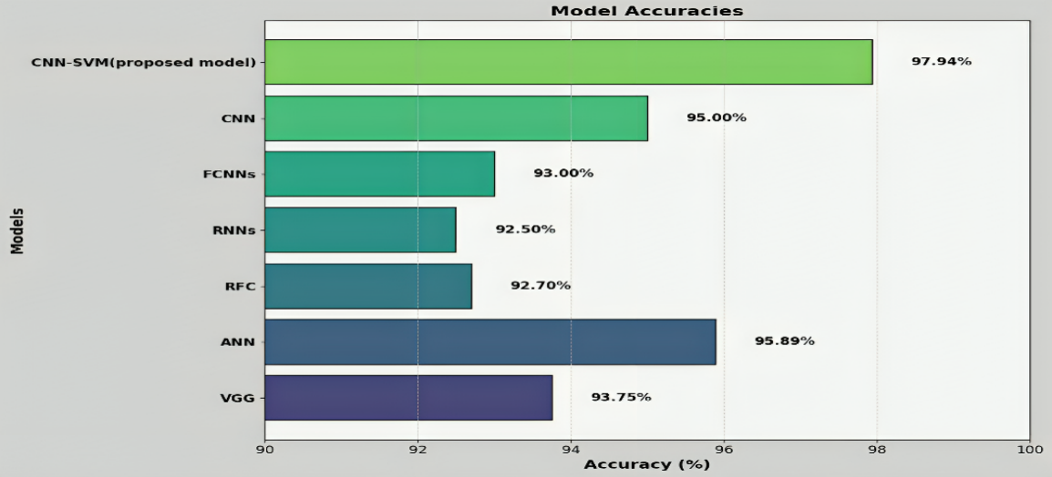

**Fig 9.1 Accuracy comparison on different model.**

Comparing the suggested CNN-SVM method shows clearly higher accuracy at 97.94% than the other models.

**Sensitivity:** Sensitivity, or Recall, measures the ability of the model to correctly identify all positive instances. A high sensitivity indicates that the model is good at detecting positive cases, which is particularly important in applications like medical diagnostics (e.g., brain tumor detection), where missing a positive case could have serious consequences. In the design of the CNN-SVM model, the sensitivity value was obtained as minutely as 95% which exceeds that of traditional approaches

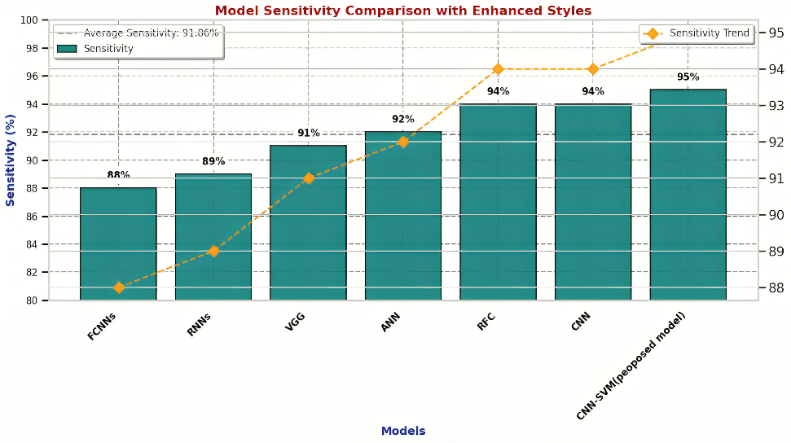

**Fig 9.2 Sensitivity Comparison on different models.**

**Specificity:** Specificity is the ability of the model to correctly identify negative instances (true negatives). A model with high specificity will correctly identify a majority of non-positive cases as negative, minimizing the occurrence of false positives. For instance, in a fraud detection system, specificity ensures that legitimate transactions are not incorrectly flagged as fraudulent. CNN-SVM achieved the highest specificity of 98.1 %, excelling in MRI classification.

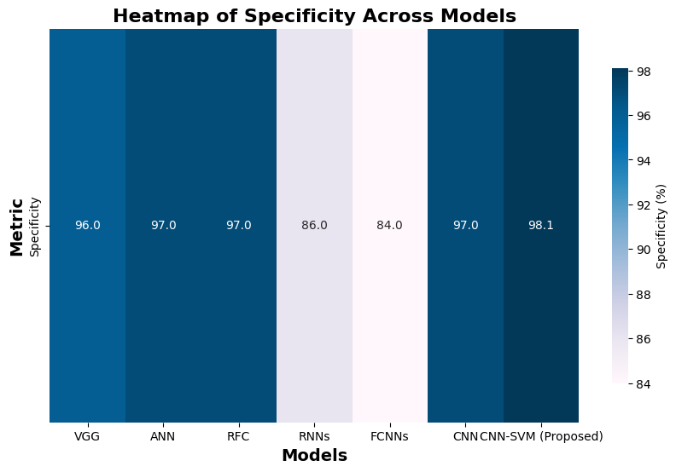

**Fig 9.3 Specificity comparison on different models.**

**Jaccard Coefficient:**

The Jaccard Coefficient measures the similarity between two sets—the predicted positive cases and the actual positive cases. It is particularly useful in evaluating tasks like image segmentation or multi-label classification, where it quantifies the overlap between the predicted and actual sets.

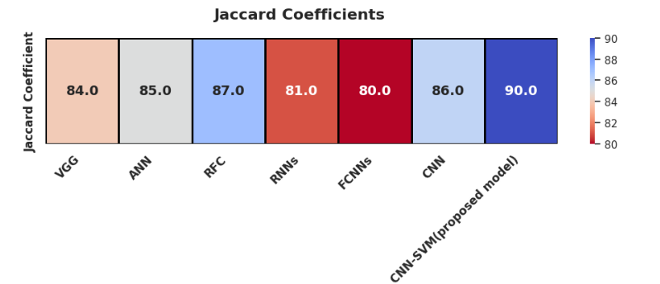

**Fig 9.4. Jaccard Coefficient on different models.**

The analysis from the above graphs comparing accuracy, sensitivity, specificity, and Jaccard coefficient of different algorithms reveals that ‘CNN-SVM' consistently outperforms 'VGG', 'ANN', ’RFC’, ’RNNS’, ’FCNNS’ and 'CNN' across all metrics. It exhibits higher accuracy, sensitivity, specificity, and Jaccard coefficient, indicating its effectiveness in making correct predictions, minimizing false positives, capturing relevant instances, and maintaining a balance between sensitivity and specificity. Overall, 'CNN-SVM’ demonstrates superior performance, suggesting its suitability for classification tasks compared to established models.

|  |  |  |  |  |
| --- | --- | --- | --- | --- |
| Model | Accuracy (%) | Jaccard Coefficient (%) | Sensitivity (%) | Specificity (%) |
| VGG | 93.75 | 84 | 91 | 96 |
| ANN | 95.89 | 85 | 92 | 97 |
| RFC | 92.70 | 87 | 94 | 97 |
| RNNs | 92.50 | 81 | 89 | 86 |
| FCNNs | 93.00 | 80 | 88 | 84 |
| CNN | 95.00 | 86 | 94 | 97 |
| **CNN-SVM** | **97.94** | **90** | **95** | **98.1** |

**Table 2 .Model Performance Comparison**

### TEST CASES

To ensure the reliability and robustness of the brain tumor detection system, several test cases should be considered. These test cases evaluate the system's ability to correctly process inputs, handle errors, and provide accurate predictions.

***Test case 1: Tumor***

**The system has successfully detected a tumor in the uploaded MRI image and displayed the result with the message "Tumor Detected" in the center of the screen.**

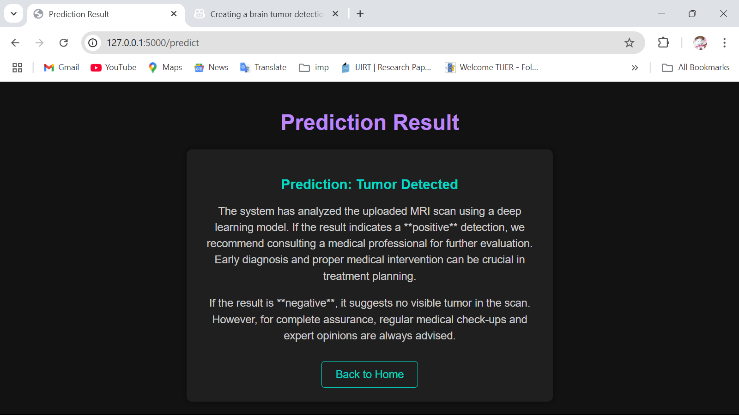

**Fig 10.1** Status tumor detected

***Test case 2: No Tumor***

**The system has analyzed the uploaded MRI scan and determined that no tumor is detected in the image.**

**The displayed output is the prediction result of a brain tumor detection system using a deep learning model. The system has analyzed the uploaded MRI scan and determined that no tumor is detected in the image.**

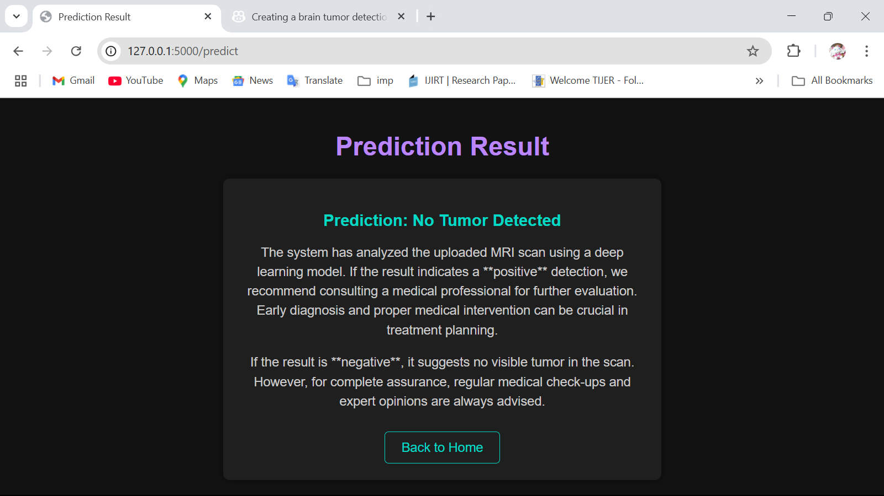

**Fig 10.2** Status No Tumor Detected

*Test case 3: Error Image*

**Fig 10.3** Status Invalid Image

The displayed output indicates an **"Error - Invalid Image"** message, meaning the uploaded file is not recognized as a valid brain MRI scan. This error is part of the system's **input validation** process to ensure only appropriate images are analyzed.

### USER INTERFACE

### The User Interface (UI) of the brain tumor detection system is designed to be intuitive, user-friendly, and visually appealing. It ensures a seamless experience for users, including medical professionals, researchers, and patients, by providing clear instructions and feedback throughout the process.

### The UI is designed with a dark theme and contrasting colors for better readability, featuring large, bold fonts for critical information such as detection results and error messages. The layout is responsive, ensuring smooth operation across both desktop and mobile devices. Additionally, interactive elements such as hover effects, real-time validation, and a loading animation during MRI analysis enhance user engagement. The system provides a simple, efficient, and accessible experience, allowing users to quickly upload an MRI scan and obtain reliable tumor detection results. Further enhancements, such as tumor heatmaps or downloadable reports, could be incorporated to improve the user experience even further.

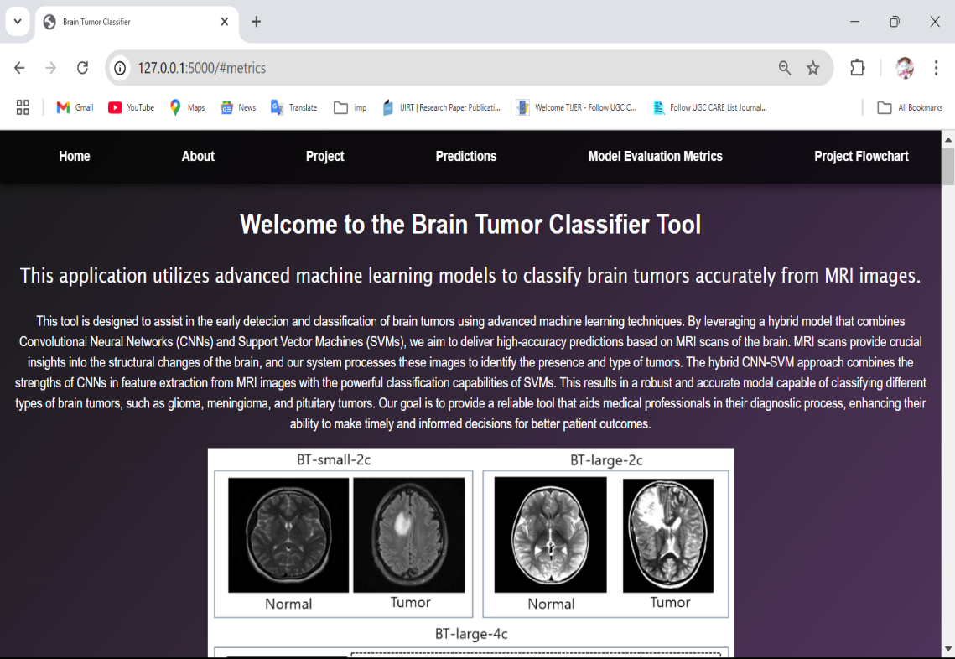

**Fig 11.1** Home Screen

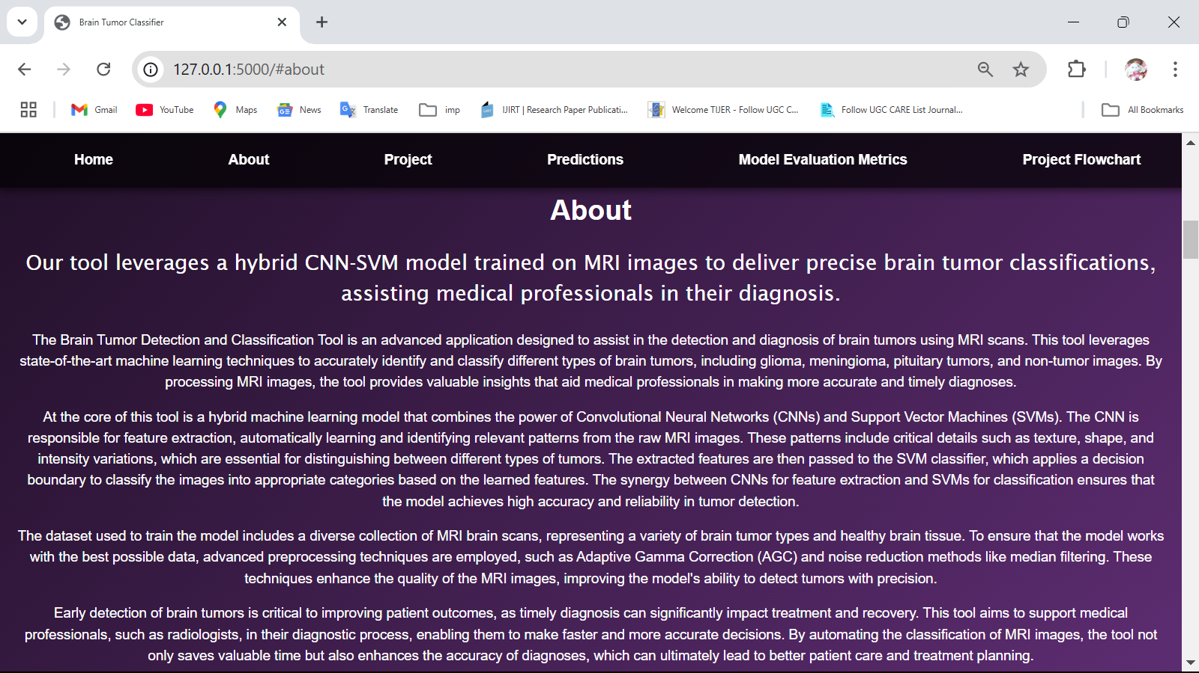

**Fig 11.2** about screen

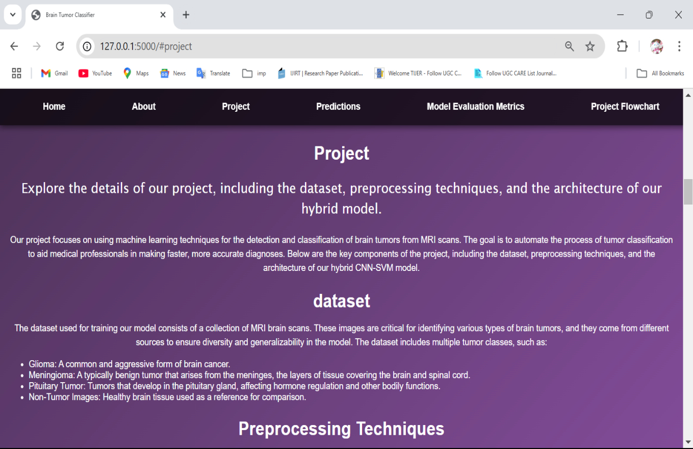

**Fig 11.3** project screen



**Fig 11.4** model evaluation screen

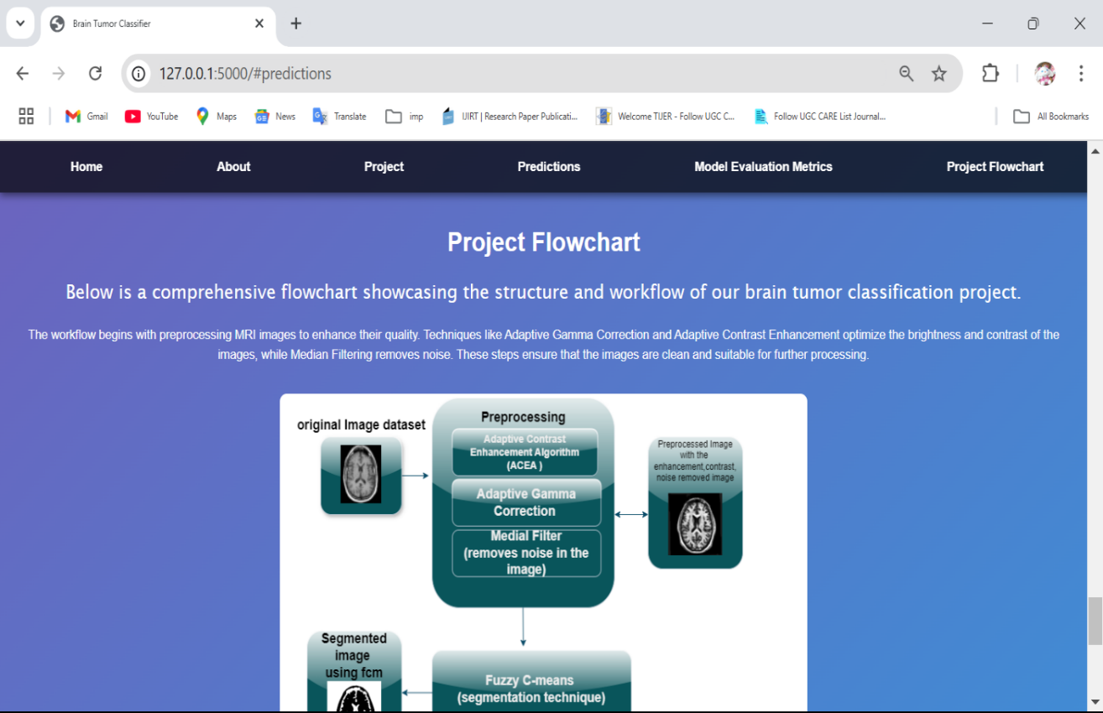

**Fig 11.5** project flowchart screen

### CONCLUSION

The CNN-SVM model is a promising tool for detecting brain tumors with impressive accuracy, achieving 97.94% in simulations. This hybrid model combines the strengths of Convolutional NeuralNetworks (CNNs) and Support Vector Machines (SVMs) to automate the process of feature extraction and classification. CNNs automatically extract important features from medical images, reducing the need for manual intervention, while SVMs effectively classify the images based on those features. This combination offers a more efficient and accurate approach to detecting brain tumors compared to traditional methods, which often require extensive human input and manual feature selection.

One of the key advantages of the CNN-SVM model is its ability to simplify the detection process, making it faster and easier than traditional methods. In clinical environments where time is crucial, this model’s ability to quickly analyze and detect tumors can lead to faster diagnoses, ultimately improving patient care. Additionally, the high accuracy rate demonstrated in simulations suggests that this method has great potential for real-world applications, offering better tumor detection and fewer missed diagnoses.

Looking ahead, further studies are needed to test and refine the CNN-SVM model. One key focus should be integrating the model into existing healthcare systems. This would involve making the model compatible with various medical imaging technologies and ensuring it can be used in real-time for quick decision-making. Additionally, efforts should be made to validate the model across diverse patient populations and imaging conditions to ensure its reliability in a wide range of clinical scenarios.

To make the model more accessible to healthcare professionals, researchers should also develop an intuitive user interface. Such an interface would allow clinicians to easily interpret the results, visualize tumor segments, and make informed decisions about treatment. Overall, the CNN-SVM model holds great potential in advancing brain tumor detection, and with continued research and development, it could become a vital tool in clinical practice, helping doctors make quicker and more accurate diagnoses.

### FUTURE SCOPE

The CNN-SVM model is a promising tool for detecting brain tumors with impressive accuracy, achieving 97.94% in simulations. This hybrid model combines the strengths of Convolutional Neural Networks (CNNs)and Support Vector Machines (SVMs) to automate the process of feature extraction and classification. CNNs automatically extract important features from medical images, reducing the need for manual intervention, while SVMs effectively classify the images based on those features. This combination offers a more efficient and accurate approach to detecting brain tumors compared to traditional methods, which often require extensive human input and manual feature selection.

One of the key advantages of the CNN-SVM model is its ability to simplify the detection process, making it faster and easier than traditional methods. In clinical environments where time is crucial, this model’s ability to quickly analyze and detect tumors can lead to faster diagnoses, ultimately improving patient care. Additionally, the high accuracy rate demonstrated in simulations suggests that this method has great potential for real-world applications, offering better tumor detection and fewer missed diagnoses.

While the model shows significant promise, future research should focus on integrating it into clinical software for wider use in hospitals and medical centers. To improve tumor detection further, future work could involve incorporating more advanced imaging techniques, such as color images and 3D scans, which provide more detailed and comprehensive views of the brain. These advanced imaging methods could enhance the model's ability to segment tumors more accurately, leading to better treatment planning and outcomes.

Incorporating 3D scans or colored images into the CNN-SVM model could also help with tumor segmentation, ensuring that the boundaries of tumors are more precisely defined. This would allow clinicians to plan more targeted treatments, such as surgery or radiation therapy, while minimizing damage to healthy tissue. By using richer imaging data, the model can better detect and analyze tumors, providing more reliable results for clinicians.Looking ahead, further studies are needed to test and refine the CNN-SVM model. One key focus should be integrating the model into existing healthcare systems. This would involve making the model compatible with various medical imaging technologies and ensuring it can be used in real-time for quick decision-making. Additionally, efforts should be made to validate the model across diverse patient populations and imaging conditions to ensure its reliability in a wide range of clinical scenarios.

To make the model more accessible to healthcare professionals, researchers should also develop an intuitive user interface. Such an interface would allow clinicians to easily interpret the results, visualize tumor segments, and make informed decisions about treatment. Overall, the CNN-SVM model holds great potential in advancing brain tumor detection, and with continued research and development, it could become a vital tool in clinical practice, helping doctors make quicker and more accurate diagnoses.

### 

**14. REFERENCES**

1. S. Solanki, U. P. Singh, S. S. Chouhan, and S. Jain, “Brain tumor detection and classification using intelligence techniques: an overview,” IEEE Access, vol. 11, pp.12870–12886, 2023.

2. S. Anantharajan, S. Gunasekaran, T. Subramanian, and R. Venkatesh, “MRI brain tumor detection using deep learning and machine learning approaches,” Measurement: Sensors, vol. 31, p. 101026, 2024.

3. N. Noreen, S. Palaniappan, A. Qayyum, I. Ahmad, M. Imran, and M. Shoaib, “A deep learning model based on concatenation approach for the diagnosis of brain tumor,” IEEE Access, vol. 8, pp. 55135–55144, 2020.

4. M. I. Razzak, M. Imran, and G. Xu, “Efficient brain tumor segmentation with multiscale two-pathway-group conventional neural networks,” IEEE Journal Biomedical and Health Informatics, vol. 23, no. 5, pp. 1911–1919, 2018.

5. S. Ahmad and P. K. Choudhury, “On the performance of deep transfer learning networks for brain tumor detection using MR images,” IEEE Access, vol. 10, pp. 59099–59114, 2022.

6. M. Li, L. Kuang, S. Xu, and Z. Sha, “Brain tumor detection based on multimodal information fusion and convolutional neural network,” IEEE Access, vol. 7, pp. 180134–180146, 2019.

7. H. A. Shah, F. Saeed, S. Yun, J. H. Park, A. Paul, and J. M. Kang, “A robust approach for brain tumor detection in magnetic resonance images using finetuned efficient net,” IEEE Access, vol. 10, pp. 65426–65438, 2022.

8. A. Younis, L. Qiang, Z. Afzal, M. J. Adamu, H. B. Kawuwa, F. Hussain, and H. Hussain, “Abnormal Brain Tumors Classification using ResNet50 and its Comprehensive Evaluation,” IEEE Access, 2024.

9. M. Agarwal, G. Rani, A. Kumar, P. Kumar, R. Manikandan, and A. H. Gandomi, “Deep learning for enhanced brain tumor detection and classification,” Results in Engineering, vol. 22, p. 102117, 2024.

10. Jagannadham, S. L., Nadh, K. L., Sireesha, M. (2021, November). Brain tumour detection using CNNs. In 2021 Fifth International Conference on I-SMAC (IoT in Social, Mobile, Analytics and Cloud)(I-SMAC) (pp. 734-739). IEEE.

11. R. Ezhilarasi and P. Varalakshmi, “Tumor detection in the brain using faster RCNN,” in 2018 2nd International Conference on I-SMAC (IoT in Social, Mobile, Analytics and Cloud) (I-SMAC), pp. 388–392, IEEE, August 2018.

12. A. A. Radhi, “Efficient algorithm for the detection of a brain tumor from an MRI image,” International Journal of Computer Applications, vol. 975, p. 8887, 2017.

13. Toğaçar, M., Ergen, B., Cömert, Z. (2020). BrainMRNet: Brain tumor detection using magnetic resonance images with a novel convolutional neural network model. Medical hypotheses, 134, 109531.

14. Sharma, K., Kaur, A., Gujral, S. (2014). Brain tumor detection based on machine learning algorithms. International Journal of Computer Applications, 103(1).

15. Moturi, Sireesha, SN Tirumala Rao, and Srikanth Vemuru. "Optimized feature extraction and hybrid classification model for heart disease and breast cancer prediction." International Journal of Recent Technology and Engineering 7, no. 6 (2019): 1754-1772.

16. Greeshma, B., Sireesha, M., Thirumala Rao, S. N. (2022, February). Detection of arrhythmia using convolutional neural networks. In Proceedings of Second International Conference on Sustainable Expert Systems: ICSES 2021 (pp. 21-30). Singapore: Springer Nature Singapore.

**Enhanced Classification and Detection of Brain Tumor using Hybrid Deep Learning and Machine Learning Models**

Sireesha Moturi1, Divvela Bala Sri Abhigna2, Gaddam Saranya3, Shaik Sameera4, Chinnam Harini5, and Dodda Venkata Reddy6

1*,*2*,*3*,*4*,*5*,*6 Department of Computer Science Engineering, Narasaraopeta Engineering College, Narasaraopet, India

[*sireeshamoturi@gmail.com,](mailto:sireeshamoturi@gmail.com) [abhidiveela@gmail.com,](mailto:abhidiveela@gmail.com) [gaddamsaranya4@gmail.com,](mailto:gaddamsaranya4@gmail.com) [sameerashaik22498@gmail.com,](mailto:sameerashaik22498@gmail.com) [chinnamharini30@gmail.com,](mailto:chinnamharini30@gmail.com) [doddavenkatareddy@gmail.com](mailto:doddavenkatareddy@gmail.com)

**Abstract.** In recent years, deep learning has become an influential tool in medical imaging,especially the present work illustrates a new tech- nique for brain tumor identification based on magnetic resonance im- ages(MRI) using the combination of convolutional neural networks and support vector machine techniques. The proposed model combines CNNs performing feature extraction effectively, while SVMs classify with high precision. To begin with, some preprocessing methods like adaptive gamma correction, adaptive contrast enhancement, and median filtering are ap- plied to MRI images so as to improve image quality and minimize noise interference. Fuzzy c-means clustering technique is used to extract impor- tant texture features like energy, mean values or entropy from GLCMs represented as matrices of grey levels co-occurrence pairs. CNN helps with acquiring deeper features from segmented images which serve as inputs during training phases of SVM classifiers based on those features thus obtained from them (CNN), eventually yielding high performance levels. An hybrid model using CNN-SVM showed an accuracy rate of 97 .94%, sensitivity 95% , specificity 98.1% when it came to distinguish- ing between normal and abnormal brain tissue. Therefore, this hybrid model demonstrates its capability in tumor detection due to combina- tion of both CNN and SVM hence providing an alternative automated approach for early diagnosis.

**Keywords:** Magnetic Resonance(MRI) Images,Fuzzy c-means Segmentation,CNN- SVM Hybrid Model,GLCM Feature Extraction

1. **Introduction**

Among the most terrible types of cancer, brain tumors necessitate immediate de- tection for successful treatment. MRI is crucial in spotting brain tumors because of its best quality and precision. However, manual interpretation by radiologists can be time-consuming and inconsistent, necessitating automated systems to detect and classify malignant brain tumors with high accuracy. This improves

diagnosis and treatment outcomes. In India, the incidence of brain tumors is on the rise, with around 40,000 new cases projected annually. Early and pre- cise detection is essential to improve survival rates, as delays or errors can lead to misdiagnosis and further suffering. Accurate classification of tumors, such as glioma,meningioma, and pituitary tumors [1], ensures patients receive the in evaluation of healthcare images,particularly advanced Convolutional Neural Networks [2] and Support Vector Machines are used. SVMs are known for their classification accuracy as well as their ability to generalize while CNNs excel in image classification by automatically learning hierarchical features.This re- search paper suggests a hybrid model integrating CNN with SVM for tumor recognition in brain [3]. There are several advanced preprocessing methods such as Adaptive Contrast Enhancement Algorithm (ACEA), adaptive gamma cor- rection, normalization, equalization, median filtering , and data augmentation which improve performance. Fuzzy C-Means (FCM) segmentation and GLCM technique are used to precisely select tumor areas and extract features. This hy- brid model neural networks aims at achieving higher accuracy and reliability in detecting and classifying brain tumors as shown in Fig 1, so as to provide more effective and personalized treatments approaches.

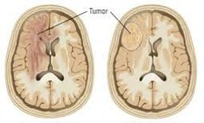

**Fig. 1.** Classification of healthy brain tissues and tumor brain tissue

The major contributions of this study consist of:

1. Incorporation of cutting-edge preprocessing algorithms such as Adaptive Contrast Enhancement Algorithm (ACEA), non-linear gamma enumeration tool, scaling, histogram modification, all within a single scan, to enhance image resolution and facilitate the extraction of features from MRI images.
2. Utilization of Fuzzy C-Means (FCM) segmentation for more accurate tumor

region extraction, along with Grey Level Co-Occurrence Matrix (GLCM) for reliable feature extraction.

1. Development of a hybrid CNN-SVM model for better classification and dif-

ferentiation of brain tumors using MRI scans.

1. Comprehensive analysis of the effectiveness of our proposed model based on a dataset of MRI images, with comparisons to conventional methods.
2. Examination of different evaluation metrics to assess the performance and reliability of the suggested approach.

This entails evaluating several performance metrics to ascertain the validity and stability of the said model. Particularly, the study will explain the model’s reliability and its capability of brain tumor detection through the exploration of other metrics like accuracy, sensitivity, specificity, and precision. The goal of the suggested model with hybrids systems incorporated is the improvement of the detection and classification of brain tumors coupled with machine learning and deep learning techniques alongside a lot of pre processing techniques. This would provide a lot of improvements in the dissociative diagnosis enabling health care workers to make appropriate decisions in a short period, thereby reducing the chances of patient mistrust. To wrap up, this CNN-SVM model offers a great opportunity to be successfully employed for the goal of treating brain tumors by optimizing the existing treatment resources.

1. **Related Works**

Solanki S. addresses techniques for identifying and classifying brain tumors using CNNs and transfer learning models including RESNET-100 and VG- GNET.Traditional methodologies like SVMs and RFs present difficulties in au- tomation while CNN’s enhance accuracy of classification by a margin of 10-15%. Furthermore, propelling up its performance is transfer learning which adds an ad- ditional 5-10% .M. Imran [4]enhanced CNN-based detection with a DCNN and a three-stage preprocessing technique, lead for enhanced output evaluated to mod- els like VGG16 and VGG19.According to Ahmad S. and Choudhury P.K. [5], they have conducted a systematic examination of the progress made in machine learning and deep learning with respect to identifying tumors based on MRI, whereby it was shown that models which had undergone training before, like Inception-v3 and DenseNet201, can attain above 90% level of accuracy although there still remain some optimization challenges that must be addressed. To solve problems in single-modal techniques, Shah H. A [6]presented a CNN aimed at multi-modal MRI fusion. As noted in [8], EfficientNet-B0 is also considered to be one of the best models on tumor detection; therefore, it is recommended to use transfer learning and data augmentation methods to deal with limited datasets.M. Agrawal proposed enhanced brain tumor detection and classifica- tion using deep learning models used inception V3 model for better results [9]. Sireesha,M. used cnn for better tumor classification [10] used magnetic resonance images with this efficient techniques brain tumor detection and classification is done efficiently to secure more accuracy.The article discusses an approach to detecting brain tumors using the Faster R-CNN [11] model which efficiently performs tumor identification in MRI images by region proposal networks en- abling real time detection. This technique is shown to be highly precise making it possible to reduce the time taken in diagnosis in the imaging process.

* 1. **Problem Statement:**

Brain tumors quite serious, could cause paralysis and long term treatments. Their implications vary based on their size, location and type. Early diagnosis prevents complications.There is therefore a need for better instruments for quick, precise diagnosis to facilitate prompt treatment with improved out comes for patients.

1. **Proposed methodology**

The emphasis of this investigation is to detect brain tumors in MRI images [12] by employing deep and machine learning methods [14] as in Fig 2. The pre- processing phase is performed through the ACEA algorithm and median filter after segmented using fuzzy c-means and features are extracted through GLCM. Following this, a hybrid CNN-SVM model is applied to classify these features thereby increasing the accuracy of detection.

* 1. **Dataset collection:**

We assessed our model employing Kaggle dataset [2]encompassing T1-sequenced improved MRI scans [7] obtained from individuals diagnosed with brain tumors, as shown in Fig 3. This dataset contains meningioma, glioma, pituitary, and no tumor slice images, respectively collected from [https://www.kaggle.com/](https://www.kaggle.com/datasets/vivekp7039/figshare-brain-tumor-dataset-converted-to-png) [datasets/vivekp7039/figshare-brain-tumor-dataset-converted-to-png](https://www.kaggle.com/datasets/vivekp7039/figshare-brain-tumor-dataset-converted-to-png).

* 1. **Preprocessing:**

**ACE - Adaptive Contrast Enhancement Algorithm (improvised algo- rithm)** ACE algorithm improves the image contrast by means of local statistics such as mean pixel intensity and standard deviation. ACE adjusts the image’s brightness depending on its different parts. Hence, while some areas may be highlighted more than others, each one remains clear and easily visible than before.

The first step is to slice the picture into segments for localized contrast mod- ification by(1).

1 Σ

Next, we calculate the standard deviation,the mean using equation (2):

After gathering local averages and standard deviations (equations 1 and 2),as shown in equation (3). The modified pixel value can be expressed by this formula:

*p*new = *µ* + *k ·* (*p − µ*) (3)

With the use of local means and contrasts, this method improves pixel and image quality thereby giving a better appearance to the whole image.

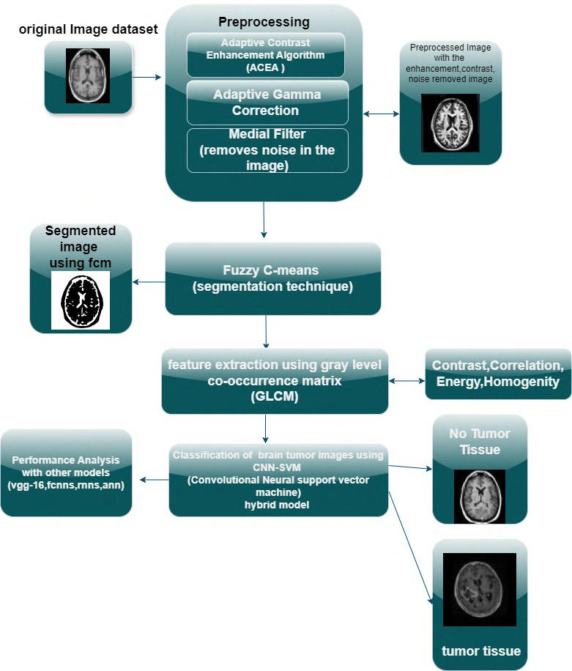

**Fig. 2.** Procedure Outline for the Developed Technique.

**Adaptive Gamma Correction Algorithm(AGC):** AGC alters brightness and contrast locally to enhance MRI images for brain tumor detection; it enables better visualization of tumors than their neighboring tissues. In contrast to con- ventional gamma correction, AGC adjusts the value of gamma for each zone.The formula used to determine the corrected pixel intensity *I*corrected (equation 4) is as follows:

*I*corrected(*x, y*) = *I*(*y*)*γ*local (4)

To obtain clear, high resolution images, AGC is used to increase local gamma value, *gamma*local, in MRI images.

**Median filter:** Median filtering is a widely used technique for reducing noise. It helps clean up images while preserving important details.At each position, the central pixel’s value is replaced by the median of the values within the window. The new pixel value is computed using the formula(5):

*u*updated(*a, b*) = median*{p*(*a − m, b − n*)*, . . . , p*(*a* + *m, b* + *n*)*}* (5)

Here,*u*updated(*a, b*)(5)represents the new parameter of (a,b) where (a,b) is the updated parameter of the pixel at position (a,b). This median takes account of the pixel values gathered from a window around (a, b) such that k represents half the window size.

* 1. **Enhanced Image Segmentation Through Fuzzy C-Means Clustering:**

The Fuzzy C-Means (FCM) segmentation is an often-used unsupervised cluster- ing technique Certainly, brain tumors can be detected and segmented using fuzzy c-means method (FCM). This is an improvement over conventional methods be- cause FCM takes into account the inbuilt fuzziness of data unlike traditional techniques that apply hard classifications.

In the process of Cluster Centre Computation, new cluster centers are computed

through the formula (6):

*j*

*N*

*i*=1

*v*

*m ij*

Σ

*µ*

=  *i*=1 *ij*

(6)))

Then, update the membership values based primarily on the distance between data points and cluster centers (6) using the formula:

*c k*=1

Σ

2

*v−*1



*ai−xj ai−xk*

(7)

The objective function can be calculated to check for convergence using for- mula (8):

*C*

*jm* = Σ Σ *vm · xi − µj * 2 (8)

*ij*

This process ends when it reaches a predetermined level of the objective function

(8) or when it has carried out its maximum number of iterations. Otherwise, the processes are repeated.

* 1. **Feature Extraction using GLCM :**

A gray level co-occurrence matrix known as GLCM is a common textual study method that examines spatial correlations of pixel intensities in MRI images. This statistical technique captures texture information, helping to differentiate tissues and detect pathological features like tumors in medical MRI scans. The

Following several statistical features can be obtained from GLCM to characterize the MRI image texture. In this approach was suggested, contrast, dissimilarity, homogeneity, energy, correlation.

1. Contrast: It measures the intensity difference between neighboring pixels. A

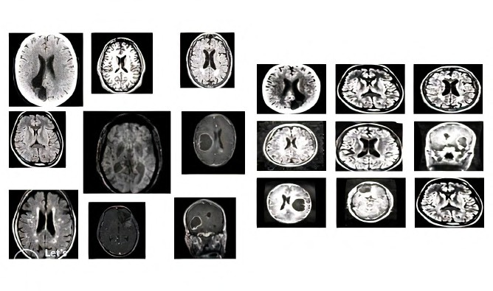

**Fig. 3.** Comparisons of Different and Same Sizes Sample MRI Images

higher contrast value from (9) which may be useful in differentiating tumor areas from normal tissue.

contrast = (*p − q*)2*a*(*p, q*) (9)

Σ

*p,q*

1. Correlation:In an image, correlation measures of how much image data points(pixels) are related linearly to one another. This indicative bare skeleton measure (10) indicates how intensity correlates with the pixel map of different positions in any given place.

correlation = *l,m*(*l − µx*)(*j − µy*)*P* (*l, m*)

Σ

*σxσy*

(10)

1. Energy: It represents (11) the combination of the class features in the GLCM, which means that the text is identical.

Σ

energy = *R*(*i, j*)2 (11)

*i,j*

1. Homogeneity:In (12) measures how close the distribution of features in the GLCM is to the diagonal.

homogeneity =  *Q*(*i, j*)

Σ

1 + (*i − j*)2

(12)

*i,j*

* 1. **Integrated Hybrid Models WithCNN and SVM for Enhanced Classification:**

This model Combines the feature extraction of CNN neural network with the classification of SVM; hence optimizing image analysis and category boundaries.

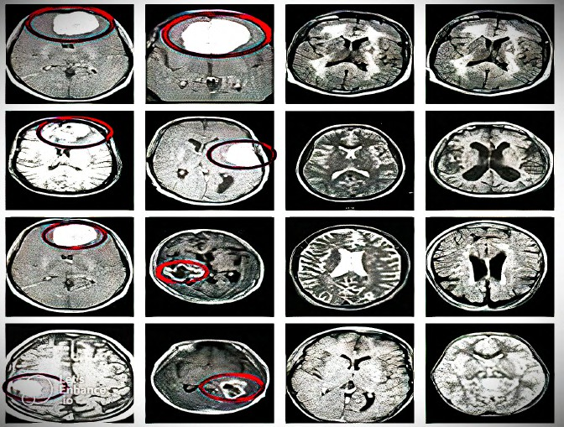

**Fig. 4.** Hybrid CNN-SVM Model for Classification Approach

**Designing Approach for Hybrid CNN - SVM system:** The CNN-SVM model in it, various raw images are passed through a CNN [13] where rectified linear unit (ReLU) activations and pooling layers help to maintain important information while reducing dimensions. After that, a fully connected layer(13) compresses the flattened output which is then classified by the SVM machine learning model that searches for the best hyperplane for class separation.

Σ

*f* (*x*) = sign

*n i*=1

*βizi Φ*(*xi, x*) + *c*!

(13)

**Implementation of CNN-SVM Hybrid Model Architecture:** In order to effectively create a CNN-SVM structure , the initial step is teaching a CNN using a loss function, for instance cross entropy loss, in order to achieve the extraction of useful features.

This training consists of image segmentation which improves the feature ex- traction and the entire system performance(14).

LCNN = *−* Σ *i* = 1*n* [*yi* log(*pi*) + (1 *− yi*) log(1 *− pi*)] (14)

**Model Output:** The outcome model of CNN-SVM combine CNN to extract features and SVM for the ultimate classification which enhances prediction ac- curacy, as in Fig 5.

**Developing the CNN-SVM Hybrid Model A Training Methodology:** The training mode for CNN-SVM hybrid model uses dual optimization strategy making use of the two. The CNN [11] is initially trained to extract feature vectors from input MRI images. These are fed into SVM [15] for classifying purposes.This system performs alternating updates of both CNN and SVM based on metrics

a. results than when only CNN or SVM were used separately. The developed model identifies and detect the tumor as shown in Fig 4 efficiently.

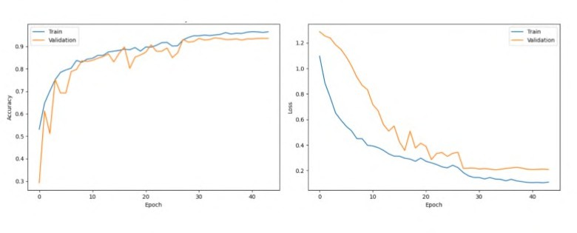

**Fig. 5.** CNN-SVM model accuracy and loss

1. **Results and Discussions:**

Using Python 3.10 based deep learning or Machine Learning methods,this section is devoted in brain tumor detection from MRI images. The evaluation of models has been done through TP, TN, FP and FN metrics that compare CNN-SVM model with other models such as CNN, VGG, RNN, RFC, FCNN and ANN. Accuracy, Jaccard index as well as sensitivity are used to measure performance.

* 1. **Accuracy**

The performance of a model in accurately distinguishing between tumor types and normal tissue is referred to as the accuracy(15).It is a key metric for mea- suring performance.

Accuracy = *TP* + *TN*

*TP* + *TN* + *FP* + *FN*

(15)

Comparing the suggested method shows clearly higher accuracy at 97.94% as shown in Fig 6.

* 1. **Specifivity:**

Specificity(16) measures the proportion of true negatives, indicating how well a test identifies the absence of disease. As shown in Fig 7, CNN-SVM achieved the highest specificity of 98.1 %, excelling in MRI classification.

Specificity(TNR) = *TN*

*TN* + *FP*

(16)

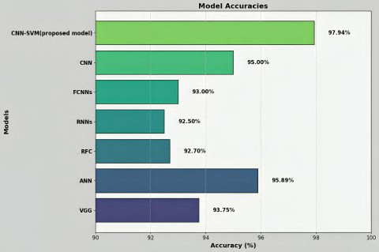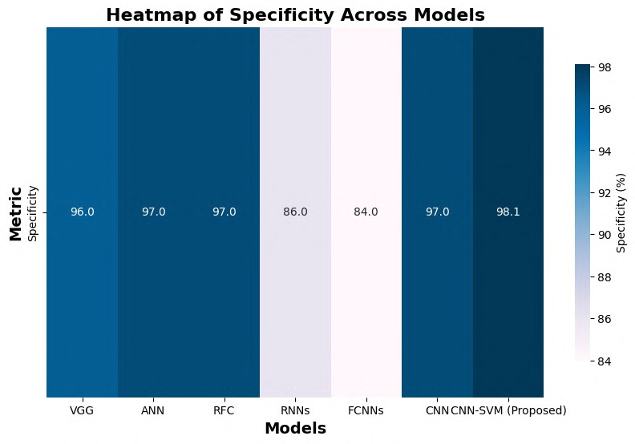

**Fig. 6.** Accuracy comparison. **Fig. 7.** Specificity comparison.

* 1. **Sensitivity:**

True positive probability is what sensitivity assesses. In the design of the CNN- SVM model, the sensitivity value(17) was obtained as minutely as 95% which exceeds that of traditional approaches.

sensitivity = *TP TP* + *FN*

(17)

* 1. **Jaccard Coefficient**

Jaccard coefficient, commonly referred to as the Jaccard index or intersection over union (IoU) (18), is a primary measure in image segmentation and analysis. Here,Fig 9 shows Jaccard index of the analysis of the different models.

jaccardcoefficient = *|p ∩ q|*

*|p ∪ q|*

(18)

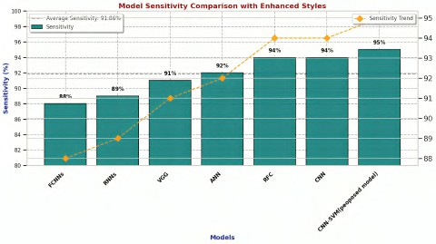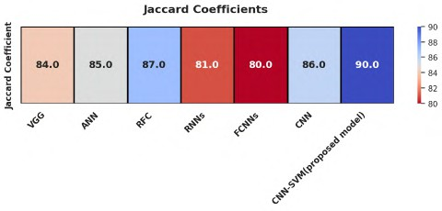

**Fig. 8.** Sensitivity Comparison. **Fig. 9.** Jaccard Coefficient.

1. **Discussion:**

In Table 1, the performance measures of several machine learning techniques are compared. These techniques include CNN, ANN,RFC,RNN,FCNN among others and the proposed model CNN-SVM plus the VGG architecture. Though each model has its level of accuracy, speed and overall performance, the costs in terms of computational power also differ across the models. For example, high-performance ANN models require sophisticated hardware where they are deployed and are dependent on tuning of hyperqualities which often results to differences in their performances. Random Forest Classifiers have a reputation for being versatile and capable of dealing with diverse data, the ensemble meth- ods tend to be expensive in terms of computing power as the number of trees increases which in most cases leads to delays especially with bigger data sets. RNNs are great for tables and graphs that have all the data points in a particular order, but they cannot handle farther back gaps so well and tend to be heavier on the processing.

**Table 1.** Performance comparison of different models.

|  |  |  |  |  |
| --- | --- | --- | --- | --- |
| **Model** | **Accuracy** | **Jaccard Coefficient** | **Sensitivity** | **Specificity** |
| VGG | 93.75 | 84 | 91 | 96 |
| ANN | 95.89 | 85 | 92 | 97 |
| RFC | 92.70 | 87 | 94 | 97 |
| RNNs | 92.5 | 81 | 89 | 86 |
| FCNNs | 93 | 80 | 88 | 84 |
| CNN | 95 | 86 | 94 | 97 |
| CNN-SVM(propsed) | 97.94 | 90 | 95 | 98.1 |

The hybrid model that combines CNN [16] and SVM proves to be a suitable contender that is less time-consuming and more efficient in terms of performance by combining the feature extraction advantage of CNNs and the classification prowess of Support Vector Machines (SVM). An in-depth presentation of the performance metrics, such as accuracy, specificity, sensitivity, and Jaccard’s in- dex for each model across experiences with various datasets is demonstrated in the Fig 6-9. Such figures indicate the performance capabilities of each model in various scenarios.Visual assessments of the models under review further con- firm the superiority of the combined CNN-SVM model in terms of performance metrics with respect to the discussed other models.

1. **Conclusion:**

Developed CNN-SVM model is very effective at detecting brain tumors with an accuracy of 97.94% Through advanced types of deep neural networks enabling easier approach to automatic feature extraction by using a supporting vector ma- chine classifiers combination, it becomes quite simpler than traditional methods thereby offering faster and easier way out. This model was found by simula- tions to have potential for better accuracies, and future researchers should focus on incorporating it into clinical software by using color images or 3D scans in order to achieve better tumor segmentation. Simulations have shown how vi- able this method is thus promising improved accuracy levels in regard to brain tumor detection using CNN-SVM models. Future research here is most impor- tant however; incorporating these algorithms into clinical software would en- hance their practical uses in hospitals while working with colored photographs or three-dimensional scans could also assist better tumor segmentation leading to a more comprehensive instrument for diagnosing and planning treatment of brain tumors. As a whole, the CNN-SVM model is a promising step forward in the detection of brain tumors; it includes hybrid approaches that utilize deep learning techniques as well as machine learning ones for effective and accurate results. To enhance its usefulness in medical imaging, subsequent studies must seek to diversify its usage and implement it in health care systems.

**References**

1. S. Solanki, U. P. Singh, S. S. Chouhan, and S. Jain, “Brain tumor detection and classification using intelligence techniques: an overview,” *IEEE Access*, vol. 11, pp. 12870–12886, 2023.
2. S. Anantharajan, S. Gunasekaran, T. Subramanian, and R. Venkatesh, “MRI brain

tumor detection using deep learning and machine learning approaches,” *Measure- ment: Sensors*, vol. 31, p. 101026, 2024.

1. N. Noreen, S. Palaniappan, A. Qayyum, I. Ahmad, M. Imran, and M. Shoaib, “A

deep learning model based on concatenation approach for the diagnosis of brain tumor,” *IEEE Access*, vol. 8, pp. 55135–55144, 2020.

1. M. I. Razzak, M. Imran, and G. Xu, “Efficient brain tumor segmentation with

multiscale two-pathway-group conventional neural networks,” *IEEE Journal of* *Biomedical and Health Informatics*, vol. 23, no. 5, pp. 1911–1919, 2018.

1. S. Ahmad and P. K. Choudhury, “On the performance of deep transfer learning

networks for brain tumor detection using MR images,” *IEEE Access*, vol. 10, pp. 59099–59114, 2022.

1. M. Li, L. Kuang, S. Xu, and Z. Sha, “Brain tumor detection based on multimodal information fusion and convolutional neural network,” *IEEE Access*, vol. 7, pp. 180134–180146, 2019.
2. H. A. Shah, F. Saeed, S. Yun, J. H. Park, A. Paul, and J. M. Kang, “A robust approach for brain tumor detection in magnetic resonance images using finetuned efficient net,” *IEEE Access*, vol. 10, pp. 65426–65438, 2022.
3. A. Younis, L. Qiang, Z. Afzal, M. J. Adamu, H. B. Kawuwa, F. Hussain, and H. Hussain, “Abnormal Brain Tumors Classification using ResNet50 and its Compre- hensive Evaluation,” *IEEE Access*, 2024.
4. M. Agarwal, G. Rani, A. Kumar, P. Kumar, R. Manikandan, and A. H. Gandomi, “Deep learning for enhanced brain tumor detection and classification,” *Results in Engineering*, vol. 22, p. 102117, 2024.
5. Jagannadham, S. L., Nadh, K. L., Sireesha, M. (2021, November). Brain tumour detection using cnn. In 2021 Fifth International Conference on I-SMAC (IoT in Social, Mobile, Analytics and Cloud)(I-SMAC) (pp. 734-739). IEEE.
6. R. Ezhilarasi and P. Varalakshmi, “Tumor detection in the brain using faster R- CNN,” in *2018 2nd International Conference on I-SMAC (IoT in Social, Mobile, Analytics and Cloud) (I-SMAC)*, pp. 388–392, IEEE, August 2018.
7. A. A. Radhi, “Efficient algorithm for the detection of a brain tumor from an MRI image,” *International Journal of Computer Applications*, vol. 975, p. 8887, 2017.
8. Toğaçar, M., Ergen, B., Cömert, Z. (2020). BrainMRNet: Brain tumor detection using magnetic resonance images with a novel convolutional neural network model. Medical hypotheses, 134, 109531.
9. Sharma, K., Kaur, A., Gujral, S. (2014). Brain tumor detection based on machine learning algorithms. International Journal of Computer Applications, 103(1).
10. Moturi, Sireesha, SN Tirumala Rao, and Srikanth Vemuru. "Optimized feature extraction and hybrid classification model for heart disease and breast cancer pre- diction." International Journal of Recent Technology and Engineering 7, no. 6 (2019): 1754-1772.
11. Greeshma, B., Sireesha, M., Thirumala Rao, S. N. (2022, February). Detection of arrhythmia using convolutional neural networks. In Proceedings of Second In- ternational Conference on Sustainable Expert Systems: ICSES 2021 (pp. 21-30). Singapore: Springer Nature Singapore.

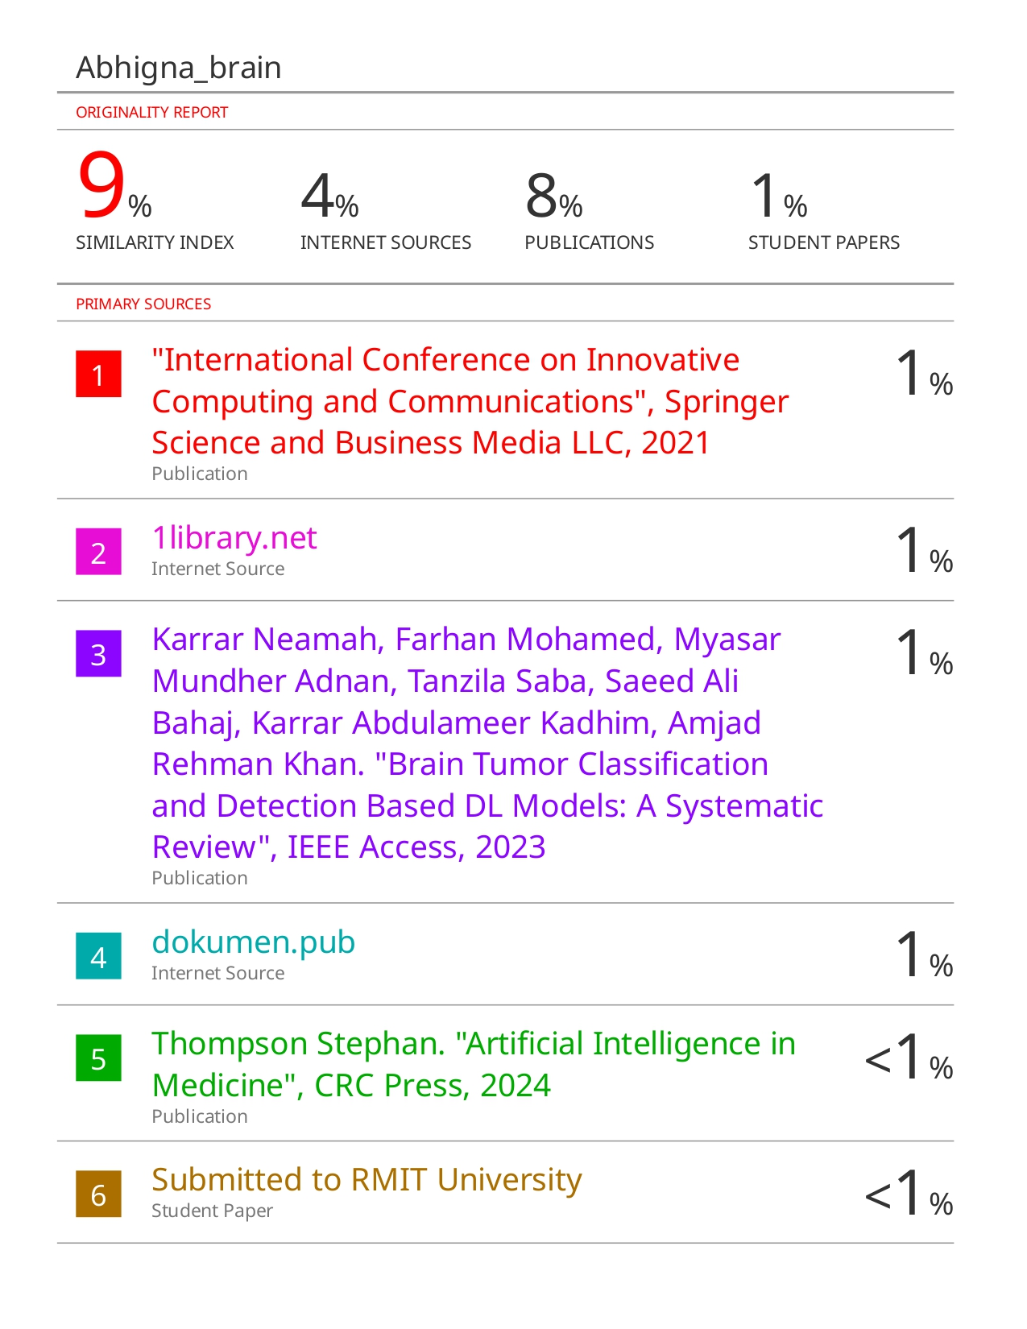

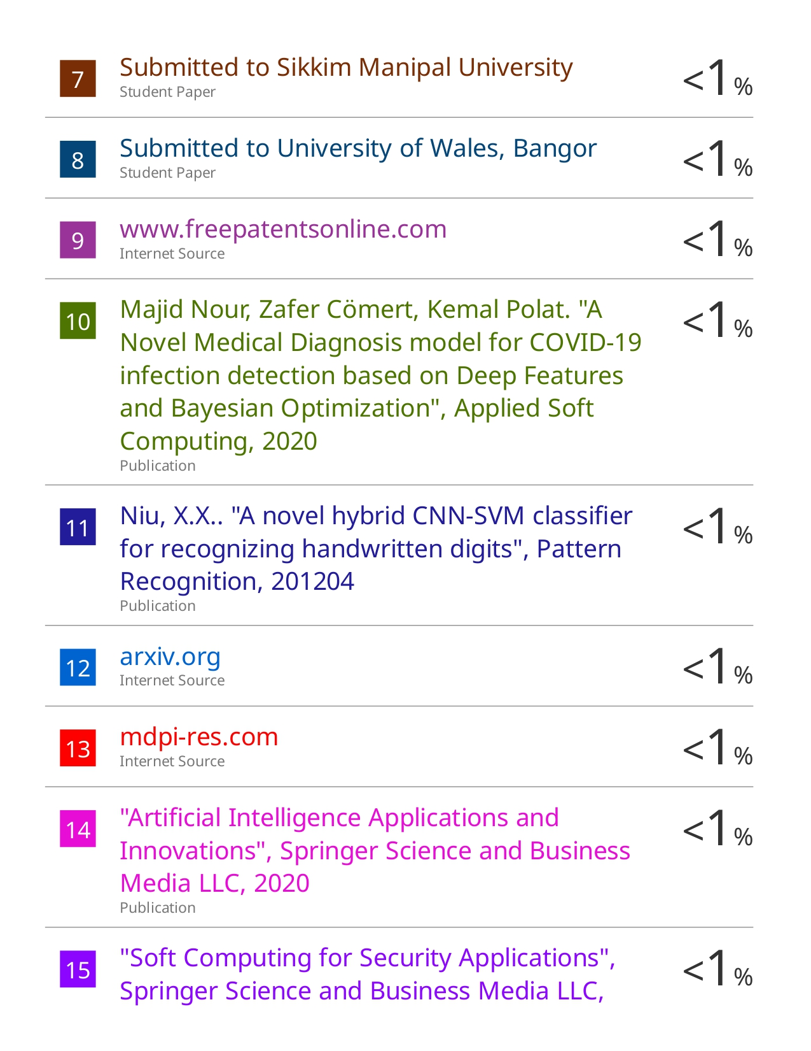

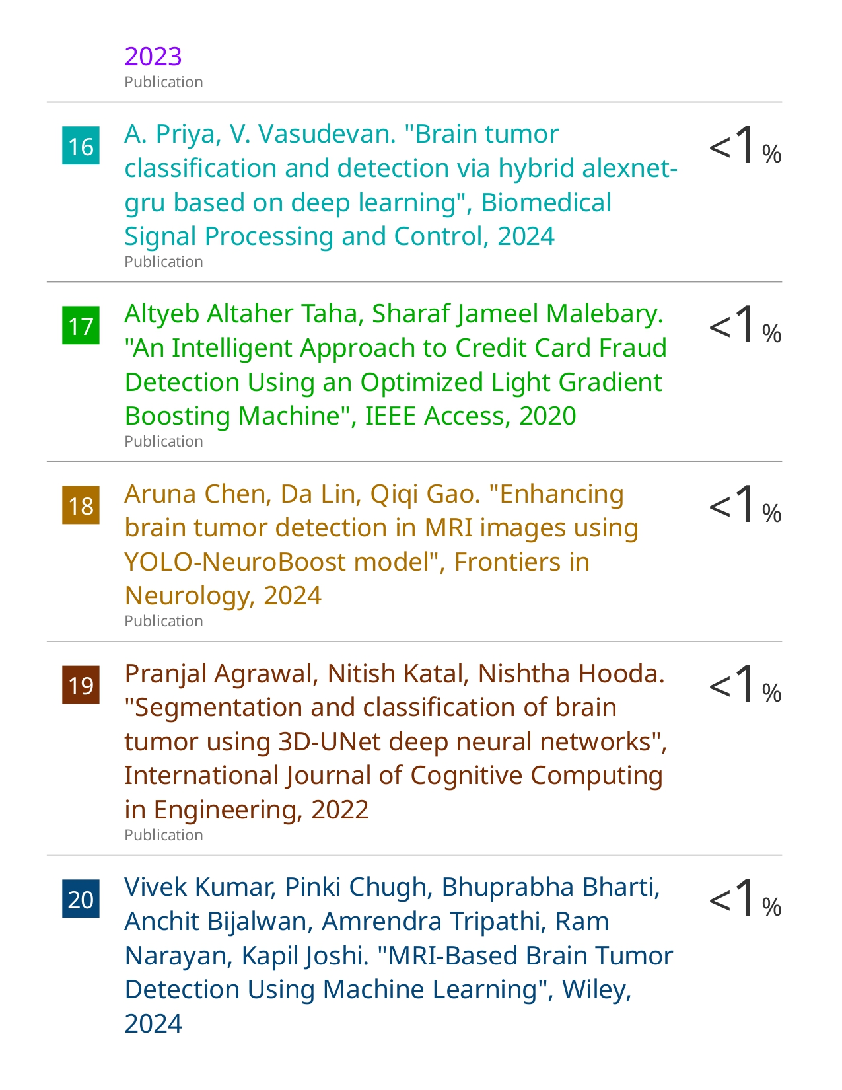

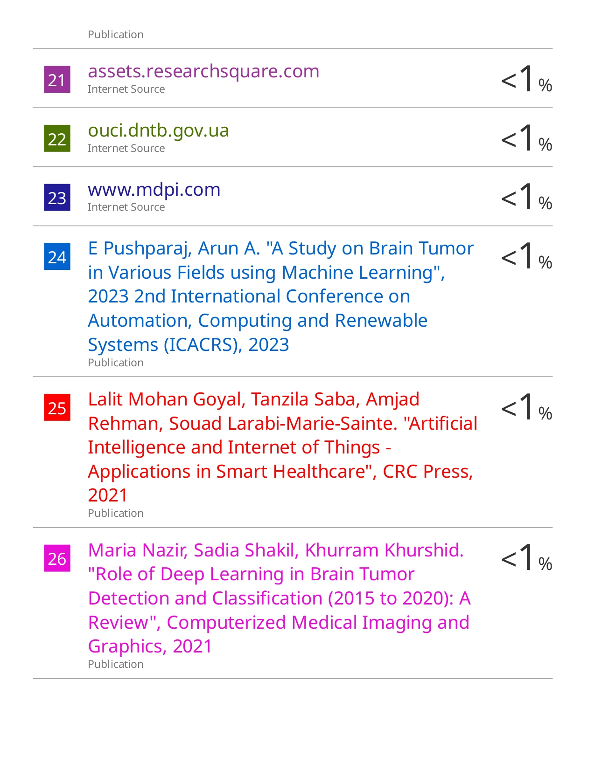

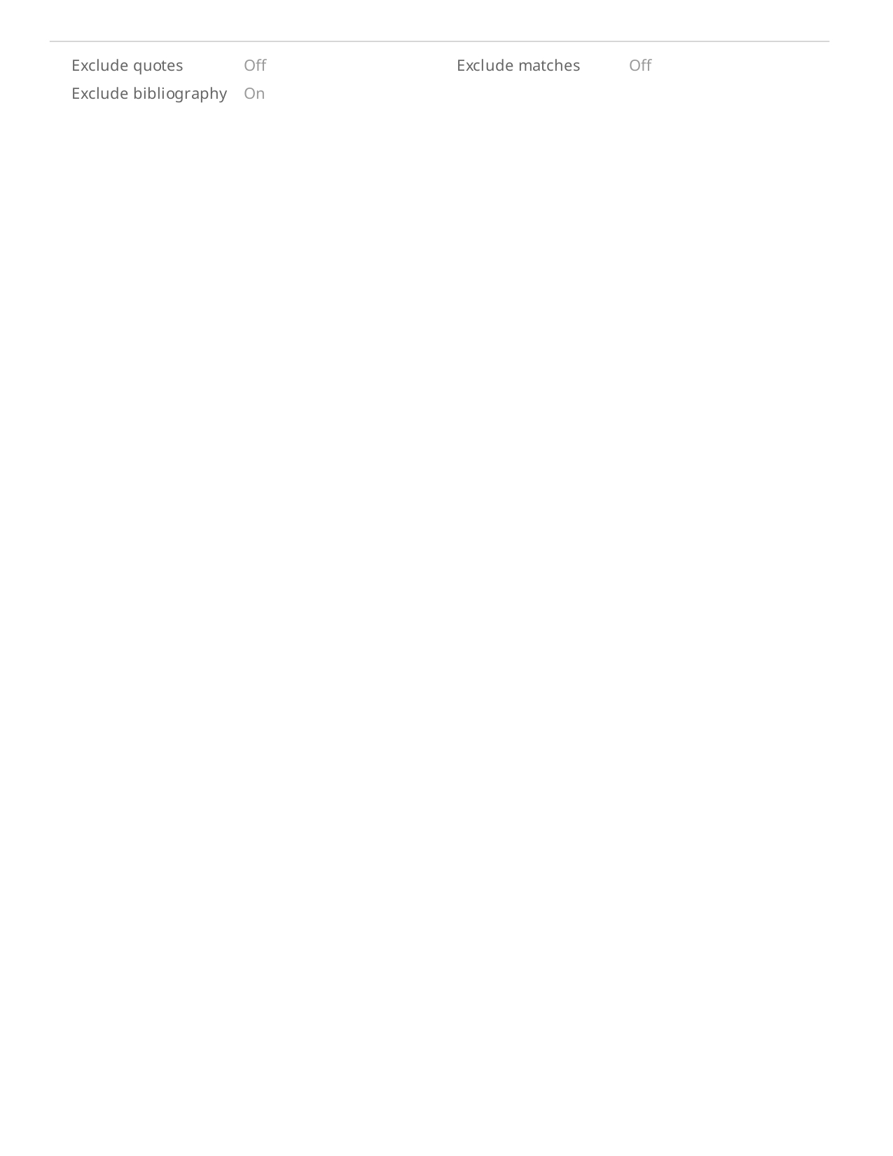 **Certificate of Presentation**

